KAMPONG UPGRADING AND GREENING
Enabling and Learning Processes for Consolidation-based Urban Settlement Redevelopment

Budi PRAYITNO
Associate Professor, Departement of Architecture and Planning, Faculty of Engineering, Gadjah Mada University, Yogyakarta 55281, Indonesia ; budiprayitno_ugm@yahoo.com

- SUSTAINABLE HABITAT INITIATIVES
The phenomenon of urbanization, climate change and urban governance were the backgrounds of the sustainable habitat initiation. The crisis of dense residence area in the river-bank of marginal areas in Yogyakarta, Indonesia as a result of urbanization had caused ecological problems as the rivers whose initial role were urban assets that support the urban ecological system became rear areas (backyard) undergoing environmental degradation. It triggered the urban heat island phenomenon, a result of the concentration of numerous activities that caused the urban temperature to increase. Furthermore, the governmental system processing towards regional autonomy had the potential for generating regional-ego and sectoral-ego making it difficult to coordinate urban governance.
Therefore, Sustainable Habitat Laboratory of Universitas Gadjah Mada took the initiative to bring out the issue as an object of education implementation for sustainable development. The program was conducted by using the methods of mapping and analysis of the potential and vulnerability of settlement livelihood kampongs and overcoming the problem by means of network concept.
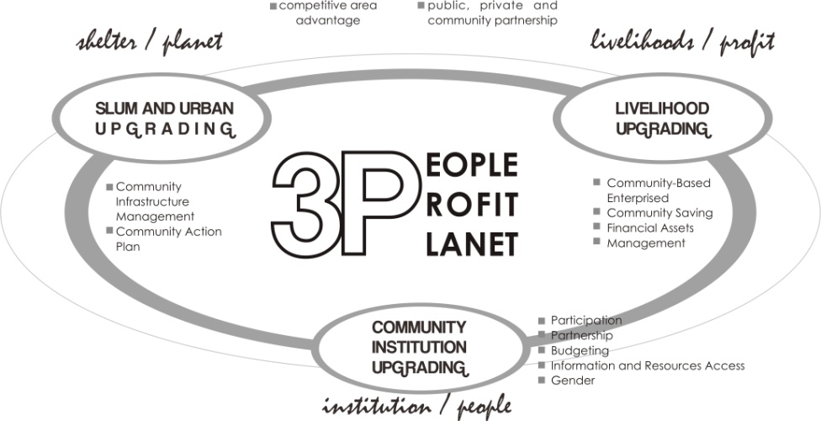
The approaches is based on explorative and descriptive research. The creating living space consolidation activities are analyzed through the harmonious consolidation between “ecological conservation components and economic development components”, “economic development components and cultural conservation components” and “ecological conservation components and cultural conservation components” of kampung living culture and riverfront space regeneration in the context of area-based and citywide creative urban design.

Fig 1. Profit and Planet Upgrading Concept

In order to implement the program a network concept comprising area network, community network and program network was developed. Area network is an effort to overcome regional-ego, community network strengthens institutional coordination, and program network synergies various sectors to overcome sectoral-ego.
- WINONGO KAMPONG UPGRADING AND GREENING
The kampung housing assets opportunities and vulnerability in the Winongo urban riverfront area involves identifying not only the threats to individuals and households and their assets, but also their resiliance and ability to mobilize assets to exploit opportunities and resist or recover from negative effects of changing environment. The ability of kampung community to reduce or avoid vulnerability and to increase financial assets productivity depends on their ability and creativity to manage and transform their assets into income,food or other basic needs by intensifying and diversifying their existing assets.
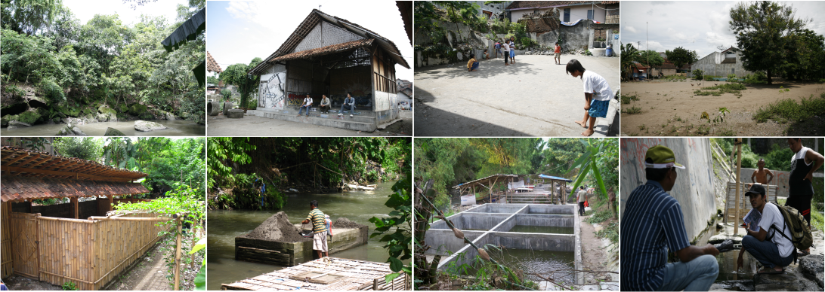
The impact of kampung domestics activities to Winongo river condition are growing significantly. Increasing the number of new settlement development, industrial and economic activities tend to be unbalanced with the natural ecological capacity. The Winongo Kampung Upgrading and Greening Initiatives try to integrate the riverfront environment values into kampung settlement and community infrastructure upgrading through strategic and integrated program of riverine natural assets revitalization and kampung cultural and historic site regeneration in the form of kampung urban green corridor tourism development.

Fig 2. Eksisting Condition Winongo River

Winongo riverfront area is characterized by densily populated settlement and most of them are near to the city center. Rivers width varies from 5 meter to 20 meter. The widest river located in southern area. Several river bodies has experienced sedimentation showd by shallow river depth only 0,5 meter deep while the deepest until 2,5 meter deep. Riverbank slopes varies from 0,5 % to 90 % where the most steep is about 12 meters tall. The natural character of Winongo riverfront is typically dominated by bamboo, stones in some segments and several local springs. Several segments have beautifull scenic of natural landscape. Winongo is also keeping some histotic sites such as Donotirto traditional public bathing site,Gedono spring and Prince Diponegori site. The social character of the kampung community is relatively dynamic with intense interaction. Art groups are well managed and being a potential cultural assets for tourism attractiveness.
There are many ecological assets to establish harmonious consolidation with cultural assets for generating economic activities ( improving economical assets ), such as riverfront area beautification with creating the stage for community traditional performance art, conserving the heritage or historic site in Donotirto traditional public bathing and Gedono local spring water for attractive tourism destination. The community-based institutional consolidation also well managed through declaration of Forum Komunikasi Winongo Asri, Bangunrejo as kampung cultural village.
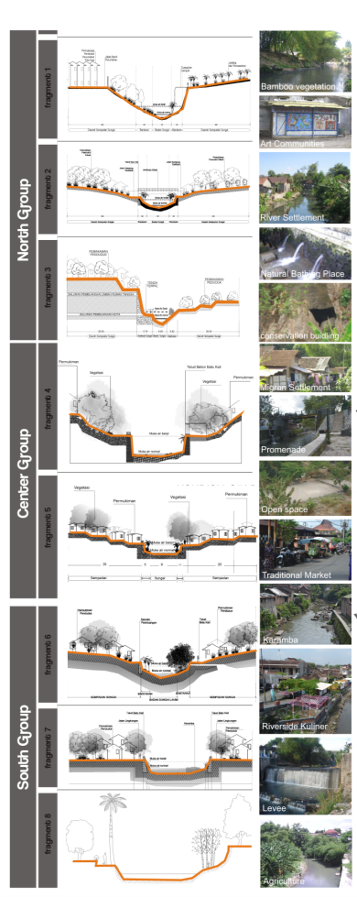
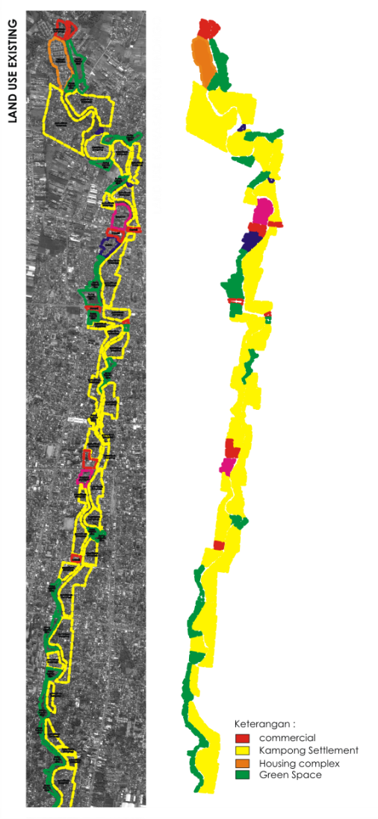
However, some threats and vulnerability of kampung livelihoods assets can be found in several segments in the form of caramba fish farm which cause river flow to blend and influence the water speed and debits, traditional informal farm of pig, chicken, duck and cow and some kinds of small scale community industry.

Fig 3. Land Use and River Section Asset
Fig 6. Existing Data
- MAIN PARTNERS AND ROLES
The network concept developed in the Sustainable Habitat Initiatives affiliated several elements, namely the community, government, business people, and scholars. A network concept, involving the city government, business people (through the Corporate Social Responsibility/CSR program), and Sustainable Habitat Laboratory (which is a Joint Center Inter-University of several universities in Yogyakarta, coordinated by Universitas Gadjah Mada), was developed through assistance in forming Winongo Asri Communication Forum, a participatory and self-help community organization.
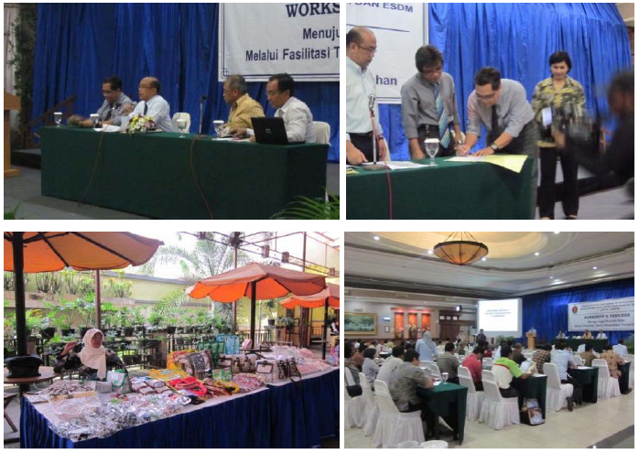
Winongo Asri Commmunication Forum (FKWA) was a partner in the implementation of education for sustainable development program in the role of enabling the institutional livelihood asset. The institutional capacity in accessing and improving the resources for residential development was continual, especially in overcoming obstacles regarding sectoral-ego, regional-ego and coordination.

Fig 4. Workshop, Established Foundation, and Exhibition

The local government established an intermediary organization in the form of a foundation named Yayasan Jogja Kota Kita (Jogja Our City Foundation), which was initiated by the Mayor of Yogyakarta, Sustainable Habitat Laboratory Universitas Gadjah Mada, and Slum Upgading Facilities (SUF/finance consultant institution of UN Habitat for Slum Upgrading) to coordinate the implementation of Village Upgrading and Greening program.
The business people and the financial institutions worked together with the Jogja Our City Foundation and Sustainable Habitat Laboratory UGM in the form of financial guarantee for the implementation of Education for Sustanable Development.
- CONTRIBUTION OF KAMPONG UPGRADING AND GREENING
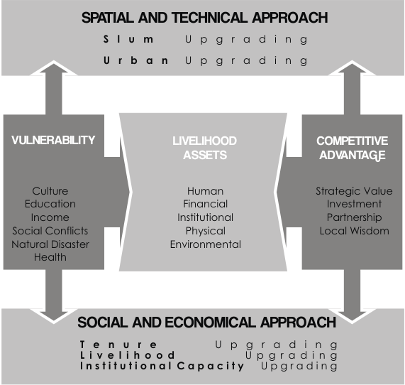
The innovative aspect resulted from the program was the enabling and consolidating of the livelihood assets villages in a concept of networks that had not been done often. The network concept implemented in the program managed to resolve the problems regarding regional-ego, sectoral-ego, and the lack of coordination.

Fig 5. Livelihoods Sustainability Approach

The program used an area-based consolidation approach, which consolidated livelihood assets kampongs in an area network system, and citywide consolidation approach that consolidated livelihood assets kampongs in a city-scale network system. Through this concept, the structuring concept of village upgrading and greening implementation could be systemically structured, both at the river bank area at local scale and citywide scale. The concept of sustainable kampong community livelihood had been integrated into urban spatial and infrastructure that exhibited implications in the increase of welfare along with the emergence of economic opportunities (integrating the villages’ strategic area competitiveness urban tourism development).
The long-term uniqueness of the sustainable habitat network program for village upgrading and greening was the increase of the river’s ecological quality as urban natural asset in the function of urban heat island mitigation means. Sustainable structuring of the riverbank residence area could reduce the risk of urban temperature increase, which posed a risk of urban heat island. By improving the community’s livelihood through tourism activities and creative industries, the community would achieve a better welfare state.
An important factor (critical factors) determining the success of the program was an inter-stakeholders institutional enabling, whether it be at the government, community, business people or university level (enabling stakeholders).
Critical governance that drove the program to success were the capacity and political will. These were initially short-term development-based and relatively a top-down program in nature that had been transformed into a long-term sustainable development-based project and a participatory and network-based governance in nature. The community was enabled through assistance in formulating their needs in the form of mapping of the potential and the problems within the residential environment in the sustainable habitat concept, on the people’s initiation, and facilitated by the local government, business people and university.
Development dilemmas are often controlled by numerous interests (many sectoral and political interests) that generally oriented towards economical interest in the program had successfully been synergized in the form of symbiotic networks of the development of urban tourism programs that suited the character and image of Yogyakarta as one of the tourist destinations in Indonesia.
The institutional barrier that had been constraining the development of sustainable settlements was the lack of coordination, which in the program was scheduled in the institutional capacity building program at various levels (from the community level until the local government level) and inter-subjects (inter-stakeholders) level.

- UPSCALING OF PROJECTS RESULTS
Kampong Upgrading and Greening in the Grand Concept of Sustainable Habitat Development began at the residence area level at the Winongo river bank, Yogyakarta. Along with the assistance process, it was developed into wider scales, namely the province and national scales. In 2009, the program was developed at the citywide scale comprising 3 rivers (Code River, Winongo River and Gadjah Wong River) and it was, again, developed in 2010, not only at the riverbank area level but at the province scale, by means of Yogyakarta Green Province Declaration. In addition, in the declaration attended by international stakeholders , it was agreed that the Green City Network should be established. In 2011, a workshop on establishing the Green City Network was held. Through socialization in the forms of seminars, workshops, talk shows and skits broadcasted on television, the program managed to be one of the priority programs that would be more widely improved in the year 2012.

