Bridge to the World

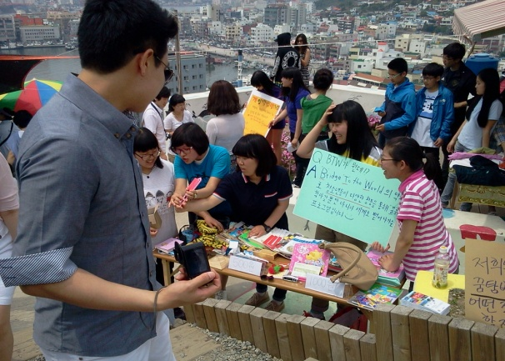
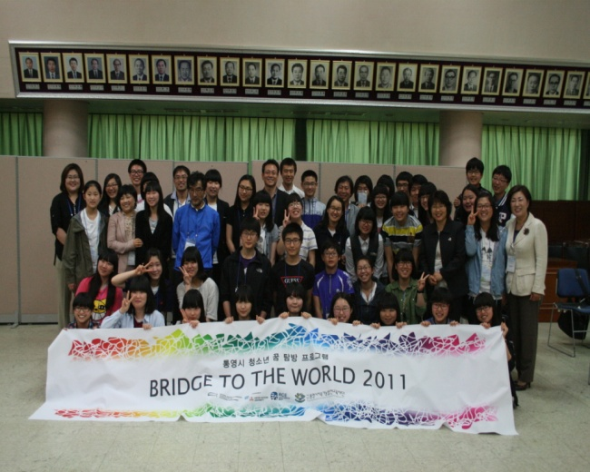
‘Bridge to the World (hereafter BTW)’ is a programme of RCE Tongyeong for adolescents, who research and study for sustainable development. Three teams have been selected every year (total nine teams), and they visited to city of RCEs in abroad from 2008 to 2010 and suggest a plan for sustainable development, comparing with RCE Tongyeong. In 2011, B.T.W. had transformed its aim; the number, a way over the three years, as career exploration for sustainable development more students are participating than last years. ‘BTW’ still remains its aim to make adolescents’ ability stronger and cultivate future responsible citizen. It consists of monthly training, experiencing job, research and study, fund raising, and excursion.

The program has now been established as one of the most popular youth programs in the city, training young leaders on sustainable development. The program has been acknowledged by Korean National Commission for UNESCO as 2011 ESD Official Project, based on its role in promoting ESD and understanding of sustainable development.

Category 1_ Contribution to innovative multi-stakeholder learning and educational process for sustainable development.

BTW is to present the vision of sustainable development to future leaders, the youths of Tongyeong, by providing opportunities for a self-researched study trip abroad to experience and study topic related to participants’ sustainable future in RCE cities around the world. It is one of the first overseas research program solely targeting secondary school students in Korea and it is fully sponsored by RCE Tongyeong. In 2011, around 100 students applied for this program and 43 students broke competition and qualified as ‘final participants’ after competitive presentation of their study plans. These students teamed up with 1 teacher, the BTW teams are eager to make their ideas for sustainable future come true in Tongyeong.
This program distinguishes itself from other conventional overseas training and observation program in that the participating students can select the researching RCE cities and topics which relates to sustainable development. Also, the program works to share the knowledge and experience of the trip with the general public by producing and distributing reports and holding reporting workshops. Our main object of the program is that it can act as a gateway to the world for the young people and open their eyes to the road to a sustainable future.
In order to explore various issues related to sustainable development theme, the participants tap into the RCE local, national and global networks. Partner groups are asked to share expertise and knowledge with the participating youths in the form of study visits, consultation meetings and lectures. During the program duration of twelve months, the participants collaborate with NGOs, schools and institutions of Tongyeong, Korea, and an RCE city of their choice. Thus, the multi-stakeholder partnership of RCE Tongyeong is the basis of this program. The partnership provides opportunities to learn from various activities and expand the ideas of the young people.

Category 2_ Building enabling conditions for sustainability change
Participant students have developed their annual theme and activities based on collaboration of team. In particular, students have designed their various aspects based on three main filed of sustainability. Main activities are as follows.

Environmental aspect
- Basic environment education provided to all participants, including empty plate movement
- Key environmental issues including local and global challenges taught through lectures, study visits and research
- Students researched their visiting theme by themselves
Climate change and islands (RCE South Pacific), Island for youth (RCE Okayama), Eco-city (RCE Munchen)
- Participants performed campaigns to raise awareness on environmental issues

Social aspect
- Key social issues related to sustainable development are taught through lectures, study visits and research
- Student team research themes and visited RCEs include;
Youth participation at local festivals(RCE Toronto), Career development(RCE Yokohama), Movie industry and local community(RCE Kodagu), Education system and youth participation(RCE Denmark), Independence movement of Korea and Role of Tongyeong(Reedly city, CA. USA), RCE Youth network(RCE Kitakyushu)

Economic aspect
- Key economic issues related to sustainable development are taught through lectures, study visits and research
- Student team research themes and visited RCEs include; Revitalizing traditional market(RCE Cairo)

Category 3- Bridging local and global perspectives on sustainable development
Over the past four years(2008-2011), ‘BTW’ has sent 13 teams of 100 young people to 13 RCE cities.

- As the outcome of team-based research activities, some of the proposals made by youths materialized after the program. Under the education system of Korea, young people are often treated as ignorant in need of parental guidance until they enter university. Thus BTW, a program based on self-management and self-responsibility of youth, is considered challenging to both participants and their parents.

For example, team M.O.T researched traditional market based on the subject ‘traditional market with adolescent’ in Tongyeong and Cairo in Egypt. Through survey among young people of Tongyeong, the team found that the main reason why their students go to traditional market is to eat snacks and thus promoted snack restaurant in Tongyeong market to their friends at school. In addition, the team developed a fusion dish made from local ingredients “seafood resotto” and persuaded two school canteens to introduce the menu to students.

Category 4- Upscaling of ESD and sustainable development projects and activities
The major strengths of this BTW ESD initiative is that it is a self-managed problem – solving process that requires multiple capabilities including self-discipline, ability to communicate and collaborate with others, understand issue and search for information, and basic foreign language skills.

The primary success factors include active participation of youth, the financial and policy support from the local government, understanding of parents and teachers involved, support from RCE partner organizations and the global RCEs network, and dedication of coordinating teachers.

Category 5- Assessment of collaborative ESD projects activities and initiative
Key strategies of BTW are as follows. Participant students have been informed by their coordinate teachers for their annual theme, target, and monthly activities. These self planned activities have encouraged students to increase their own sustainability.

- Self-planned research with limited guidance : Provide time and opportunity to enhance ownership and responsibility of youth
- Expand field of interest from personal career development to local community and global issues
- Problem-solving process related to sustainable development issues
- Action-based program contributing towards a sustainable future
Please see the category 2 if you want to see more information

Category 6- Application of innovative networked governance strategies
One of the most importance key success points in BTW is networked governances. The each number of teams has various gender, age, and school. Through frequent meeting they should know how to cooperate with numbers. Successful collaboration can inspire students to have a priority for visiting RCEs in abroad. Secondly, students have to knock the gate of institutes beyond their school. Students should ask for the help of policemen, lawyer, a producer of broadcasting to research their own theme. Every year students have to contact secretariat of RCE in other country to research their own theme and coordinate their own schedule there. These activities can let student to develop their own network and governance skill.

