Presented in the 7th AP RCE Regional MEETING, USM, Penang, Malaysia; 26-29 August 2014
Study on the Traditional Practices for Solid Waste Recycling in Rural Homes

Professor Mohammed Ataur Rahman, PhD
Director, Centre for Global Environmental Culture (CGEC) and
Coordinator, WWOOF Bangladesh
IUBAT—International University of Business Agriculture and Technology
4 Embankment Drive Road, Sector No. 10, Uttara Model Town, Dhaka-1230, Bangladesh
E-mail: marahman@wwoofbangladesh.org, marahman@iubat.edu
Website: www.wwoofbangladesh.org, www.iubat.edu
ABSTRACT

Solid wastes are important components for recycling biomass to return the nutrients to their origin. Traditionally, the people of the Ganges and the Brahmaputra basins have been recycling solid wastes for centuries. The practices which are followed here have scientific merit but in most of the cases, the people are ignorant about those facts. The present study was conducted in 90 rural homes of Ishwarganj and Nandail Upazillas under the district of Mymensingh. The objectives of the work were to find out the scientific explanations of the recycling practices. The study showed that the traditional procedures which are being applied on trial-and-error basis got the effective result of supplementing organic materials to the soil. Although these effective practices have been used generation after generation, in-depth studies were not carried out. This study has uncovered the scientific reasons behind many of the traditional practices of solid waste management. Chemical analyses revealed that most of the macro-nutrients, namely potassium, phosphorus, nitrogen, calcium, sulphur, magnesium, iron and total organic matter contents were not depleted; rather, the total organic matter contents increased significantly after the recycling. This kind of rural home-based and short-cycled solid waste management ensures zero depletion of organic soil content.

INTRODUCTION

Civilization began when nomads first took shelter in permanent homes and started cultivating the earth. Home became their centre of all activities. They used to collect their livelihoods from the surroundings, learnt to process and store them for their use in their homes. During the processing and utilization, the un-utilized remaining, called the ‘wastes’ were left, thrown away or stored for degradation and recycling. From the experience, people acquired knowledge for easy and safe recycling methods for better utilization of wastes in favor of natural environment. Home is a microenvironment and fulfils an ecosystem.

Traditionally, the inhabitants of the Ganges and Brahmaputra Plains were more conscious about hygiene, natural resources and agricultural practices and they were used to practice simple methods in their homesteads knowingly on unknowingly, which are really important and scientifically rich even during this advanced technological era.

However, with the advancement of mechanization and industrialization and the influences of western culture many of the traditional cultural practices have lost their importance and are not in use by the common people. Therefore, it is essential to collect the age-old practices used by the common people for waste management and biomass recycling. These should be studied to investigate their scientific merit and re-establish their positive roles in the present complicated situation aroused by the modern cultures, specially, by the chemicals and shortcut cultures. With this aim, Centre for Global Environmental Culture (CGEC) of IUBAT—International University of Business Agriculture and Technology along with Homestead Cropping and Ecoagriculture Research Center for Sustainable Rural Development (HCERCSRD) conducted the present study in a few villages with rice crop-based farming of Mymensingh in the Brahmaputra Basin.

MATERIALS AND METHODS

During the study, the sources of waste, previous and present practices of waste and residue management were investigated; relevant information and data were collected from the fields and villagers. Fact-finding works were done through physical observation, analysing data and comparison with present practices. Traditional practices are supported by figures and question-answer methods with the villagers. Chemical analysis of soil was done in the laboratory of the Bangladesh Tea Research Institute, Srimangal. The present study carried out in-depth analysis of the major crops and activities are focused.

OBSERVATION

The following major sources of wastes in the rural homes are found, in most cases the biological products come from the fields, homestead forests, ponds, rivers, Haors, Bheels, and the markets, are utilized and processed and the residues are recycled through some traditional practices.

The main sources of solid wastes are:
- Agricultural crops
- Foods
- Pets and domestics
- Litter and sweepings
- Fuels
- Clothing
- Building materials
- Utensils
- Corpses, faeces and excreta

Agricultural Crops

Major crops
- Food crops: Rice, wheat, millets, sugarcane, lentil, pulses, potato, vegetables, onion, garlic, ginger, turmeric and chilies etc.
- Fruits and nuts: Mango, jackfruit, litchi, banana, carambola, papaya, pineapple, lemons and oranges, black berry, Bullock’s heart, coconut, betel nut, Palmyra palm and dates etc.
- Meats and Fishes: Beef, mutton, chicken and fresh water fishes and prawn etc.
- Fibres: Jute, hemp, silk cotton, coir and silk etc.
- Oilseeds: Mustard, linseed, peanuts, sesame and castor oil etc.
- Corms and tubers: Arums (Colocasia spp.), Elephant foot yam, Kham-aloo (Dioscorea atata)

Rice

Rice is the major crop produced by the farmers of the villages. After harvesting this field crop, the grains are separated from the panicles, are cleaned by sieving or blowing out the debris, Chittas etc. Husks and bran are also removed manually by traditional Dheki and or power operated husking machine. Residues viz. straws, Chittas, husks and bran have the secondary uses and then undergo decomposition or burnt to ashes. The common practices are:

Table No. 1 Traditional uses and recycling of rice residues

Residues | Primary Use | Secondary Use | Dispersal, decomposition and recycling
Straws | Fodder, Thatch, Packing materials, Fuel | Mulch | Cow-dung, Ash, Compost
Chittas | Fuel | Mulch | Ash, Compost
Husks | Fuel, Smoking, Mud-wall cladding | Mulch | Ash, Compost
Bran | Fodder, Poultry feed |  | Excreta, Compost
Jute

Jute is the second most important crop produced by the farmers of the selected villages. After maturity, jute is harvested from the field, rotten in water; fibres are separated from the sticks, dried and bundled for sale. Fiber is the primary product used for weaving, ropes and threads etc. Sticks are also dried and used as fuel, thatch, wall cladding and also for making pulp.

The common practices are:

Table No. 2 Traditional uses and recycling of jute residues

Residues | Primary Use | Secondary Use | Dispersal, decomposition and recycling
Sticks | Fuel, Fence, Cladding, Thatch, Chips, Paper pulp, Support for creepers and climbers | Mulch | Ash, Compost
Leaves | Vegetable, Fuel, Fodder, | Mulch | Ash, Compost
Pods/Capsules | Fuel | Ticca (carbon), Mulch | Ash, Compost
Roots | Fuel | Ticca (carbon) | Ash, Compost

Sugarcane

Sugarcane is another important crop produces in this area. After maturity, the canes are harvested and sent to the mills or brought to the homes for traditional roller driven juice squeezer. The bagassee, leaves, leaf sheaths and twigs are the major residues which are utilized and recycled

The common practices are:

Table No. 3 Traditional uses and recycling of sugarcane residues

Residues | Primary Use | Secondary Use | Dispersal, decomposition and recycling
Bagassee | Fuel, Paper pulp, Packing materials | Mulch | Ash, Compost
Leaves and leaf sheaths | Fuel, Fodder, Cladding, Thatch | Mulch | Ash, Compost
Twigs | Propagation | Fodder and fuel | Ash, Compost
Roots | Fuel |  | Ash, Compost

Vegetables

Vegetables are also important crops produced in this area. The common vegetables are egg plants, tomatoes, amaranths (Danta, Lalsak), arums, beans, cucumbers, pumpkin, gourds, Pui, cinopodium, radish, cauliflower, cabbage and drumsticks etc.

The common practices are:

Table No. 4 Traditional uses and recycling of vegetables residues

Residues | Primary Use | Secondary Use | Dispersal, decomposition and recycling
Whole plant | Fodder |  | Ash, Compost
Leaves and leaf sheaths | Fodder |  | Ash, Compost
Twigs | Propagation |  | Ash, Compost
Roots/bulbs | Fodder, propagation |  | Ash, Compost

Disposal of Solid Wastes

Solid wastes are disposed and recycled traditionally for hundreds of years. The people of the experimental area informed that they did not know when these systems were started. They also do not know the reasons for such accumulation of the refuses separately with distinct groups. They might have used trial and error method to establish best process for recycling. One thing is clear from the interrogation that, they know the need and benefits of the wastes for their crop production. During the study, it was also found that people followed some specific methods for specific purpose of conducting the simplest ways of decomposition and recycling. A utilization and decomposition chart of household refuses is shown below.

Usually the green garbage and dungs of cow and horse are disposed in a pit of 2-3 meter
- Compost Pit: Cow-dung, goat droppings, fodder residues, waste green vegetables,
- Sweepings: Fallen dry leaves, chicken and duck droppings,
- Ash Heap: Fuel wood ash from the kitchen, burnt dry leaves and straws, etc.
- Human faeces: Latrine
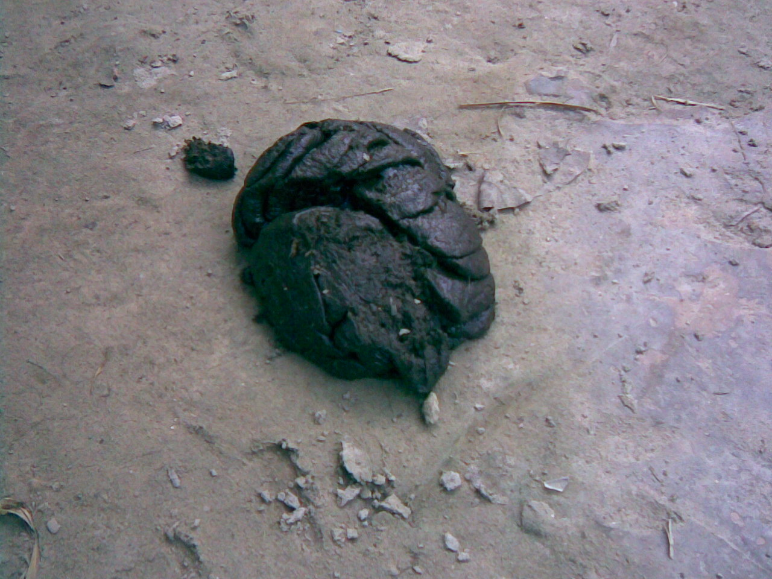
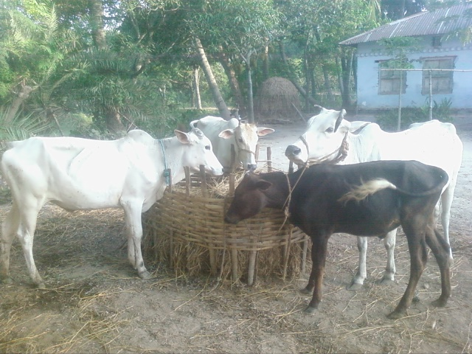
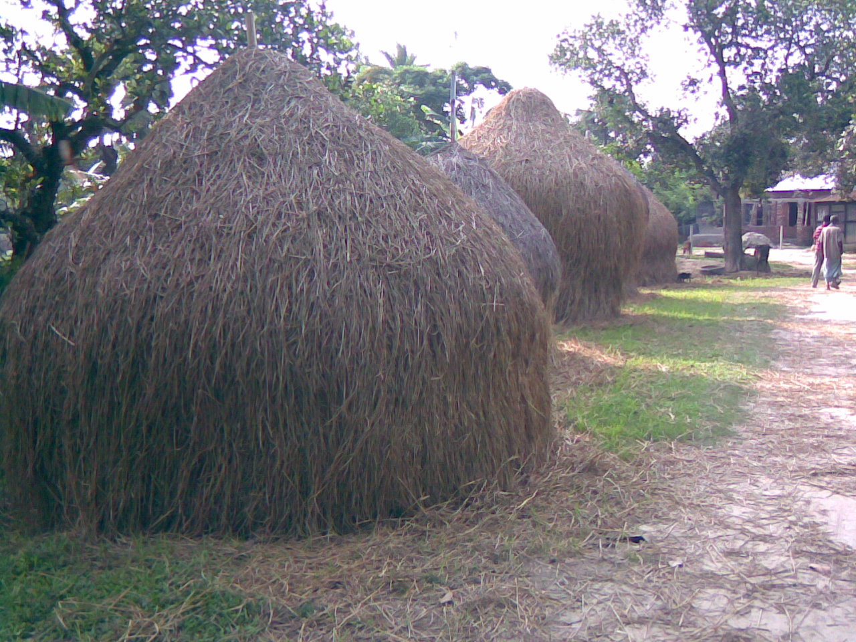

Fig. 1. Heap and rice straw
Fig. 2. Cows eating straw

Fig. 3 Cow-dung

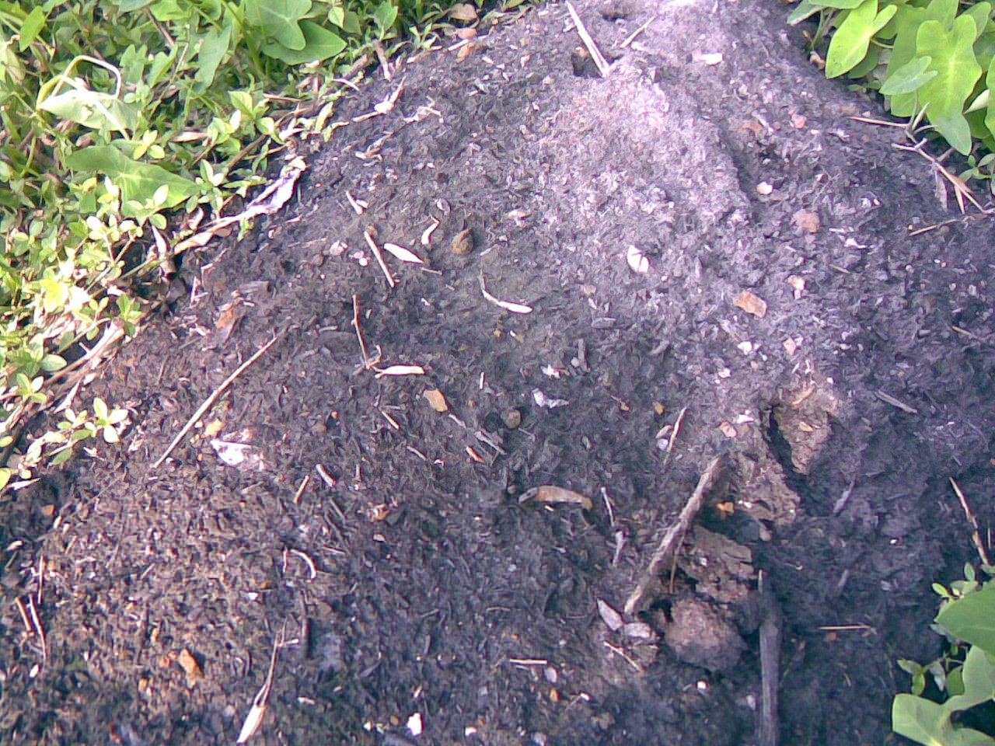

Fig. 4. Drinking water
Fig. 5. Compost heap
Fig. No 6. Compost

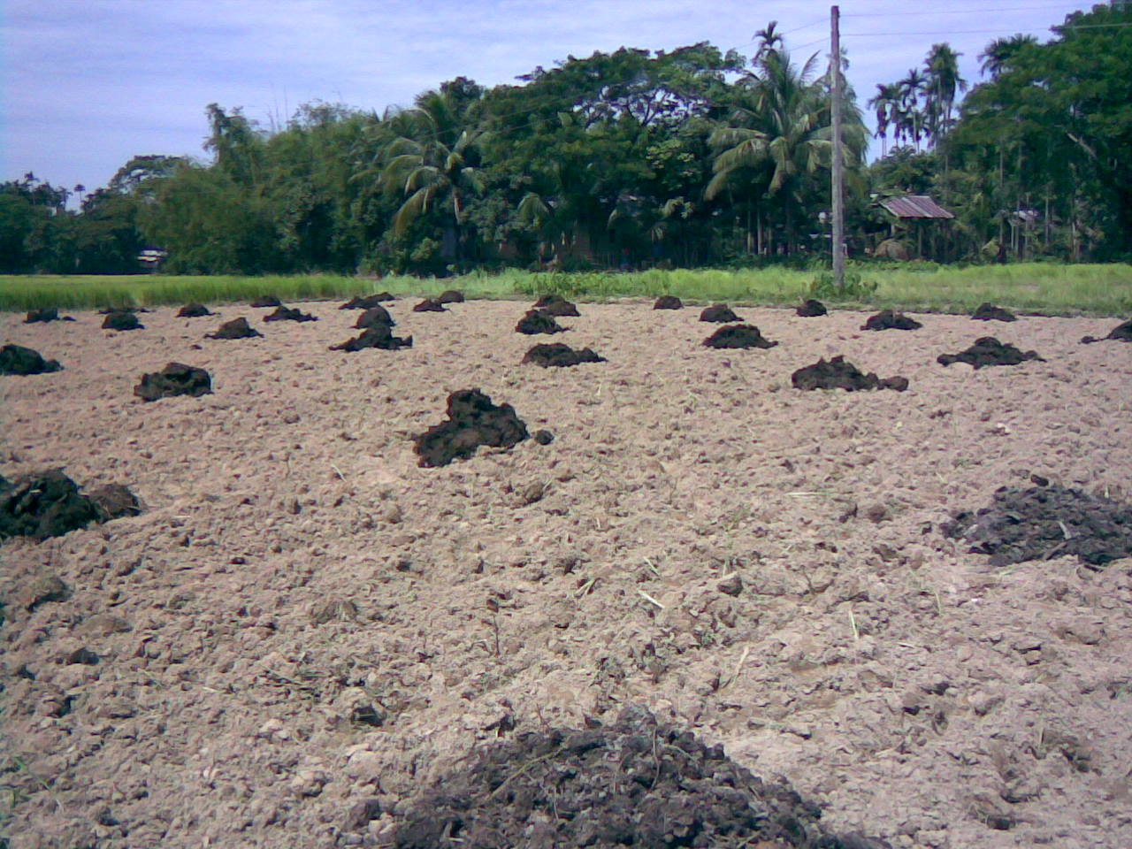

Fig. 7. Compost in the field Fig. 8. Fuel wood Fig. 9. Withered thatch
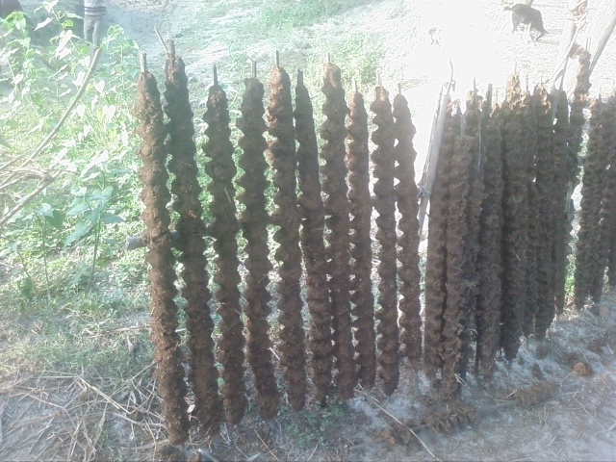
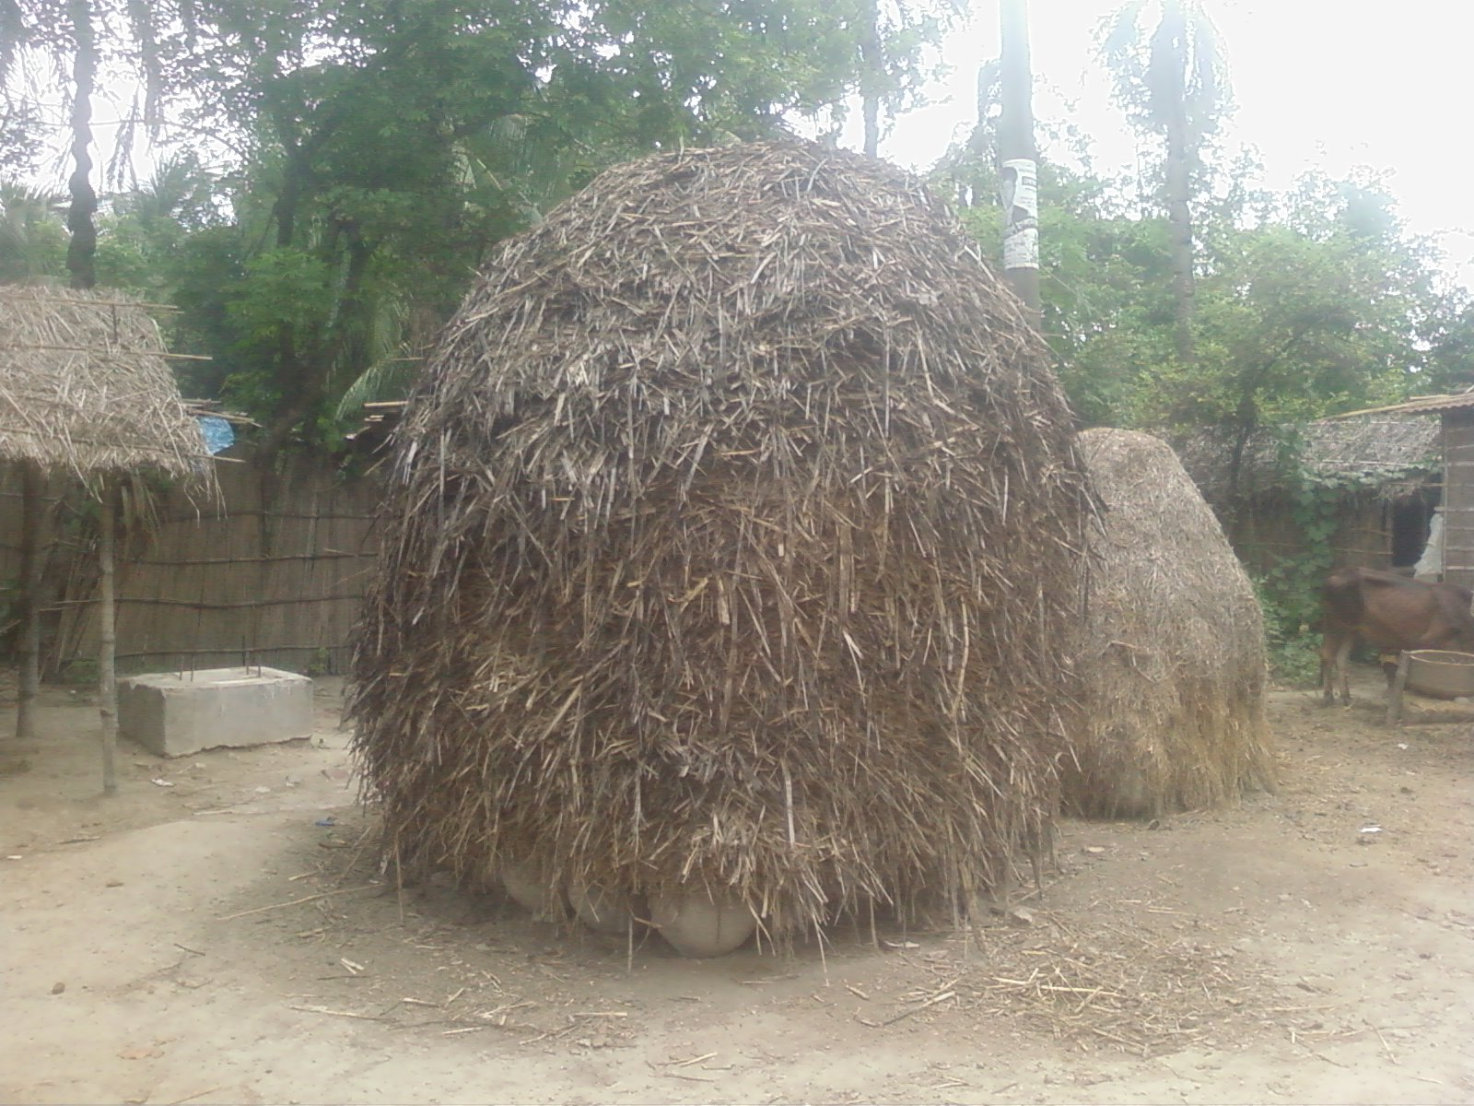
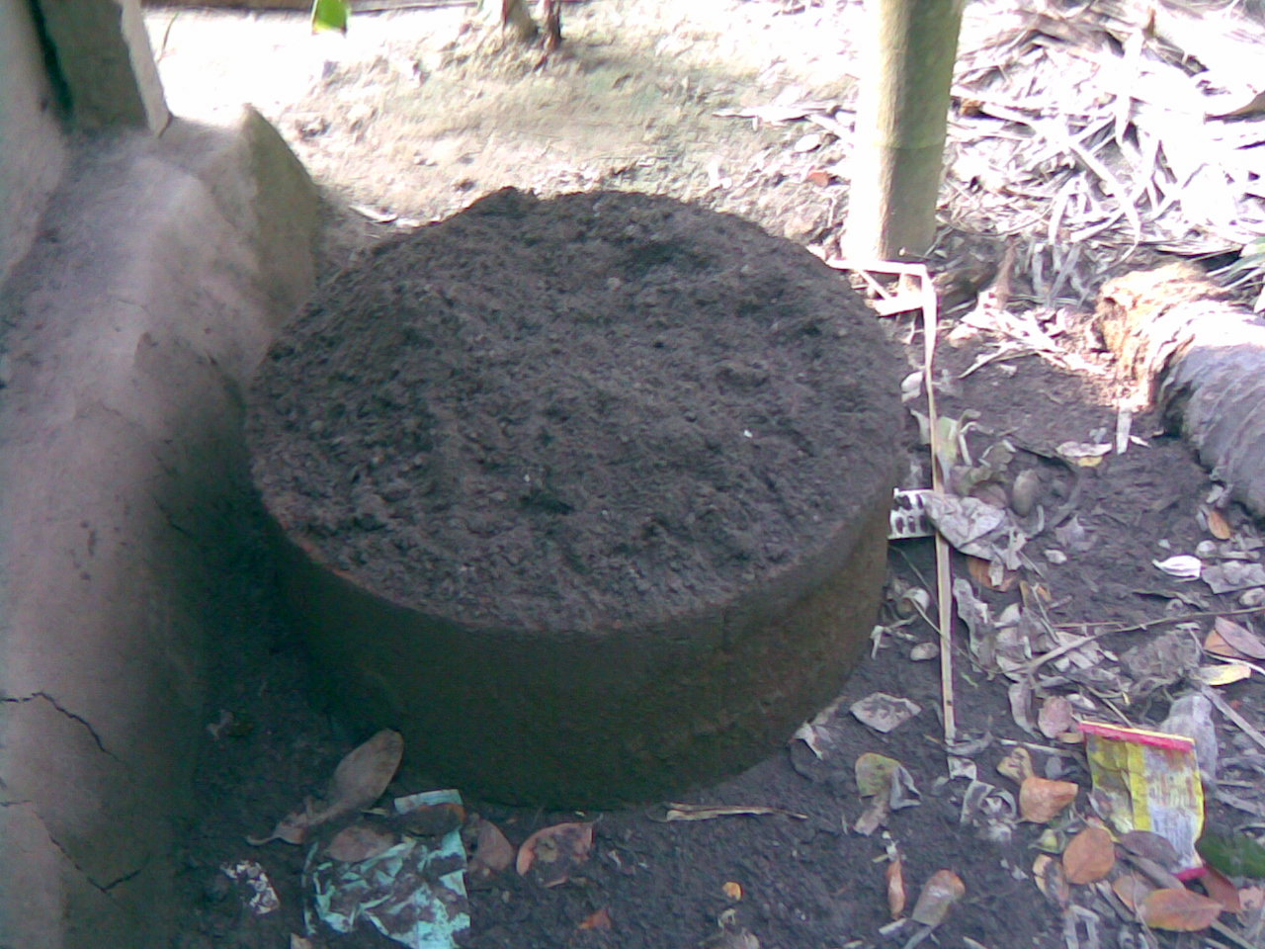

Fig. 12. Cow-dung sticks

Fig. 11. Ash collection
Fig. 10. Sugarcane Bagassee.

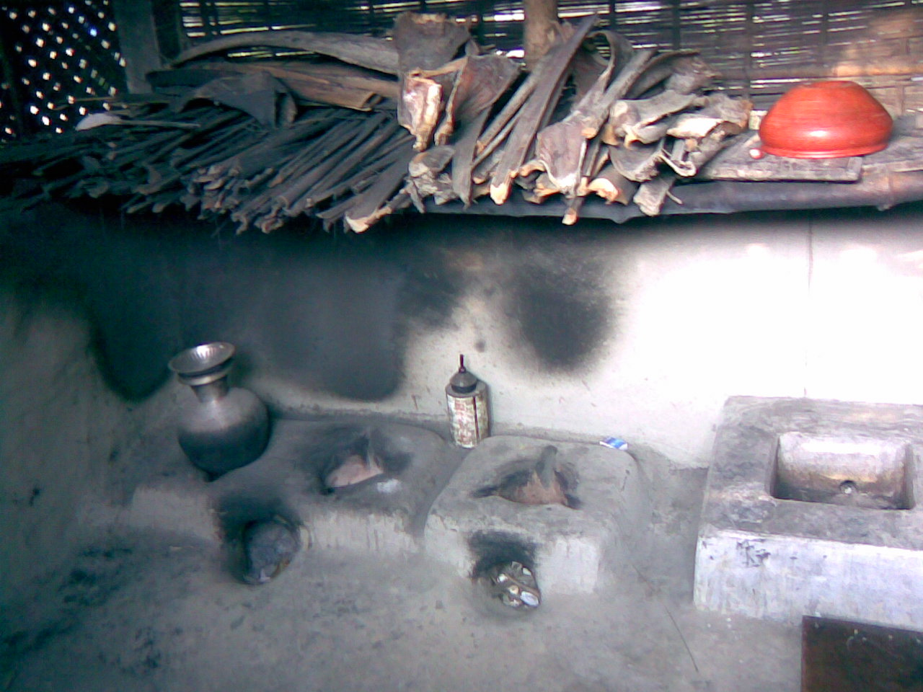

Fig.. 15. Ash application
Fig. 13. Kitchen
Fig. 14 .Large stove

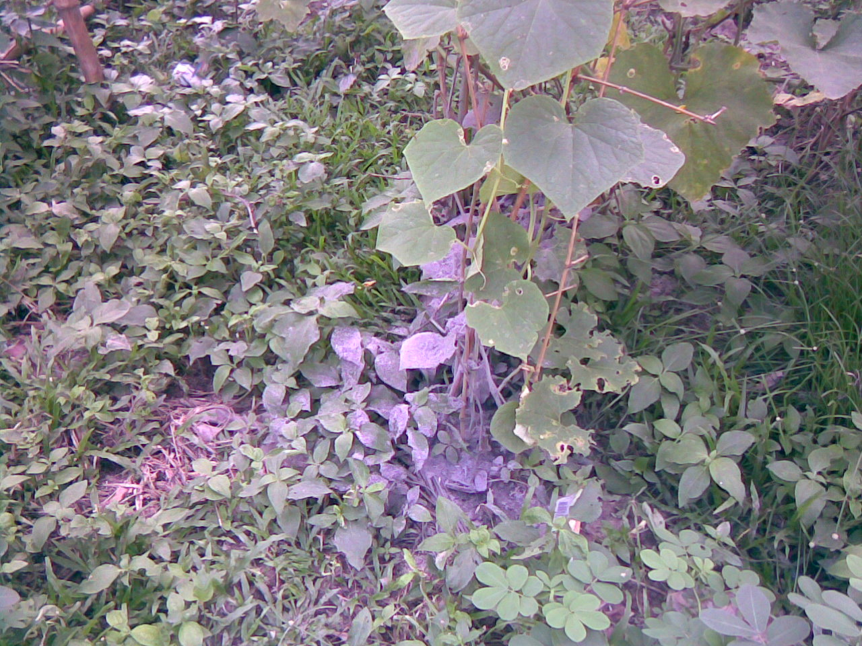
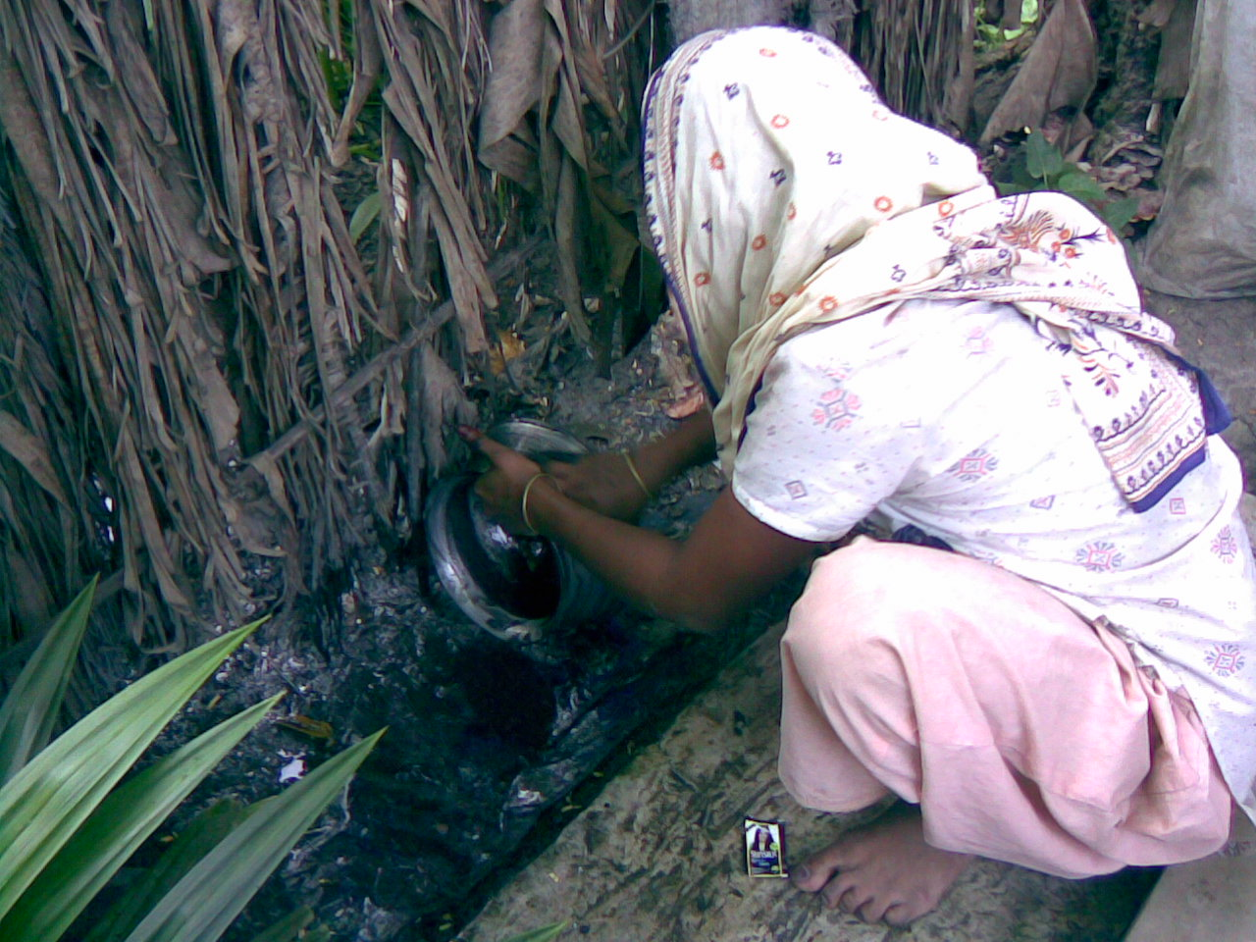

Fig. 16. Ash application Fig. 17. Cleaning utensil with ash Fig. 18. Jute hanger

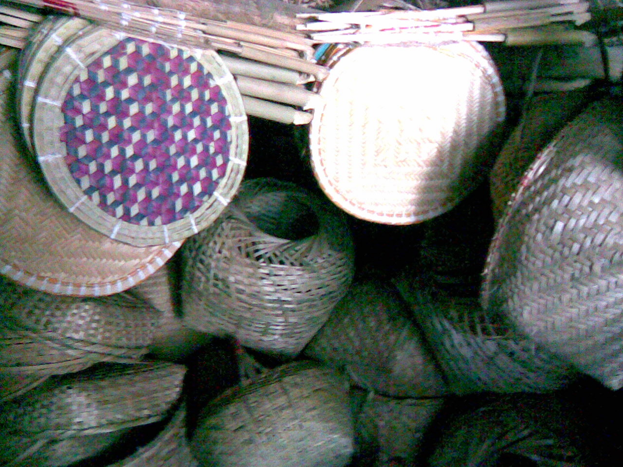
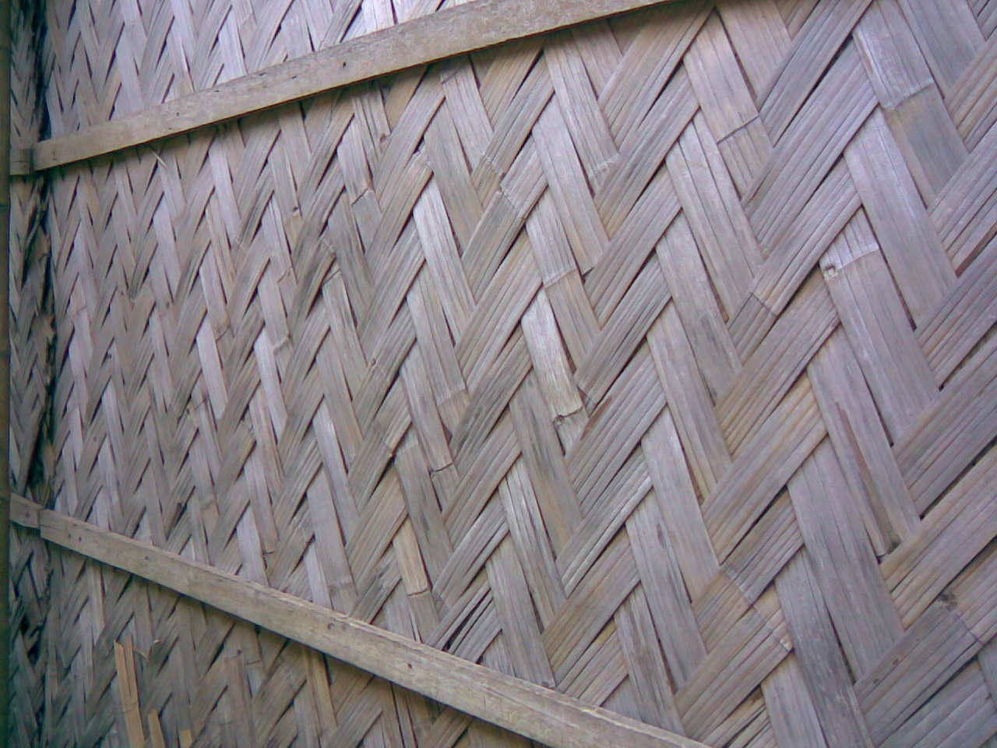

Fig. 21 .Floor cladding with Dung & Husk
Fig. 20. Bamboo cladding
Fig. 19. Bamboo crafts
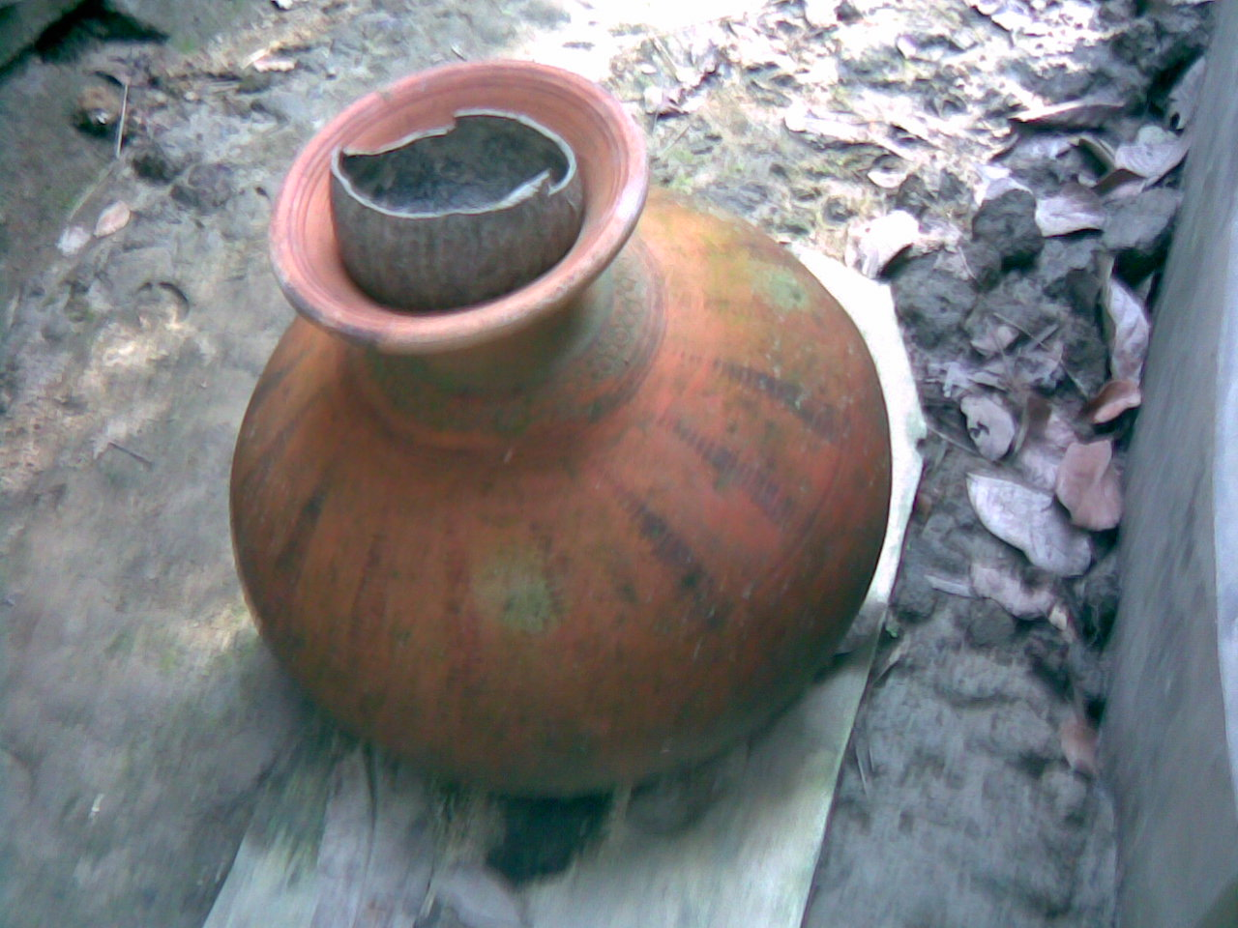

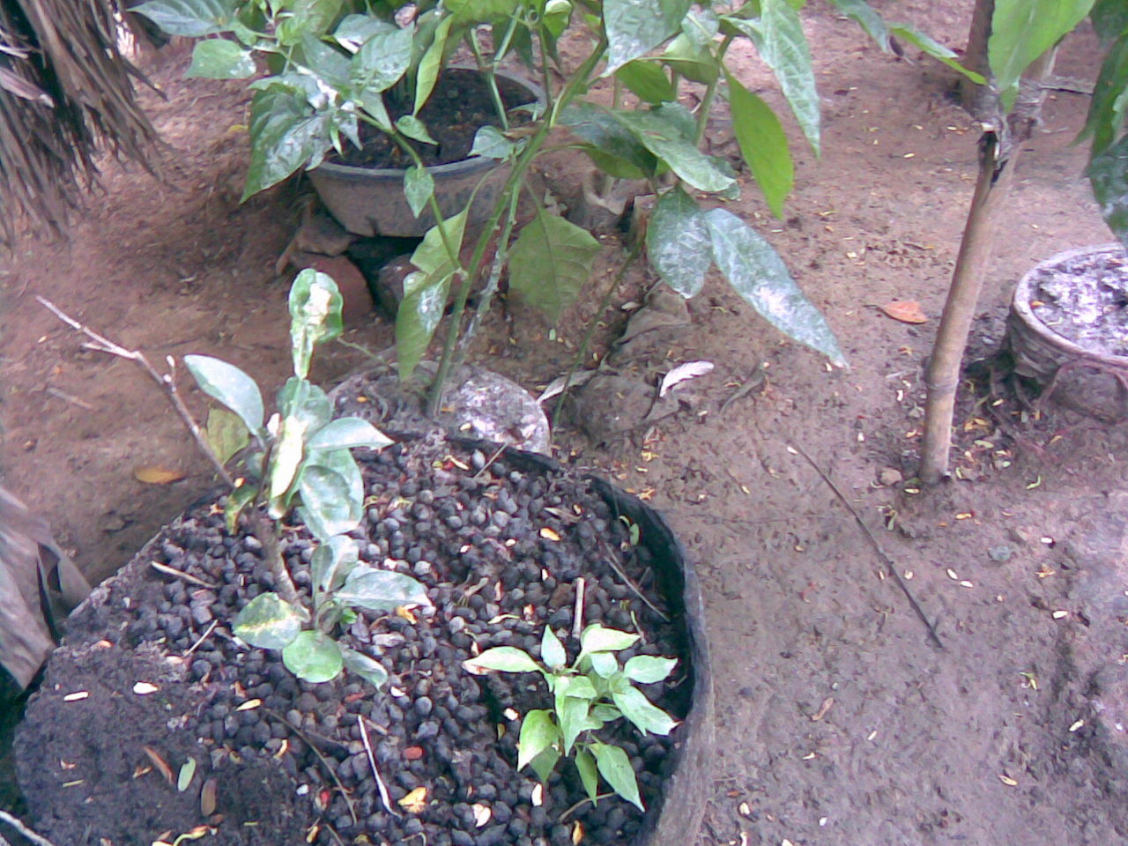

Fig. 22. Pitcher/Coconut shell Fig. 23. Goats eating banana sheath Fig. 24 Goat droppings
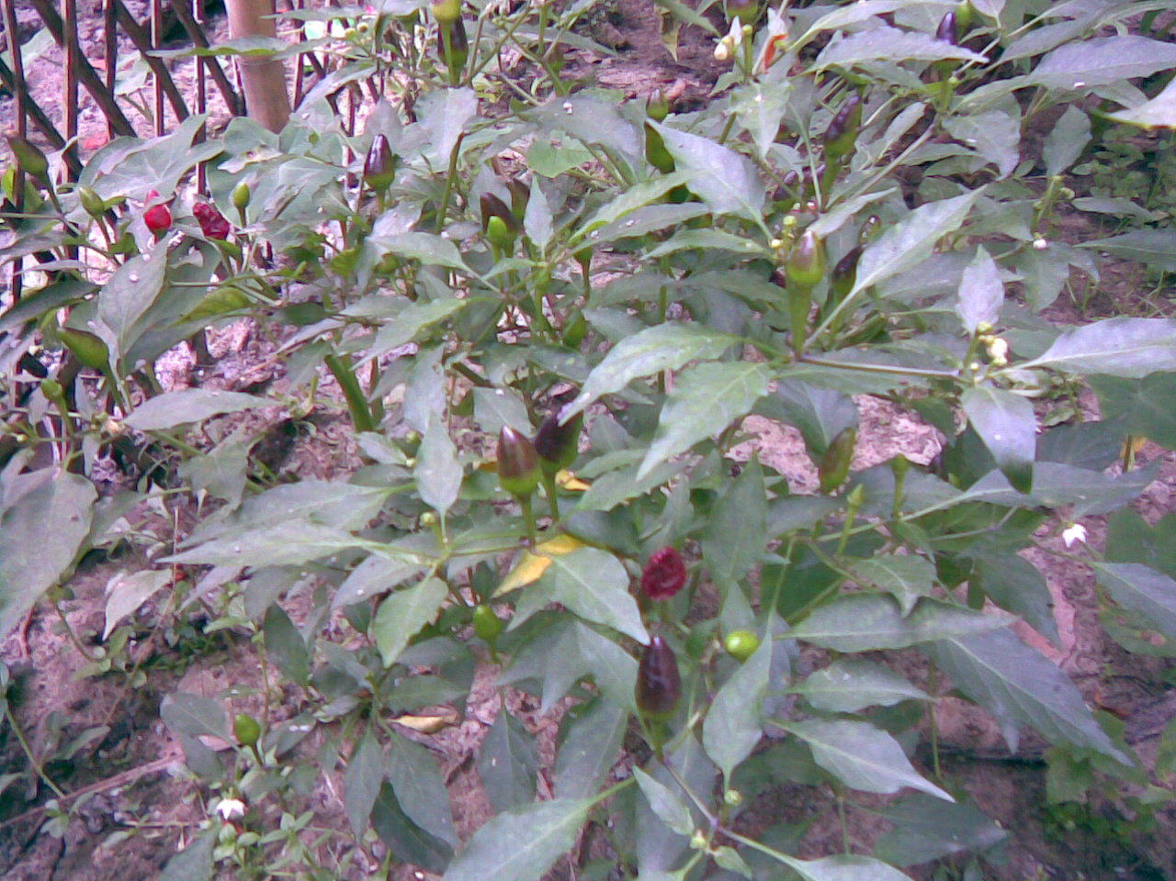

Fig. 25. Chili Fig. 26. Chicken room Fig. 27. Mulched Bamboo
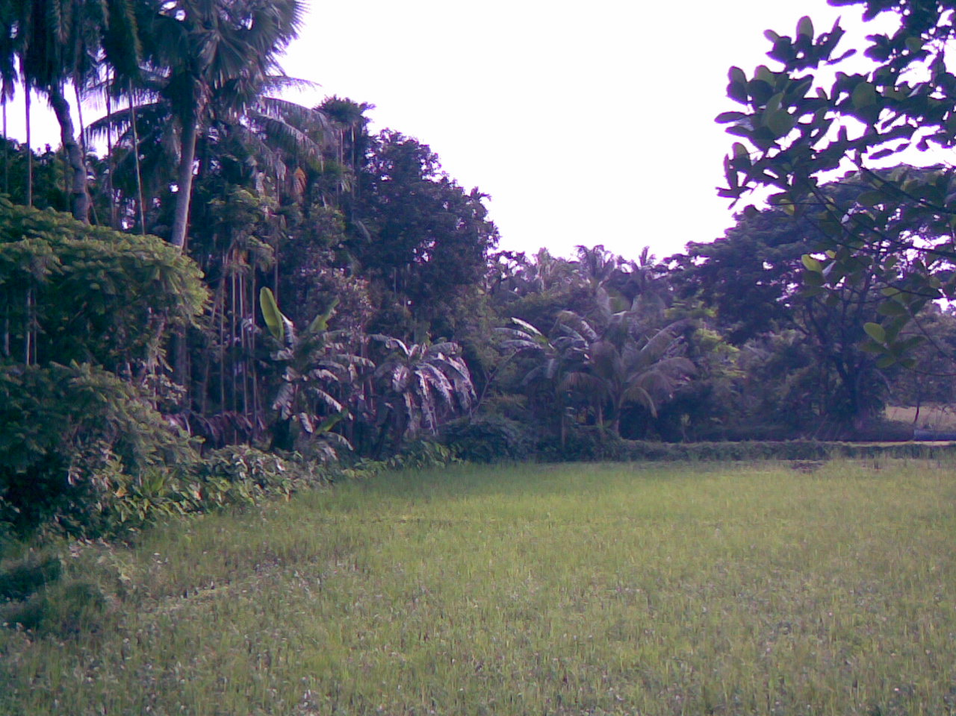

Fig. 28. Bamboo beams &thatched roof Fig. 29. Betel nut leaf fence
Fig 30.Luxariant growth of homestead plants

Utilization and decomposition chart of household refuses

Withering

Fuel
Paddy/Rice
Straw
Husk/Chitta
Bran
Boiled Rice
Thatch
Fuel /Mulch
/
Food
Faeces

Rotten/Excess Rice
Fodder
Decomposition
Decomposition
Dung
Feed
Compost
Ash
Latrine/ Compost

Compost

Feed

Chicken

Duck
DroppingsExcreta
Sweeping Heap
Pigeon

Compost
Babies

Faeces
Latrine/
Compost
Human

Refuses
Sweeping Heap

Decomposition
Fish

Bones
Cat
Droppings

Rotten Fish
Sweeping Heap

Compost

Human
Faeces

Latrine/Compost
Decomposition

Meat
Dogs/Cats
Droppings

Bones/Horns

Fertilizer
Sale

Fruits
Human

Cow

Goat
Peelings
Seeds
Faeces

Latrine/Compost

Dung /Droppings
Sweeping Heap

Feeds/ Food /Propagation
Decomposition Compost

Cat
Green
Vegetables

Green Garbage
Goat
Human

Dung / Droppings

Faeces/ Latrine/Compost

Glassware/Ceramics
Bottles, Plates and Utensils,, etc.
Sale for recycling
And reuses
Metal, Aluminum, Brass, etc.
Bottles, Plates and Utensils,, etc.
Rubber, Leather and Plastic,, etc.
Shoes, Combs and Cans,, etc.
Compost

Earthenware
Pitcher, pots, containers, Motka and utensils, etc,
Broken pieces
Root Aeration

Clothes / Fiber
Kantha
Bag/Rag /Napkin
Compost
Decomposition

Succession of decomposition flora and fauna during green garbage and cow-dung compost

Dung/green garbage
Fly/Bacteria
Larva/Ants
Ascobolus
Basidiomycetes
Weevil
Earthworm
Mature fertilizer
Cropping field

Results and Discussion

Chemical analyses revealed that the total organic matter and the ingredients viz. nitrogen, phosphorus, potassium, sulphur, magnesium, calcium, iron are not depleted after intense cropping. Analysis was done by taking samples from the fields which were not applied with any chemical fertilizers other than compost and mulching and no significant change was observed after intense cropping. The result is shown in the table 5:

Table 5 : Soil analysis report

Soil ingredients | Ingredient in April 2012 (ppm) | Ingredient in April 2013 (ppm)
Nitrogen | 1230 | 1410
Potassium | 85 | 95
Phosphorus | 40 | 40
Magnesium | 55 | 55
Calcium | 100 | 110
Iron | 125 | 120
Sulphur | 45 | 40
Total Organic Matter (%) | 1.57 | 1.61

Green garbage and cow-dung are decomposed in a 3m X 3m X 1.5m open pit, usually 20-30 meter from the houses. The major wastes are cow-dung, vegetables refuses, wet straws, green grasses, urine-mixed straws and sweepings from the cowshed. It takes about 7 to 8 months to complete decomposition starting from the month of February and March. The villagers do not mix ashes and dry leaves with the green garbage and cow-dung. Since ash does not contain nitrogen and dry leaves contain very low nitrogen, decomposition of green garbage delays significantly.

However, all fallen leaves and sweepings are gathered in a separate place and chicken, pigeon and duck droppings etc. are kept together for quick decomposition. As the dry leaves have very high carbon and low nitrogen (Rahman 2004 and 2005), the villagers are used to add fish remains, chicken droppings and baby stool etc. which contain high nitrogen (Talukder et.al. 1993) with sweeping leaves for quick decomposition. However, in the wet season: June to August the sweepings decompose readily but in the dry season especially from October to April they use the sweepings mostly for mulching and some people burn them to make ashes.

The villagers are found to store ashes in a separate place or container. The ashes are mainly from wood, rice husk, jute sticks, rice straws, burnt leaves, dry cow-dung (Ghote) and cow-dung sticks, rejected or withered building materials. Leaves of coconut, betel nut and Palmyra palm etc. are usually used for making brooms, household utensils, handicrafts, fencing and also for mulching of coconut, areca nut, bamboos etc. However, after withering they are often used as fuel. These mulches are readily decomposed and the ashes are used as fertilizer and also to control insects.

After decomposition of the refuse, the villagers obtain manure and use this according to the needs of the crops. They use ashes for enrichment of soil fertility and to control pests and diseases. Thus, they ensure recycling of biomass to the cropping land which keeps the soil at zero depletion of nutrients through their traditional practices.

However, with the advancement of modern technology, mechanization and urbanization have been hampering rural home-based short-cycled biomass recycling and the countryside is suffering a great nutrient depletion. Therefore, we need in-depth study to incorporate traditional knowledge for improving the fertility of the soil of Bangladesh.

ACKNOWLEDGEMENTS

I gratefully acknowledge Professor M Alimullah Miyan, Vice Chancellor and Founder of IUBAT—International University of Business Agriculture and Technology for sponsoring the project. I would also like to acknowledge Professor Eric Frank, a pioneer in the fields of Education for Sustainability and a naturalist, and Former Professor of University of Bath, United Kingdom for financial support, as well as, his encouragement and cooperation. I am grateful to all of the villagers of Ishwarganj and Nandail Upazellas of Mymensingh, Bangladesh, who helped me providing valuable information and sharing their knowledge.

Special thanks are extended gratefully to my colleague Dr A.C. Basak, my friend Dr Robin Upton and my students of College of Agricultural Sciences, who scrutinized the manuscripts with great patience and helped me in many ways during preparation of the article.

REFERENCES

Rahman, M.A. 2004: Plantation Crops and Organic Farming: Research Articles Series-1 Some Environment Related Problems and Their Solutions. Touhid Publication, Dhaka, Bangladesh. pp 9-43.

Rahman, M.A. 2005: Plantation Crops and Organic Farming: The Principle of Organic Farming, Touhid Publication, Dhaka, Bangladesh. 80 pp.

Talukder A, Islam N, Klemm R and Blocm M, 1993: Home Gardening in South Asia, The Complete Handbook, Helen Keller International. In Training Manual on Plant Propagation and Nursery Management, Horticulture Research Development Project (FAO/UNDP/AsDB Project: (BGD/87/025) in collaboration with Department of Agricultural Extension, Bangladesh Agricultural Development Corporation, Dhaka, 1995 pp 155-156.

NB: Pictures removed to reduce the size of the file: 4,5,8,14,15,18,21, 23,26-29

