GEORGETOWN RISE
Advancing Resilience, Innovation, Sustainability and Education in Georgetown County

A U.N. REGIONAL CENTRE OF EXPERTISE (RCE) ON EDUCATION FOR SUSTAINABLE DEVELOPMENT

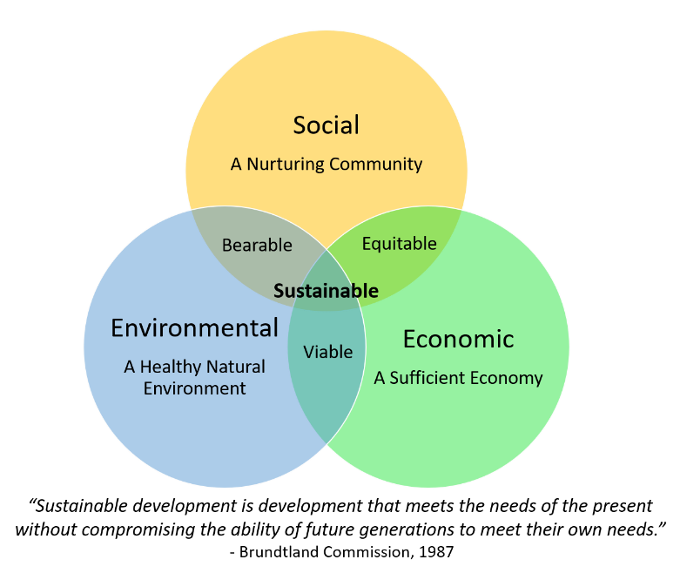

Our Vision
The vision of GEORGETOWN RISE is to develop Georgetown County by protecting its vast natural resources, unique heritage, and rich cultural diversity into a healthy community with a thriving economy that eliminates poverty by providing living wage jobs to an educated workforce with skills for the 21st Century.

The U.N. Sustainable Development Goals
17 Goals to Transform our World

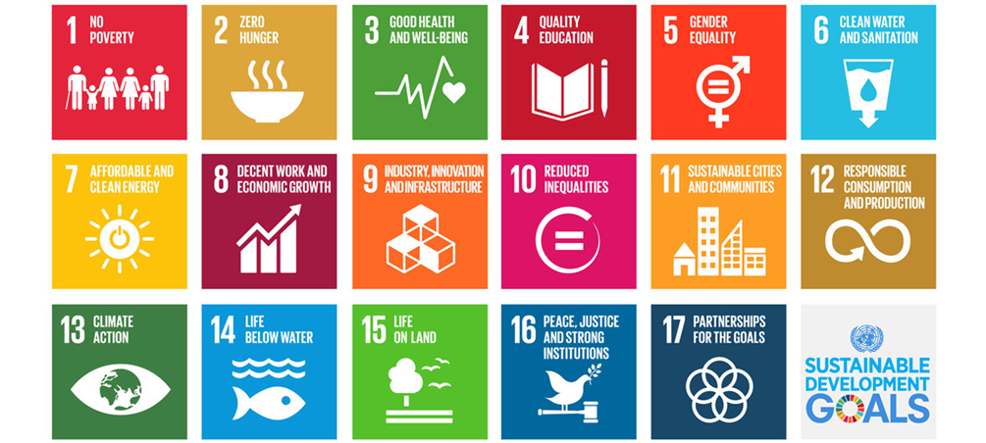

GEORGETOWN RISE
UN Youth Corps
Progress Report
August 2018

Executive Director: Dr. Pamela Martin

UN Youth Corps
The Georgetown RISE United Nations Youth Corps initiative is a high impact, transformative learning program centered on giving students real life skills and experiences in Georgetown County with an integrated teaching/learning component that links county goals to the UN Sustainable Development Goals.
The Youth Corps is intended to contribute to our industry and public institutions and inspire a new generation of professionals in our county to live, work, and play here.

Spring 2018 Pilot:

Internships | Results
- Working Waterfronts /Georgetown Innovation Center | Tiny Homes Business and Grad. Assistantship
- City of Georgetown  West End Redevelopment | SC Planning Assoc. Grant
- Tour de Plantersville /The Village Group | 100 Participants and New Job
- Growth on the Waccamaw Neck / Georgetown County Office of Planning and Zoning | Career Change and Summer Employment
- National Estuarine Research Reserve – Marine Debris project | Graduate School
- NOAA Sea level Rise Grant | Career Choice
- Georgetown County Office of Public Works | Career Choice
- Georgetown County Office of Environmental Services | Career Choice
- Georgetown County Office of Parks and Recreation | Graduate School
- Georgetown County Office of Economic Development (2) | Career Choice
- Town of Pawleys Island | Hired
- UN Youth Ambassadors (2) | Hired
- Waccamaw Council of Governments | Law School

Summer 2018:
11 students received paid internships ($4000 each) to work in 11 organizations/ departments:
Internships | Results
- The Bellamy Law Firm | Law School
- Carolina Energy Conservation (2) | 2 Hires
- Georgetown County Office of Environmental Services | Career Choice
- The Litchfield Company | Possible Hire
- Pawleys Island/Litchfield Business Association | Developing Organization Leadership
- Screen Tight | Possible Hire
- Tidelands Health | Career Choice
- Town of Pawleys Island | Hired
- The Village Group | Hired
- Waccamaw Council of Governments | Career Choice

