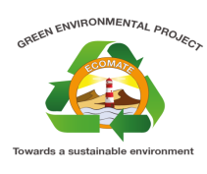

The Green Environmental Project
Introduction
The Green Environmental Project is an activity under the Regional Centre of Expertise (RCE) Network. The project is aimed at developing and supporting a peer to peer learning environment, where youths can teach each other through workshops for skill building, and developing environmental projects and promoting sustainable tourism within Swakopmund.
Goals
- To be a platform where school environmental clubs network with each other.
- To develop a community that is aware and concerned about the environment and its associated problems.
- Develop a sense of responsibility towards the environment, relating to scientific practices to the sustainable use of natural resources
- Encourage adaptation of best practices to improve the environmental acceptability.
- To improve land use, better protection of Swakopmund’s unique landscapes and species through conservation.
Objectives
- Unite all school environmental clubs
- Promote school gardening
- Celebrate international and national environmental days
- Co-ordinate various environmental activities in school
- Raise environmental awareness within Swakopmund
- Promote partnership with local organizations
- Award organizations with the Eco-Mate Certificate for outstanding environmental practices, selection to be based on a criterion.
- Award local residents for an outstanding contribution to promote sustainable development within Swakopmund
What has been done to date?
Green Environmental Project Seminar
On 14 September 2013, the first activity for the biodiversity week, the Green Environmental Project Seminar was held at the Swakopmund Municipality Training Room. The Green Environmental Project is a project established to promote environmental sustainable practices and to develop a community that is aware and concerned about the environment and its associated problems.
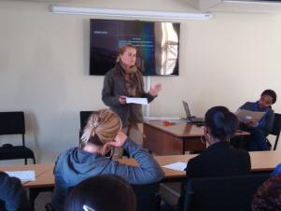
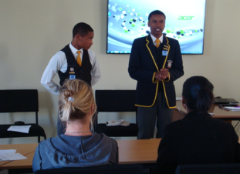
Various schools and organizations were invited to attend this seminar, they were given the platform to talk about their current environmental activities, their objectives and the challenges they are facing when steering environmental activities, within their schools, and community.

Arbor Day celebrations 2013
On 16 September 2013, the Swakopmund Municipality celebrated Arbor Day. Swakopmund Secondary and Primary Schools were invited to attend this important celebration. The participants were addressed by Councilor Rosalia Andreas-Noabes on behalf of the Swakopmund Mayor.
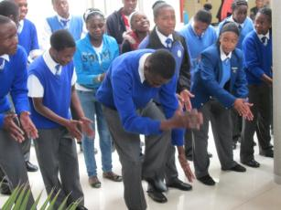
During the event two trees were planted on the Swakopmund Municipality premises and 14 trees were sponsored by Suzuki Swakopmund to local schools. Each school received two trees and two bags of composts.
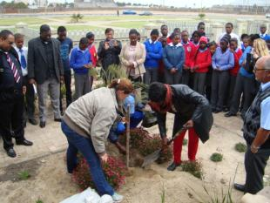
Adventure Travel World Summit Clean-up Day
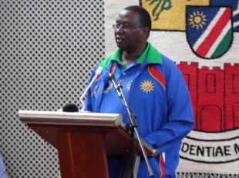
On 19 October 2013, the Swakopmund Municipality hosted a clean-up campaign in preparations for the official opening of the Adventure Travel World Summit on 28 October 2013. Very important political officials attended this event, such as the Erongo Regional Governor, Hon Gov Cleophas Mutjavikua, the Mayor of Swakopmund, Hon Clr Juuso Kambueshe and the Director of Tourism Mr Sem Shilongo. Learners from different schools and community groups were invited to take part in this event.
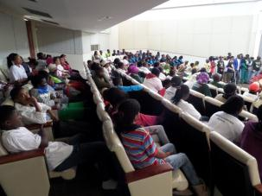
The official launch of the Green Environmental Project
On World Environmental Day, 05 June 2014, the Erongo Regional Governor, Hon Gov Cleophas Mutjavikua, the Mayor of Swakopmund, Hon Clr Juuso Kambueshe officially launched the project. Representatives from various organizations attended the launch, as well as representatives from local schools. Four organizations were awarded with the Eco-Mate Certificate for their commitment to local environmental affairs.
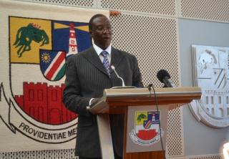
The activities are aimed at adding value to the national curriculum for basic education through the integration and promotion of environmental studies in formal education and supporting youth-led initiatives.
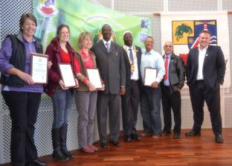
The anti-littering campaign
The Anti-littering campaign is an activity under the Green Environmental Project aimed at promoting environmental education and environmental sustainability. Littering is a continual environmental and health issue that needs to be addressed constantly.

The Swakopmund Municipality has been dealing with this problem and realized that education and awareness programs are an important part in dealing with the problem. The anti-littering campaign is a movement to educate the Swakopmund community on the causes and effects of littering and also how the public can assist the municipality with the proper disposal of waste within Swakopmund.

Goals of the anti-littering

- To educate the Swakopmund community on the effects of littering
- Eliminate littering along road sides and open spaces
- Ensure the public own up to their social responsibility towards the environment.
- Have a local annual anti-littering day

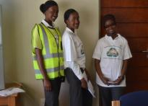
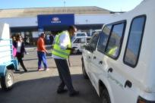
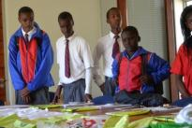
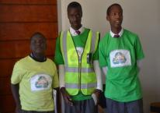
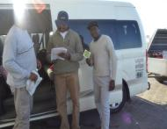
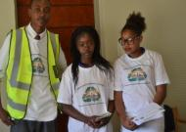

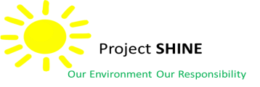

Project Shine
Project Shine was launched six years ago on World Environmental Day by the former Mayor of Swakopmund Her Worship, Cllr Rosina //Hoabes. The fundamental goal of the project was to clean the main road from Swakopmund to Arandis of littering, especially glass bottles dumped on the side of the road. The project consists of two activities namely the clean-up campaign and the creative competition.

The project sponsorship integrated big organizations like Namibia Breweries Ltd, Rio Tinto/R$ö$ssing Uranium, Walvis Municipality, NACOMA, Plastic Packaging, Bannerman Resources and the Municipality of Swakopmund.
Clean-up campaign
10 non-profit organizations are selected and a designated ward is allocated to each participating group which has to be cleaned and maintained during the 6 month period. The wards consist of one side of 10km stretch of the main road into Swakopmund from Arandis, and the adjacent 20m stretch of gravel, other open spaces between the main road and the airport, Swakop river mouth up to Mile 4 (Beach), 15km stretch of main road into Swakopmund From Henties Bay, 15km stretch of the main road into Swakopmund from Walvis Bay.
To recognize their efforts each organization will be rewarded N$1,200.00 per month over a 6 month period.
Aims and objectives
- To minimize the negative effects of pollutants in the environment.
- Promote awareness among participating organizations and the sponsor’s towards environmental conservation
- To promote and support local recycling operators
- To emphasis the economic value of waste
- To remove all glass bottles and glass fragments amongst other pollutants along the main road from Swakopmund and 40km towards Arandis.
- To involve members of the community through non-profit organizations such as churches, schools and sport clubs
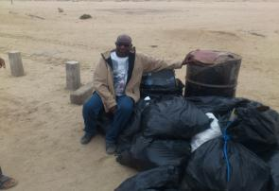
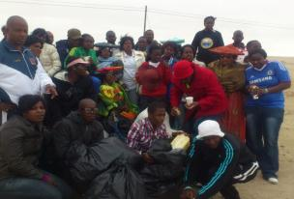
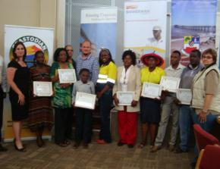
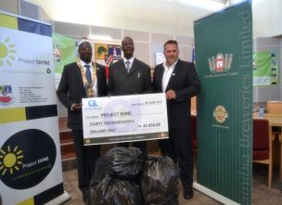
The Creative competition
The is a activity under Project Shine which invites schools from Walvis Bay, Swakopmund, Henties Bay and Arandis to create a valuable object from recyclable materials. The competition has three categories, which includes the lower primary 1-4, upper primary 5-7 and the secondary 8-12. Winners are chosen based on a judging criteria and each category has a first prize, second and third prize.

Aims and objectives
- The creative activity is aimed to stimulate students to take an active interest in the future of their environment by demonstrating their creativity.
- Promote recycling within the local community
- Encourage environmental sustainability
- Give a new viewpoint to the meaning of environmental conservation.
