Going Global: A Sustainable Development Goals (SDG) Curriculum Design Workshop

Presented by The RCE Greater Atlanta Higher Education Learning Community
February 23, 2021

Breakout group handouts for course-scale SDG integration

Backward Design Process
Learning Objectives
Assessment
Instructional Strategies

This process can be applied to programmatic or departmental desired outcomes, as well as courses and units of study.

OPENING DISCUSSION: What is your target for SDG integration? Share with the group and identify areas of overlap.

SDG Integration in Your Course

Sample SDG Integration for SDG 10:

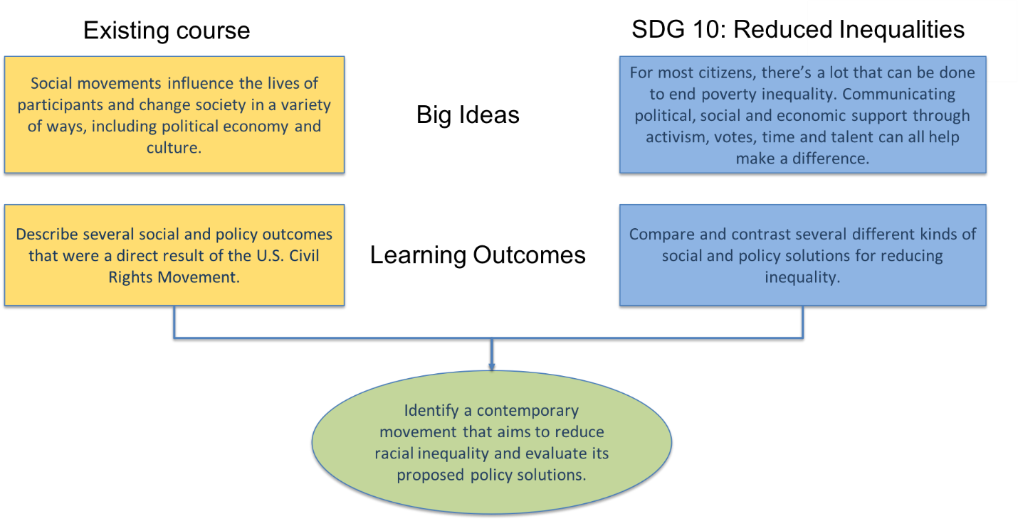

Now it’s your turn. Use the template below to integrate one or more SDGs into a learning outcome from your course:

Existing Course |  | SDG(s):
 | Big Ideas
 | Learning Outcomes

Step 1: Learning Objectives

Effective Learning Objectives are:
- Student-centered
i.e. focused on what your students will learn (instead of the content you/the course will cover)
- Action-oriented
i.e. focused on what students will be able to do (instead of the things they will “know”)
- Measurable
i.e. it should be easy to identify how you would check whether a student has mastered the relevant knowledge, understanding, or skill
- Precise
i.e. it is clear what type of knowledge you are aiming for
- Avoid use of vague action verbs & prompts, like “Students will understand X”, “Obtain a working knowledge of X”, and “Gain insight into X”.
- To clarify an objective, ask yourself: “What will a student do if s/he really understands or appreciates the point in question?”

TASK 1: Work with your group to evaluate and revise the course learning outcomes, below.

By the end of the course, students will be able to:
- Understand inequality, how to measure it, and its interrelation with other social problems.
- Understand the local, national and international processes that promote and hinder equality, such as fiscal, wage and social protection policies or corporate activities.
- Raise awareness about inequalities in their community and abroad, while showing solidarity with people who are discriminated against.
- Evaluate inequalities in terms of quality and quantity, while identifying causes and strategies to reduce them.

NOTES:

TASK 2: Developing learning objectives
For the next five minutes or so, brainstorm your responses to the following two questions:
- What do you want your students to be able to do as a result of SDG integration?
- What skills do you want your students to have as a result of SDG integration?
Aim to think in terms of the big picture – main themes, ideas, takeaways, skillsets, etc.

Consider knowledge and skills of different types:
Factual Knowledge  Basic elements students need to know to be acquainted with a discipline/solve problems in it. | Conceptual Knowledge  Relationships among basic elements that enable them to function together
Procedural Knowledge  Use of methods, skills, techniques, or algorithms. | Metacognitive Knowledge  Knowledge of cognition in general as well as awareness of knowledge of one’s own cognition.

Remember | Understand | Apply | Analyze | Evaluate | Create
Arrange  Define  Locate  Recall  Recite  Describe  Repeat  Identify  Select  Quote  Label  Copy  List  Name  State | Classify  Describe  Identify  Indicate  Organize  Interpret  Illustrate  Reorganize  Translate  Paraphrase  Summarize  Transform  Discuss  Explain  Defend  Compare  Report  Restate  Review  Rewrite | Calculate  Construct  Demonstrate  Estimate  Illustrate  Interpret  Appraise  Contrast  Criticize  Diagnose  Identify  Classify | Combine  Figure  Find  Sketch  Solve  Predict  Change  Survey  Compare  Diagram  Examine  Test  Modify | Appraise  Argue  Assess  Defend  Estimate  Judge  Predict  Qualify  Rate  Support  Critique  Recommend | Arrange  Assemble  Compose  Design  Devise  Formulate  Invent  Manage  Modify  Organize  Plan  Prepare  Produce  Propose  Set Up  Verify  Construct  Develop

Adapted in part from:
Anderson, L.W., Krathwohl, D.R., Airasian, P.W., Cruikshank, K.A., Mayer, R.E., Pintrich, P.R., Raths, J., Wittrock, M.C. (2000). A Taxonomy for Learning, Teaching, and Assessing: A revision of Bloom’s Taxonomy of Educational Objectives. New York: Pearson, Allyn & Bacon.

Bloom, B.S. (1956). Taxonomy of Educational Objectives, Handbook I: The Cognitive Domain. New York: David McKay Co. Inc.

Write your items from TASK 2 in the form of learning objectives.

By the end of the course, students will be able to:

Remember, effective learning objectives are:
- Student-centered
- Action-oriented
- Measurable
- Precise

NOTES:

Step 2: Assessments

Next, let’s think about assessments. How will you know your students have achieved your learning outcomes? What kind of assessments will you use for your course? A semester-long project? One or more exams? Weekly homework? Let’s try just one using the template below:

My assessment
What are you going to ask your students to do?
Why are you asking your students to do this, specifically?
How much are you asking your students to do (e.g., length, hours spent, etc.)?
Will students work alone or collaboratively?
Why?
Which learning objectives and/or component skills are being tested/developed?

Sample questions for your assessment

Cognitive Process | Example Question Stem:
Remember  (Retrieve relevant knowledge from long-term memory.) | Define the term…  Identify the five major…  Who is responsible for…  Write the equation for…  List the characteristics of….
Understand  (Construct personal meaning from instructional messages including oral, written, and graphic communication.) | Paraphrase important aspects of…  Explain the causes of…  Give examples of the concept…  Write a short summary of this video…  Classify observed or described cases of …  Infer grammatical principles from examples…  Compare historical events to contemporary situations…
Apply  (Carry out or use a procedure in a given situation.) | Relate the principle of ___ to this situation….  Describe an experiment to answer the question…  Determine _____ using the equation for….  Apply shadowing to produce depth…
Analyze  (Break material into constituent parts and determine how parts relate to one another or to an overall structure of purpose.) | Identify the assumptions underlying…  Given the argument for _____ , enumerate the positive and negative points presented…  Analyze the following _______ and determine the frequency of….  Given a __________ , identify the necessary components and any constraints…  Determine the author’s point of view in terms of his or her views on...
Evaluate  (Make judgments based on criteria and standards.) | Given an argument on this position, enumerate the logical fallacies in that argument…  Given the data available on a research question, take a position and defend it…  Evaluate a work of art, giving reasons in your evaluation…  On the basis of operating data over the past six months, describe if the company in the case study should buy materials from source A or source B…
Create  (Put elements together to form a coherent or functional whole, reorganize elements into a new pattern or structure.) | Write a logically organized argument in favor of…  Given a set of data derive a hypothesis to explain them…  Construct an original work that incorporates five common materials…  Write a short story relating a personal experience in the style of …
TASK 3: Using the charts above for inspiration, craft an assignment prompt or set of questions that a course included in your program might use to assess progress toward one of the learning objectives you developed.

Also consider: Formal assignments are just one way to assess student learning. What other strategies and tools might you use to evaluate the efficacy of SDG integration in your course?

Step 3: Instructional Strategies

Finally, let’s consider activities. Specifically, what will you do in your class to teach this content? Standard lecture? Group discussion? Problem-based inquiry? Consider the chart below for some active learning techniques you can bring into your lesson:
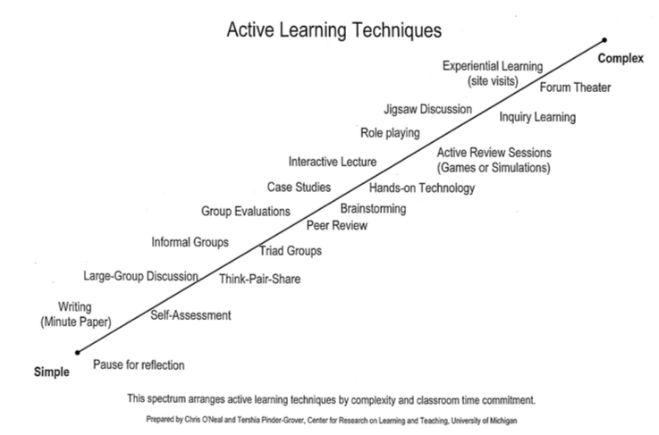

TASK 4: Brainstorm some active learning strategies you could use to integrate the SDGs into your lesson. You can find descriptions of each technique in the figure above on the next page.

Clarification Pauses: Throughout a lecture, particularly after stating an important point or defining a key concept, stop presenting and allow students time to think about the information. After waiting, ask if anyone needs to have anything clarified. Ask students to review their notes and ask questions about what they've written so far.
Writing Activities such as the “Minute Paper”: At an appropriate point in the lecture, ask the students to take out a blank sheet of paper. Then, state the topic or question you want students to address. For example, “Today, we discussed emancipation and equal rights. List as many key events and figures as you can remember. You have two minutes - go!”
Self-Assessment: Students receive a quiz (typically ungraded) or a checklist of ideas to determine their understanding of the subject. Concept inventories may be used at the beginning of a chapter to help students identify misconceptions.
Large-Group Discussion: Students discuss a topic in class based on a reading, video, or problem. The instructor may prepare a list of questions to facilitate the discussion.
Think-Pair-Share: Have students work individually on a problem or reflect on a passage. Students then compare their responses with a partner and synthesize a joint solution to share with the entire class.
Cooperative Groups in Class (Informal Groups, Triad Groups, etc.): Pose a question for each cooperative group while you circulate around the room answering questions, asking further questions, and keeping the groups on task. After allowing time for group discussion, ask students to share their discussion points with the rest of the class.
Peer Review: Students are asked to complete an individual homework assignment or short paper. On the day the assignment is due, students submit one copy to the instructor to be graded and one copy to their partner. Each student then takes their partner's work and, depending on the nature of the assignment, gives critical feedback, and corrects mistakes in content.
Group Evaluations: Similar to peer review, students may evaluate group presentations or documents to assess the quality of the content and delivery of information.
Brainstorming: Introduce a topic or problem and then ask for student input. Give students a minute to write down their ideas, and then record them on the board. An example for an introductory political science class would be, “As a member of the minority in Congress, what options are available to you to block a piece of legislation”
Case Studies: Use real-life stories that describe what happened to a community, family, industry, or individual to prompt students to integrate their classroom knowledge with their knowledge of real-world situations, actions, and consequences.
Hands-on Technology: Students use technology such as simulation programs to get a deeper understanding of course concepts. For instance, students might use simulation software to design a device or use a statistical package for regression analysis.
Interactive Lecture: Instructor breaks up the lecture at least once per class for an activity that lets all students work directly with the material. Students might interpret features of images, interpret graphs, make calculation and estimates, etc.
Active Review Sessions (Games or Simulations): The instructor poses questions and the students work on them in groups or individually. Students are asked to show their responses to the class and discuss any differences.
Role Playing: Here students are asked to ‘act out" a part or a position to get a better idea of the concepts and theories being discussed. Role-playing exercises can range from the simple to the complex.
Jigsaw Discussion: In this technique, a general topic is divided into smaller, interrelated pieces (e.g., a puzzle is divided into pieces). Each member of a team is assigned to read and become an expert on a different topic. After each person has become an expert on their piece of the puzzle, they teach the other team members about that puzzle piece. Finally, after each person has finished teaching, the puzzle has been reassembled, and everyone on the team knows something important about every piece of the puzzle.
Inquiry Learning: Students use an investigative process to discover concepts for themselves. After the instructor identifies an idea or concept for mastery, a question is posed that asks students to make observations, pose hypotheses, and speculate on conclusions. Then students share their thoughts and tie the activity back to the main idea/concept.
Forum Theater: Use theater to depict a situation and then have students enter into the sketch to act out possible solutions. Students watching a sketch on dysfunctional teams, might brainstorm possible suggestions for how to improve the team environment. Ask for volunteers to act out the updated scene.
Experiential Learning: Site visits allow students to see and experience applications of theories and concepts from the class.

Sources
Active learning. (n.d.). Relieved September 1, 2005, from University of California at Davis, Teaching Resources Center Web site: htto://trc.ucdavis.edu/trc/ta/tatips/activelearning pdf
Bonwell, C.C. (1996). Enhancing the lecture: Revitalizing a traditional format. In T.E. Sutherland, C.C. & Bonwell (Eds.), Using active learning in college classes: A range of options for faulty. (pp.31- 44). San Francisco: Jossey-Bass Publishers.
Felder, R.M., & Brent, R. (1994). Cooperative learning in technical courses: Procedures, pitfalls, and payoffs. (ERIC Document Reproduction Service, No. ED 377038).
McKeachie, W.J. (2005). How to make lectures more effective. In Teaching tips: Strategies, research, and theory for college and university teachers (11" ed.) (pp. 52-68). New York: Houghton Mifflin Co.
Paulson, D.R., & Faust, JL. (n.d). Active learning for the college classroom. Retrieved September 1, 2005, from California State University, LA. Web site: hitp www calstatela edu/deptichem/chem2/Activel
Additional consideration (if time allows):

Identifying Prior Knowledge
It is useful to be explicit about the skills and knowledge we expect our students to have when they encounter a course aligned with the SDG-related learning outcomes you have developed. With a diversity of student experience in your class, how many of your students will already come with some relevant skills and knowledge to succeed in your course? (E.g. All / Most, Some / A Few, None, or Don’t Know).

What relevant skills and knowledge do students need to have in hand in order to succeed in your course? | How many students…

Consider the skills and knowledge you identified above, along with your predictions about how many of your students are likely to have mastered those skills before the first day of class.

Review each item with the following questions in mind:

Expectation
All/Most | - How will you communicate this need/expectation on the first day of class and/or in the syllabus?  - What will you do to help students who need it to catch up and/or gain the background they need to succeed in your course?  - Are there areas where students may be “rusty” with these skills? What are some ways you can review material in order to activate/connect to your students’ prior knowledge?
Some/  A Few | - To what extent do you need to help your students learn this content during your course?  - What are some ways to help students gain these skills and knowledge – either during class or outside of class?
None | - You will need to teach these things in your course, to reasonably expect student success in your course.
Don’t Know | - What will you do to establish reasonable expectations for student prior knowledge?

Brainstorm your ideas to manage variety of student backgrounds and prior knowledge below:

