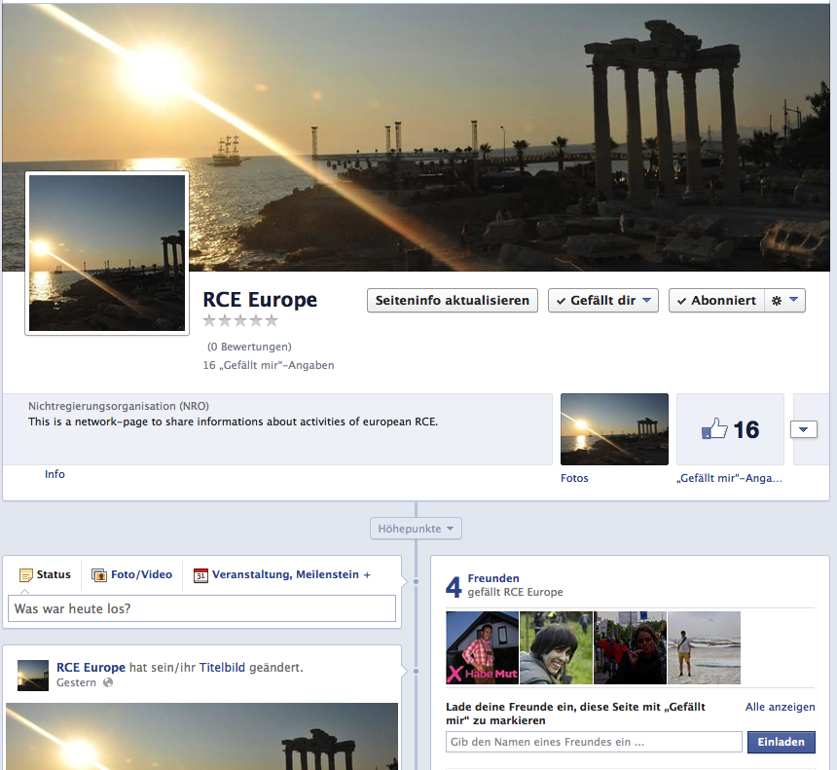

Dear Colleagues,
Jane Claricoates and I start this facebook-community to keep in touch with the european RCE.
We are looking forward to what will happen.

