KBAD—Knowledge Based Area Development
A Step Towards Community Self-Reliance and Education for Sustainable Development

Professor Mohammed Ataur Rahman
Coordinator RCE Greater Dhaka

Bangladesh is the most densely populated least developed country in the world having a population 165 million in an area 147,570 km². Most of the country is the alluvial flood plain of the Ganges and Brahmaputra Basin and is agriculture-based. But due to intense cultivation and indiscriminate use of chemical fertilizers and pesticides the land has increasingly losing its fertility. Recently growing garments, hide and leather, medicine and ship breaking industries have made a significant economic improvement but at the cost of environmental resources viz. water, air, soil, biodiversity and human health due to pollution and lack of knowledge. Although the government has taken a mass awareness to eradicate illiteracy to cover primary education which has reached at 53.7% (BBS 2013) only. About seventy percent of the youths of age 15 to 25 are still remain unskilled and many of them do not have the opportunity for higher education. For a strong nation, the youths are the strength but due to lack of opportunity for higher education and training, this population has become a great burden of the society; youths are unemployed, become lazy and they used to get involved with social crimes and political chaos.

Bangladesh is endowed with people, but has very limited natural resources and financial capital. By developing the people in the human capital, it can be overcome some of the limitations of the country’s physical capital and at the same time a foundation of generating capital resources. Considering this, Professor M Alimullah Miyan, Vice-Chancellor and the Founder of IUBAT and the pioneer organizer of establishing Non-Government Universities in Bangladesh, has postulated the concept of “Knowledge Based Area Development (KBAD)” to educate young person from each locality for giving opportunity to go for higher education in ‘marketable knowledge and skills with sustainability practices’. Through active participation of every educated individual of the society it is possible to break the vicious cycle of poverty to build up a prosperous country based on knowledge and skill. This concept has been institutionalized and strengthens the ongoing drive towards nation building and accelerates the dream of making Bangladesh a prosperous self-reliance country.
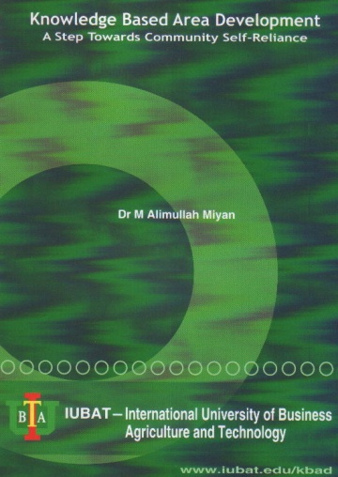
Fig. Cover page of KBAD booklet
IUBAT—International University of Business Agriculture and Technology is dedicated to research and education for a healthy, prosperous and sustainable future for nation addressing the issues of global environmental changes including climate change, poverty alleviation, resource management and natural conservation etc. to fulfill its commitment to operate the institution within a social and economically sound ecosystem towards a sustainable community. Sustainability is truly an interdisciplinary approach of various disciplines and it is a practical way of living within a community with appropriate knowledge. IUBAT has been implementing dynamic sustainable practices and emerging as a leader to tackle the challenges of sustainability with the aim to spread the practices throughout the country and it has developed this guideline as a basis of national resource to transmit the knowledge into educational institutes, communities, social and industrial organizations.
Bangladesh is one of the worst sufferers of global environmental changes and posing instability with its huge population with multifaceted crises viz. food, energy, water, waste management, pollution and natural resources. The country has been suffering from natural and human induced calamities with increased frequencies in the last few decades. Moreover, unplanned urbanization, industrialization, roads and highways; indiscriminate application of chemical pesticides and fertilizers, destruction of forests and wet-bodies, withdrawal of ground water and introduction of unsuitable practices for agriculture have aggravated the situation causing poverty, widening the gap between rich and poor, deteriorating biodiversity and harming human health.
IUBAT, the first Non-Government University of Bangladesh, has emerged as a higher education institute to create human resource capital with skilled manpower having specific knowledge on sustainability for last two decades. It has a distinct history of disaster management training, health and hygiene program for the urban slum dwellers, spreading education through education loan into the rural Bangladesh. All these efforts and expertise lead to chose right development options for the country which are sustainable. IUBAT is playing an important role in human resource development with specific knowledge about sustainable practices and gradually expanding its activities throughout the country. Presently more than 12,000 students are engaged in spreading education for sustainable development (ESD) practices by gaining knowledge, changing attitude and sustainable practices in the campus with the motto: An Environment Designed for Learning. IUBAT has started development of Green Campus with all sustainable activities since August 12, 2008. In 2011, its Centre for Global Environmental Culture (CGEC) has been acknowledged by the United Nations University (UNU IAS) as the host of the UN program of Regional Centre of Expertise (RCE Greater Dhaka) in Bangladesh.
A mandatory education for sustainability course has been introduced for all of its students of IUBAT. In this course, importance of environmental sciences, ecosystem services, basic needs and resources their availability and limitations are taught to aware students of all disciplines of the university. For a sustainable use-practice of natural resources like energy, air, water, minerals, soil and biodiversity etc., emphasizing 3R’s i.e. reduce, reuse and recycle are being practiced throughout the campus life.
For a conscious and knowledge-based society IUBAT has been teaching ethics, moral justice, and grooming up as skilled human resource for national and international job markets as well as spreading higher education allover in Bangladesh by educational funding under the KBAD program. The program under operation and its progress and the success and the challenges have been updated and published in the form of a booklet (ISBN 984-70060-0003-7) in April 2013, www.iubat.edu/kbad. KBAD can be a model for other developing countries to make human resource to bringing prosperity in the society.
The copy of the KBAD booklet has been attached.

