BUCKSPORT AND THE SUSTAINABLE DEVELOPMENT GOALS
REVIEW AND REPORT OF COMMUNITY PROGRESS: NOVEMBER 18, 2021
SUSTAINABILITY: METHODS + TOOLS
TAKIAH ANDERSON, CATE BAUER, KALINA FAULKS, MAX HALL, JAIRAN PARKER, KATEY ZIMMERMAN
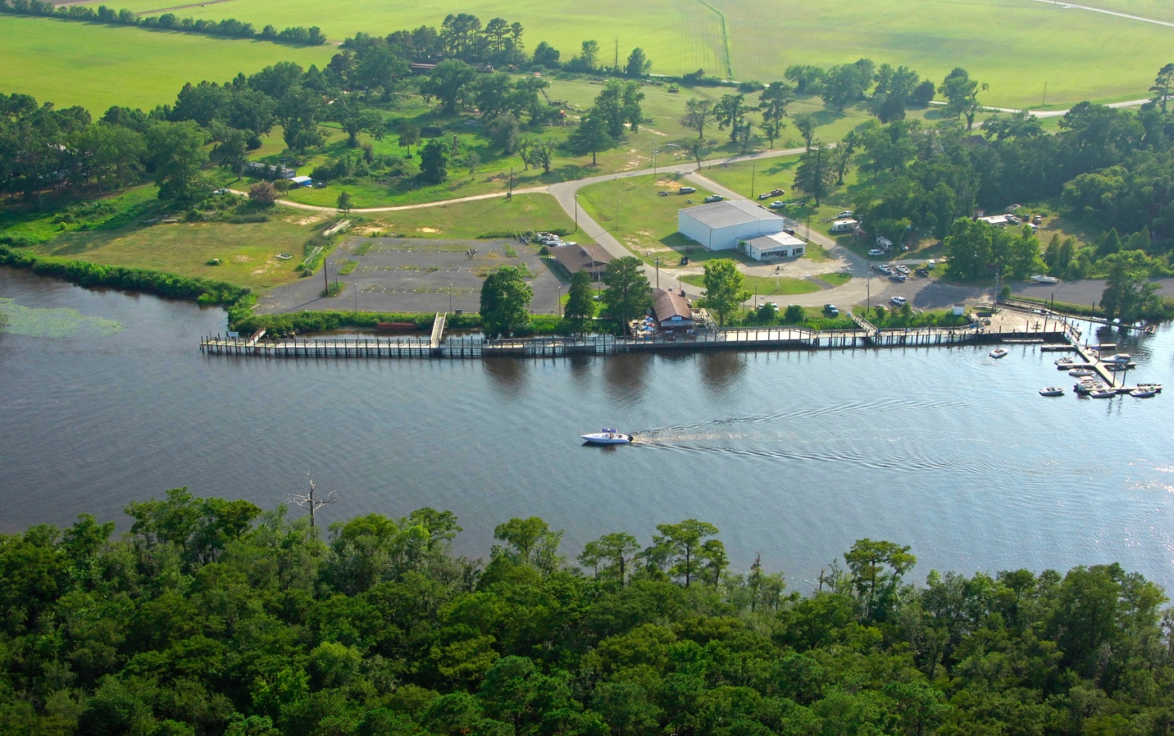

Introduction 3
Methodology 6
Timeline 7
UN SDG Framework 8
SDG 16: Peace, Justice, and Strong Institutions 11
SDG 17: Partnerships for the Goals 12
SDG 8: Decent work and Economic Growth 13
SDG 3: Good Health and Well-Being 15
SDG 13: Climate Action 16
SDG 1: No Poverty 17
SDG 15: Life on Land 18
SDG 14: Life Below Water 23
SDG 6: Clean Water and Sanitation 25
SDG 11: Sustainable Cities and Communities 27
IPBES 28
Disaster Risk Reduction 29
Recommendations for the Future 32

Introduction
Students in Dr. Martin’s Methods and Tools in Sustainability course were split into two groups and assigned to assist one of two communities. This group was assigned to assist the town of Bucksport, South Carolina. The students quickly agreed that the land that Bucksport occupies is far more valuable than the county gives it credit for, and the people who own it should be getting far more support than they have. The largest problem facing the town is flooding which has been increasing in recent years and has caused damage to many homes and properties, and both state and federal assistance have been discussed but, in many cases, have yet to be provided. Over the course of the entire semester, the group was tasked with gathering data and organizing it to provide the town and its people with the proper information to move forward in dealing with the issues they are facing. The student group did much of its own research while also collaborating with multiple organizations and individuals, pooling resources to assist the community as best they could given the limited time available to them during the semester. At the end of the semester, the group consolidated its findings and recommendations into a presentation for the people of Bucksport as well as those that are also working to assist the town.

Location: Bucksport, Horry County, SC
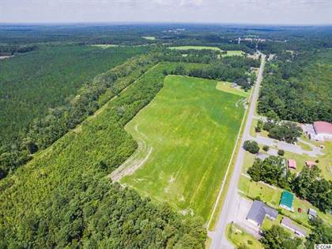
Bucksport is a rural unincorporated town in South Carolina in the southwestern part of Horry County, west of Myrtle Beach at the coordinates 33°40’37” N, 79°6’54” W. It is nestled with the Waccamaw National Wildlife Refuge to the east and west. Bucksport sits on two bodies of water; the Waccamaw River and the Cowford Swamp and is also near the Great Pee Dee River. Bucksport is along US highway 701 and is made up of forests and farmland.

Purpose of Report
The purpose of the Coastal Carolina group was to gather information that relates to the sustainability of Bucksport and the issues facing the town and use that information to find sustainable courses of action that the community may take. The students worked to gather information on several topics and issues including the culture, economy, politics, and natural attributes of the area. Through research, interviews, and collaboration the students gathered information that was examined through the lens of sustainable development in order to find potential solutions and provide data to the community for their dealings with the Horry County and Federal governments. A focus was placed on the United Nations Sustainable Development Goals, a set of global and local interlinked goals and indicators adopted by all member countries of the UN, the idea being “a blueprint to achieve a better and more sustainable future for all.” The students began finding which issues and factors related to which of the 17sustainable development goals. These goals were then used as a guide and template for figuring out which would be best actions for the community to take moving forward. Rather than only looking for quick and temporary solutions, the students worked to figure out more sustainable routes that will do more to support the community in the long term and help it to endure through both current and future issues.

Unit Analysis/ Scales: There are various scales that impact Bucksport, South Carolina. Climate change, the COVID-19 pandemic, poverty, and coastal flooding to name a few. Most of these scales affect multiple regions around the world, but for such a small, close-knit community such as Bucksport, the impact is much more severe. At the local level, coastal flooding is a major concern that needs to be addressed. Over the past five years or so, Bucksport has been hit with catastrophic flooding from heavy rainfall and severe hurricanes. The local residents have participated in meetings to discuss flood mitigation plans. Another major concern the locals face is the high unemployment rate, which has a direct relationship with the poverty level.
Who worked with us?
Working to complete this sustainability assessment for Bucksport we worked with Furman University students. Specifically looking at the cultural aspects of Bucksport’s including the Gullah Geechee culture, Furman students Sydney Spires, Jeanna Cline, and Meghan Salm did exemplary work on research and possible solutions.

Methodology
This sustainability assessment serves to examine the Bucksport community (i.e., the state of the environment, people, and economics) and answer the following questions:
- What is holding Bucksport back from prosperity?
- Why does Bucksport feel so disenfranchised?
- How do we help change their sustainability & resilience?
- How do we get people outside of Bucksport to care?
- How do we get the local government to feel inclined to protect this community?
This assessment was developed in sections using a variety of qualitative, ethnographic, and case study methodologies. A variety of tools were used to measure data including observations, meetings, and pre-existing data. The pre-existing data used were published online and came from sources such as research articles, news articles, government websites, and the Horry County Flood Resilience Master Plan Draft. The first section was the preliminary assessment where information regarding the geographic boundaries, natural attributes, social and cultural attributes, as well as economic and business attributes of Bucksport were collected. Challenges, disturbances, scales, and stakeholders that impact the community were also collected for this section. In the second section, the problems that Bucksport faces, the questions which would guide the assessment, and the unit of analysis were identified. The questions were then answered using empirical evidence and connected to the United Nations Sustainable Development Goals (UN SDGs). The hazards, vulnerability, and risks of the community, Disaster Risk Reduction measurements (from the Sendai Agreement, a global agreement on disaster risk reduction), options regarding responses, suggestions for a plan, and actions based on previous findings were investigated within section three. A conceptual framework diagram, based on one established by the Intergovernmental Science-Policy Platform on Biodiversity and Ecosystem Services (IPBES), was developed within section four and each aspect of the diagram was explained to describe the connection between nature and the people residing in the Bucksport community. Findings based on the information collected within these sections were then developed into a sustainability assessment. Ways to help the Bucksport community along with recommendations for the future were also developed based on the findings.

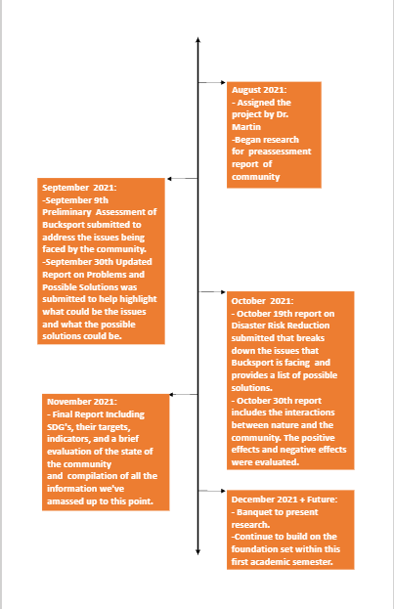
Timeline
Framework and Sustainable Development Goals
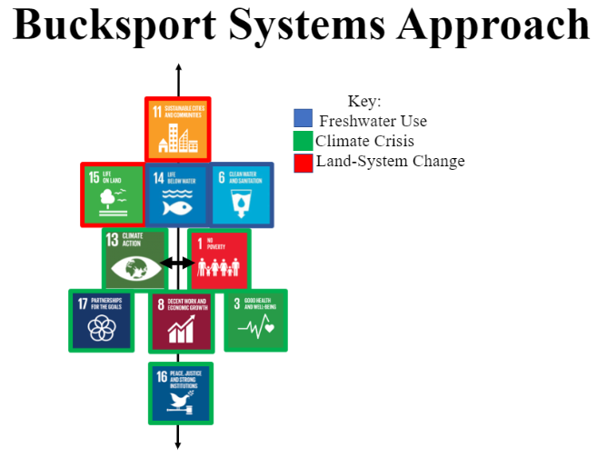
What are the sustainable development goals?
The sustainable development goals (SDG) are derived from the 2030 Agenda for Sustainable Development. It is a global, 15-year plan that involves all countries. It is centered around 17 Sustainable Development Goals and 169 targets. The goals are meant to link people and economic aspects of life on the planet and within its natural boundaries. The people element includes ending poverty and hunger and making sure that all humans can live in dignity within a healthy environment. The economic element, or prosperity, states that people have the right to prosperous lives while progressing in balance with nature. The planet element protects nature from further degradation. It also encompasses sustainable consumption, production, and use of natural resources. While simultaneously acting on the cause and effects of climate change, it also mentions preserving the needs of future generations. Peace and partnership were added along these three principles of sustainability. Peace promotes peaceful societies where justice is clearly present. Partnerships are based on collaborative solidarity towards the goals. It includes the idea that all stakeholders should be included, especially vulnerable communities (United Nations). The sustainable development goals that could be applied at a local scale were chosen to analyze the community. The goals chosen for this framework are 1: No Poverty, 3: Good Health and Well-being, 6: Clean Water and Sanitation, 8: Decent Work and Economic Growth, 11: Sustainable Cities and Communities, 13: Climate Action, 14: Life Below Water, 15: Life on Land, 16: Peace, Justice, and Strong Institutions, and Goal 17: Partnerships for the Goals. What are targets?

Why did we choose this framework?
This framework was designed based on the sustainable goals listed. These goals were chosen out of the seventeen based on what is most applicable to Bucksport and can be represented with data. Starting at the base of the framework is Goal 16: Peace, Justice, and Strong Institutions. Goal 16 is based upon peace and inclusion. It also is based on providing equitable justice and keeping institutions accountable and inclusive. We chose this as the base upon which all other goals must be built upon and included in action. The arrow demonstrates how moving from one goal to the next is more easily achieved when the goals below it are. The next goals listed are Goal 17: Partnerships for the Goals, 8: Decent Work and Economic Growth, and 3: Good Health and Well-being. These three goals are more easily achieved when Peace, Justice, and Strong Institutions are present within them and the community. Partnerships for the Goals are necessary in order to exchange valuable information as well as support communities that need it. When partners are working toward the same goal, it is achieved faster and includes more stakeholders in decisions. Decent Work and Economic Growth should also have Peace, Justice, and Strong Institutions present. Equitable access to aid, county funds, and economic expansion within the community is important in order for people to prosper. Prosperity is then linked to Goal 3: Good Health and Well-being. Good Health and Well-being includes factors of human life such as food, water, shelter, health, etc. Without the means to thrive financially, a community cannot sustain itself while maintaining its resources for future generations. Goal 1: No Poverty and Goal 13: Climate Action are next in the figure with a bold arrow between them. This arrow is meant to demonstrate how closely related the two goals are. No Poverty focuses on ending poverty, in every form. Poverty is exacerbated by climate change and its effects. Climate action is the goal dedicated to combat the drivers of climate change and the impacts it has on people, resources, and the environment. Climate change scientists predict more frequent and stronger weather events, such as hurricanes. This would prove problematic for communities, such as Bucksport, that experience flooding due to development and geography and do not have means to build back after storms. Communities cannot be sustainable and adapt to the changes brought about by climate change without the eradication of poverty and vulnerability. The next goals upward in the figure are Goal 6: Clean Water and Sanitation, Goal 14: Life Below Water, and Goal 15: Life on Land. Clean Water and Sanitation is meant to ensure that all people have access to clean water. This includes the ability to manage water sustainably. Life Below Water focuses on conserving marine resources and using them for sustainable development. Life on Land is similar. Life on Land encompasses restoration, protection, and promotion of ecosystems on land. Combating biodiversity loss is also included by sustainably managing forests, fighting desertification, and stopping or reversing land degradation. These three goals directly apply to Bucksport. Although within a terrestrial ecosystem, the unique landscape of rivers and wetlands means that water and water sanitation are both important factors to consider when looking toward the future. By implementing Climate Action in the community, as well as No Poverty, protecting the wildlife and maintaining resources are more easily attainable. All of the goals lead to the top of the figure, Goal 11: Sustainable Cities and Communities. A sustainable community would be the overall goal from the analysis of Bucksport. This goal includes making cities and human settlements safe, resilient, sustainable, and inclusive. All the goals previously listed, if accomplished, will lead to a sustainable community.

What are planetary boundaries?
Planetary boundaries are the capacity of the planet to provide resources before accessing those resources and destabilizing ecosystems. Imagine planetary boundaries as lines that are not meant to be crossed. For example, cutting down a large amount of forest is shown to disrupt other species and natural patterns that are necessary for healthy populations. Limiting oneself to a smaller number of resources within the forest allows for it to continue providing services for the people. On a large scale, this applies to the planet and all countries as a whole. For this analysis, we chose planetary boundaries based on Bucksport’s current resources and needs. The boundaries chosen are Freshwater Use, Land-System Change, and the Climate Crisis. Freshwater use refers to the water around Bucksport, such as the Waccamaw and Pee Dee rivers and the wetlands. Land-system change is in reference to the type of development that has taken place in Bucksport. The climate crisis relates to the affects that climate change could have on the Bucksport area. Sea-level rise, increased temperature and storm activity could impact the community as climate change progresses. The colors surrounding the goals are meant to link them to the related planetary boundary. Notice that Climate Crisis is most related to the goals chosen in reference to the community.

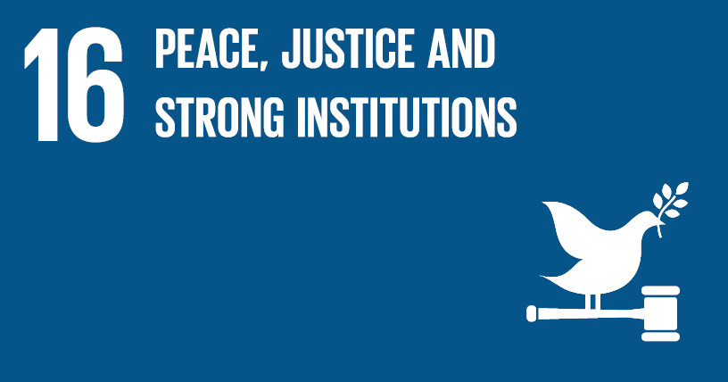
Goal Explanation: UN goal 16 is primarily focused on promoting a peaceful and inclusive society for sustainable development, providing access to justice for all and building effective, accountable, and inclusive institutions at all levels.

Introduction:
For a substantial portion of Bucksport’s history, the relationship between the town and the county and state government has been strained. This has been reflected by the American Rescue Plan (ARP, adopted to assist with COVID-19) along with the county’s Flood Resilience Master Plan, which attempt to “solve” issues that involve Bucksport. However, there has been a lack of communication between what the county has planned and what the town needs, as observed by our team in the following meetings – Bucksport community meeting October 25th. This lack of communication is decreasing inclusivity and equity simply because of the disconnect between people and institutions. There are also several property rights issues related to heirs property. Along with being overlooked on a general scale, leaving this has left some of the town's inhabitants to have a distrust of the system they feel should be helping them.

Targets and Data:
The two targets and indicators that could provide the most assistance to Bucksport would be 16.6 and 16.7. Target 16.6 which develops effective, accountable, and transparent institutions at all levels. This can be integrated through restructuring how the county notifies and broadcasts certain information out towards community members. Ensuring that there is a platform that all people commonly have access to see what changes are being made in their communities so that they may give ample feedback. Target 16.7 is when there is ensured responsive, inclusive, participatory, and representative decision-making at all levels. Public meetings need to be clearly and effectively communicated to the community in advance and in multiple formats – digital and paper in public locations to include the community center, churches, etc. Improved format for the meeting to feel more inclusive is another suggestion, based on our observations fall 2021. The meetings should create a comfortable environment in which attendees feel that they can voice their opinions and that those opinions will be taken into consideration. FEMA has also created a policy change that enables those who live on heirs’ property, property which has been inherited without a will in many cases lacking official documents, to have equal access to receive disaster relief funding (NBC News). This federal policy change is helping to ensure the equitable distribution of funds and it is a prime example of responsive and inclusive decision making that is the key to improving the resilience of the community.

Goal Explanation: UN goal 17 is centered around strengthening the means of implementation and revitalizing the global partnership for sustainable development.

Introduction:
Having strong partnerships is essential in the growth and development of Bucksport. Creating a system of support from other public and private entities along with creating partnerships that enable these entities to help the community to improve. Bucksport has begun establishing these partnerships with institutions on a state level as well as a national level such as the NAACP, the Center for Heirs Property, the Gulla Preservation Society, the Gullah Geechee Chamber of Commerce, Coastal Carolina University, and Furman University, among others. The movement toward improving partnerships that have already been established with Horry County and the other cities in the county, along with generating new partnerships with Grand Strand Water and Sewer are going to contribute to the future success of the community.

Targets and Data
Target 17.7 encourages and promotes effective public, public-private and civil society partnerships, building on the experience and resourcing strategies of partnerships, data, monitoring and accountability. This has already been established by the partnerships created by both Furman and Coastal Carolina University. These partnerships have led to the creation of reports that not only bring awareness to the severity of the situation, but also to educate those in the community regarding the issues that their neighbors are facing. Along with a commitment to establishing a better partnership with the county by utilizing the partnerships established with the two universities to push for a much-needed institutional change. Horry County is receiving $68.8 million in ARP funding, and $8.2 million being available to public service agencies. These funds that have been made available and have already been applied for can help to improve housing and infrastructure within the community (HorryCounty.org, 2021).

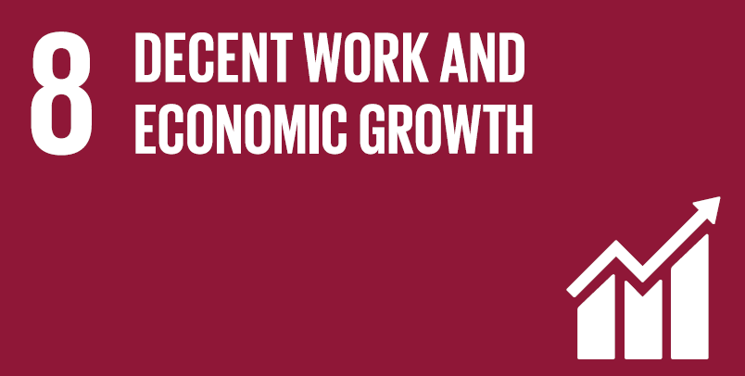
Goal Explanation: Decent work and economic growth focus on the community's economic growth that interlinks with creating decent jobs for all and improving living conditions. In terms of the UN SDG goal 8, decent work and economic growth, Bucksport is currently struggling to meet these goals for multiple reasons.

Introduction: Currently in Bucksport there are two locations for recreation: Bucksport Landing and Port Harrelson Landing. There are several small convenience stores located throughout the community including one named Glenda’s located towards the center of the community and a car wash. Also, many churches located throughout the Bucksport community including Bethel Seventh Day Adventist Church, Jerusalem Baptist Church, Mt. Moriah Baptist Church, Salem AME Church, Victory Church, and Victoria Chapel Holiness Church. Major utilities located within Bucksport are the Grand Strand Water and Sewer Authority (GSWSA) Bull Creek Water Treatment Plant and the Horry Telephone Cooperative Inc. (Flood Resilience Master Plan). Each of these make up the anthropogenic assets of the community. The term ’anthropogenic asset’ refers to built infrastructure, health facilities, knowledge, technology, and financial assets. Other anthropogenic assets include the Bucksport Marina and a nursing home, Horry County Council on Aging (Bucksport, SC). Although the Bucksport community has many anthropogenic assets, the community still lacks schools, hospitals, and doctor’s offices, which takes away from the overall quality of life.
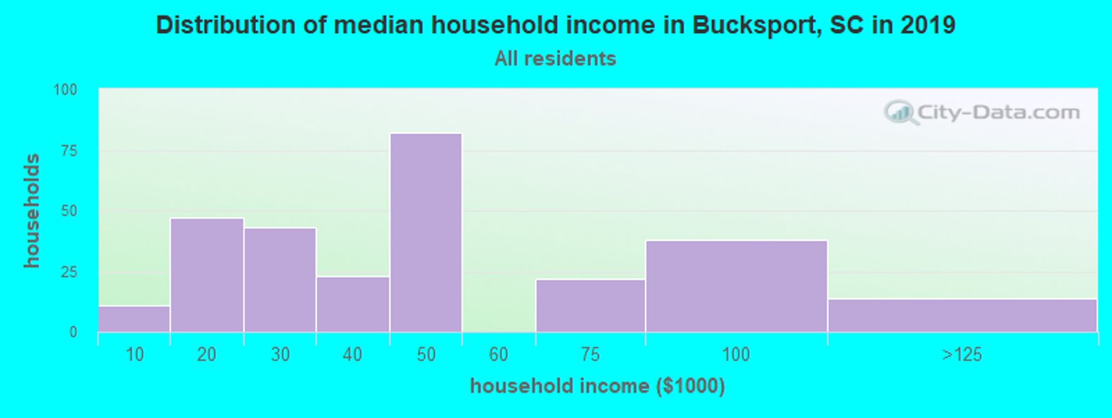
The Bucksport community is also a tourist destination that is well known for the Bucksport Marina, which is owned by the Grand Strand Water and Sewer Authority. At the marina there are floating docks, an RV campground, and kayak rentals (Ropp 2018). The Marina, however, experienced some damages from Hurricane Florence in 2018 from which they have been recovering from (“Conway Boat Marina” 2020). Looking at Bucksport’s median income, in 2019 the median household income is $41,662 whereas the median household income in South Carolina was $56,227 (Bucksport, South Carolina). This gap of household income proves the need for improvements in goal 8 decent work and economic growth.
Targets and Data: Two targets within Decent work and economic growth that Bucksport can improve on are targets 8.2 and 8.9. 8.2 focuses on diversifying, innovating, and upgrading economic productivity. Currently Bucksport is lacking in businesses and companies leading to limited jobs and economic growth. The target 8.9 focuses on creating beneficial and sustainable tourism. One possible improvement can be the addition of Gullah Geechee Community Day, like the past event Gullah Geechee Day hosted in Bucksport back in March of 2020. Another proposal from collaborators from Furman University is an artistic project (mural/sculpture) representing Gullah Geechee culture. According to the 2020 Market Report for Gullah Geechee Heritage Tourism, the potential leisure spend for the Gullah Geechee Corridor States is 34 billion dollars (2020 Gullah Geechee Heritage Corridor). There are also potential ecotourism prospects for the area, given its proximity to the Waccamaw Wildlife Refuge as well as the Waccamaw and Pee Dee rivers. These could include things such as campgrounds, river excursions from the marina, or wilderness tours into the refuge.
Goal Explanation: SDG goal number 3 focuses on good health and well-being, which consists of multiple factors like access to food, water, shelter, health, education, good social relationships, physical, energy and livelihood security, equity, cultural identity, material prosperity, spiritual satisfaction, freedom of choice, action and participation in society.

Introduction: Focusing on Bucksport’s values, the aspects that achieve good health and well-being are cultural identity, nature, shelter, health, and good social relationships.

Targets and Data: Bucksport has a strong representation and history of Gullah Geechee culture which is important to keep in mind when considering their good quality of life. The Gullah Geechee people values consists belief in God, community above individuality, respect for elders, kinship bonds and ancestors; respect for nature, and honoring the continuity of life and the afterlife (Gullah Geechee Corridor Organization). To achieve this goal, it is necessary to focus on cultural identity, respect for nature, and community above individuality. Conserving this historical land and culture is one keyway to achieve good health and well-being of Bucksport. To date there has been over 60,000 cases of COVID in Horry County. Bucksport was also heavily impacted by Covid-19. The figure below shows the spike of confirmed Covid-19 cases in September in Horry County as an example of the challenges posed to the community during the pandemic.
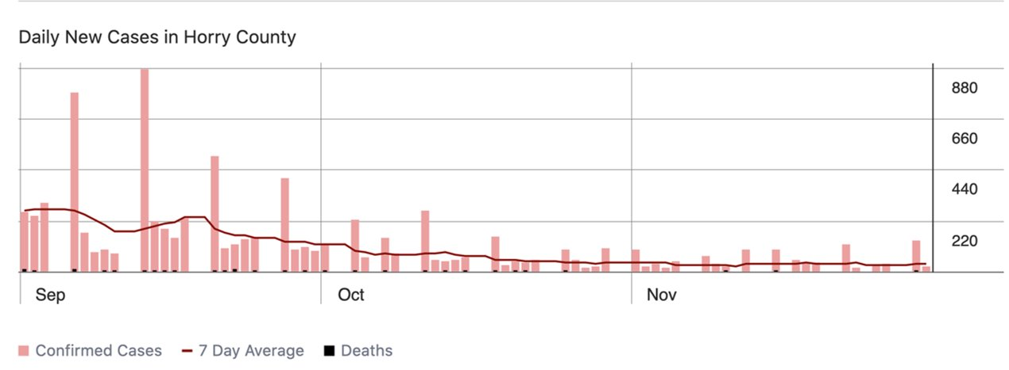

Goal Explanation: Taking urgent action to combat climate change and its impacts.

Introduction: Bucksport is currently experiencing various forms of climate change with more frequent flooding, hurricanes, extreme heat over the summer months. Developing a more detailed flood plan for the town of Bucksport is important to be able to promote the area as a carbon sink and allow the town to be promoted as one that is at the forefront of being a sustainable and green community in the future.

Targets and Data:
The SDG target 13.1 Strength Resilience and Adaptive Capacity centered around the ability for the community to be able to be both resilient and adaptive is something that is one hundred percent attainable. Bucksport is a prime community, a blank canvas, to introduce the concept of having a green community and one that is capable of being resilient and adaptive to any disasters or crises (natural, pandemic, etc). Target 13.2- Integrate Climate Change Measures into Policy and Planning focuses on climate change being present in governmental policies, planning, and strategies. Accounting for climate change and how it will affect Bucksport in the future is important when planning new infrastructure. The American Rescue Plan and the Flood Resilience Plan are examples of plans that can be used to build more sustainable infrastructure in Bucksport. However, climate action-based plans are longer lasting and include sustainable solutions to anthropogenic climate change. Current plans proposed by the county that include Bucksport do not mention climate change as a factor to be considered. We recommend that Horry County conduct local studies to assess and evaluate Bucksport to better find solutions with long-term effects. SDG target and indicator 13.3- Build knowledge and capacity to meet climate change is all about educating the community on what they can do to contribute and to spread awareness about the capacity they possess to become a green oasis here on the Grand Strand. Our work has been rolling out several studies and presenting them to the community along with community and county leaders. This will be the first step in creating a significant impact in this area that could prove invaluable to not only to the town of Bucksport, but the county as well as the state.

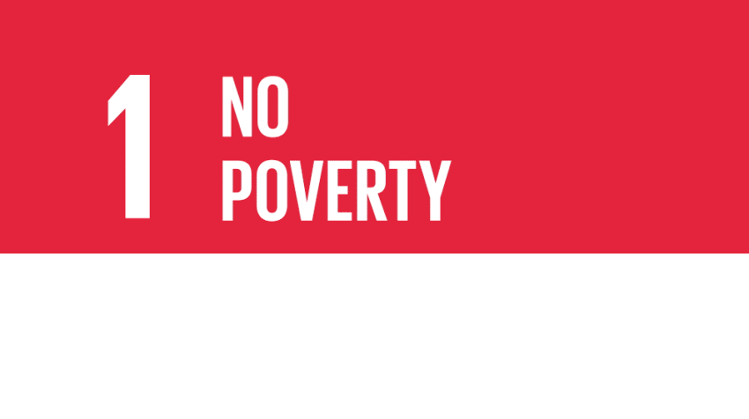
Goal Explanation: SDG Goal 1 focuses on ending poverty in all forms (United Nations Sustainable Development).
Introduction: Using the Census Reporter data, Bucksport’s poverty rate is 29.3%, which is more than double the rate in Myrtle Beach-Conway-North Myrtle Beach metro area being only 14.1%.
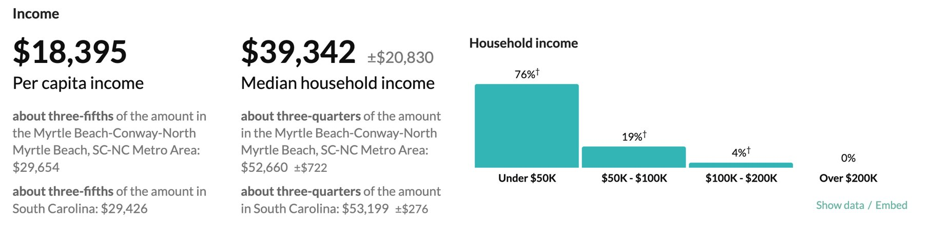

Targets and Data: The two targets that we are focusing on for improving no poverty in the Bucksport Community are 1.4 and 1.5. Target 1.4 focuses on Equal Rights to Ownership, Basic Services, Technology, and Economic Resources. One major issue Bucksport has is many of the residents are Heir’s property owners, which leads to complications when asked for proof of ownership along with getting funding from FEMA. Heirs' property is land passed down through generations without a will or deed. Historically, African Americans were unable to use legal systems to obtain titles because of economic disparities and discrimination (Heirs Property Retention Coalition). This has led to a large population of African American landowners with heir properties. More than half the population of Bucksport’s properties are heirs’ property. Recently it was stated that FEMA is changing some document rules to help families who live on heirs’ property (MSN News 2021). These changes include allowing residents to self-certify, and FEMA will be accepting letters from local officials and bills for home repair as proof of ownership. Target 1.5 focuses on building resilience to environmental, economic, and social disasters. Connecting this back to our basis SDG Goal 16 Peace, Justice, and Strong Institutions, strengthening the economy of Bucksport will make the area more viable for government assistance and protection as it becomes more valuable for the county and viable for further development.

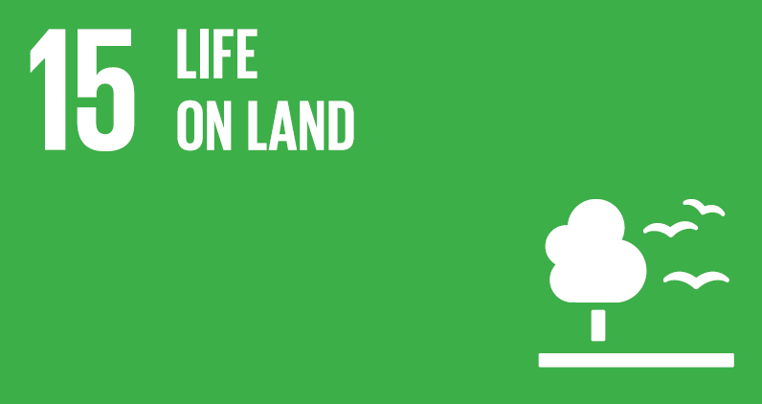
Goal Explanation: Goal 15 aims to protect, restore and promote sustainable use of terrestrial ecosystems, sustainably manage forests, combat desertification, and halt and reverse land degradation and halt biodiversity loss.
Introduction
The principal natural attributes of the community of Bucksport are the surrounding rivers, the Great Pee Dee River and the Waccamaw River. The Waccamaw is a “deep blackwater swamp stream characterized by numerous buttressed tree species” and the Pee Dee is a river that “flows through lowland swamps and scenic bluffs” and has “numerous oxbow lakes and sandbars” (US National Park Service, “Rivers- South Carolina”). Both rivers contain an abundance of wildlife and biodiversity. Other notable waterways in the area include Bull Creek, which is at the intersection of the major rivers, and Cowford Swamp, which is a tributary of Pee Dee.
The Waccamaw National Wildlife Refuge also surrounds the community of Bucksport. Within the 55,000-acre Refuge is a wide variety of ecosystems including forested wetlands, freshwater tidal marshes, and long leaf pine forests. Forested wetlands are “dominated by deciduous trees such as cypress, tupelo, red maple, elm, oaks, and gums” and have soils that are rich in minerals and organic material (US Fish and Wildlife Service). This ecosystem plays a critical part in filtering contaminants and sediment, which contributes to water quality, and storing floodwater to prevent downstream flooding. Freshwater tidal marshes make up six and a half thousand acres of the Refuge. This ecosystem also absorbs heavy rain to prevent flooding and filters contaminants. These marshes are influenced by the tide, but have little salt intrusion, and the conditions in this ecosystem made for great rice plantations in the eighteenth and nineteenth centuries. There are also long-leaf pine forests in the Waccamaw National Wildlife Refuge outside Bucksport. Longleaf pine forests are “one of the most species‐rich ecosystems in North America”, according to the US Fish and Wildlife Service, but due to logging and development in the area, the longleaf pines have lost over three quarters of their original forest cover. The refuge is home to many unique species like swallowed tailed kites, red-cockaded woodpeckers, and various migratory fish. The Waccamaw National Wildlife refuge is the northernmost nesting location for the swallowed-tailed kites, the woodpeckers are an endangered species that nest in the longleaf pines (US Fish and Wildlife Service). Keeping this area preserved and undeveloped helps to protect these species and many more and prevent flooding, which is a major threat to Bucksport.
The changes in forest cover and wetland area of Horry County are presented by NOAA’s CCAP Landcover Atlas. Between the years 1996 and 2016, the county lost 15.53% of its total forested area. Over 38 square miles (about the area of Manhattan) of this forest loss was due to development. When focusing the data area to the Waccamaw watershed instead of the county, the statistics are similar, with a 16.42% decrease in forest cover. In the Waccamaw watershed, these losses are also prominently due to development as well. Forest cover is crucial for maintaining soil fertility, the water cycle, and climate and air quality. To get more localized information on the immediate area of Bucksport, Google Earth Plus measuring tools were utilized. Bucksport's total land area is about four sqaure miles. Within their boundaries, there are eight major deforested areas which combine to be a total of about 1.21 square miles of deforested area. This accounts to 30% of the total land area of the community. The biggest cut area is utilized surrounding Grand Strand Water Authority’s facilities. These measurements do not account for the roads or individual residencies. Below is a figure that represents the rough deforested areas and the overall area of Bucksport.
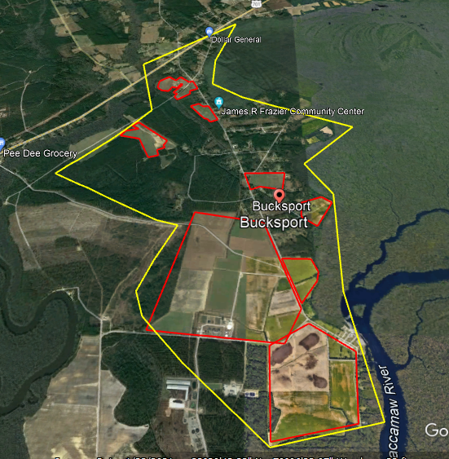
Information about soil types in the area of interest is given by USDA’s Web Soil Survey. The most abundant soil types are Lakeland sand, Hobonny muck, and Eulonia loamy fine sand. A quarter of Bucksport’s land area is Lakeland sand, which is part of the Lakeland series, characterized by very deep, excessively drained soil with rapid permeability and slow runoff (USDA, “Lakeland Series”). Hobonny muck makes up 16.5 % and is part of the Maurepas series. This soil also has very deep soil, but very poor drainage. These are organic soils that are formed in woody plant remains (USDA, “Maurepas Series”). 13% of Bucksport’s soil is classified as Eulonia loamy fine sand within the Eulonia soil series. This is “very deep, moderately well-drained soil” that is often found on upland and stream terraces (USDA- “Eulonia Series”). USDA also provided mineral deposit maps. Below is a localized geologic map of the community of Bucksport, taken from the Geologic Map of the Bucksville Quadrangle, showing that the most abundant mineral deposits in the area are barrier island reef deposits, estuarian deposits, and estuarine and marine deposits. Below the map are descriptions of what minerals are commonly found in each map unit (Doar 2014).
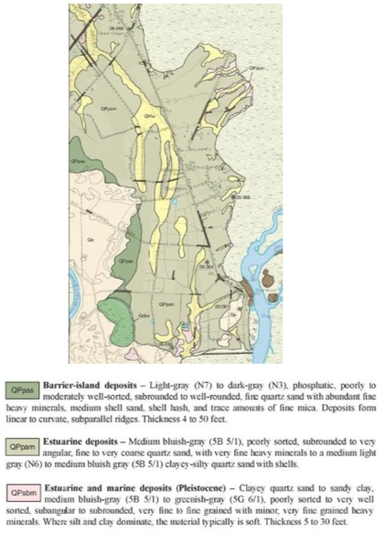

Targets:

The target indicators that Bucksport should be focused on are 15.2 and 15.9. 15.2 seeks to End Deforestation and Restore Degraded Forests. This target is crucial to help mitigate flooding. Since the area has lost so much of its forest cover, Bucksport is more susceptible to flooding, having lost its natural protective barriers. Dedicating some of the open space to replanting trees and creating natural areas could help the community in the long run. 15.9 encourages Integrating Ecosystem and Biodiversity in Government Planning. Bucksport’s location in the middle of the Waccamaw Wildlife Refuge is beneficial for this goal, since the refuge already has regulations and policies in place to protect biodiversity and ecosystems. The land in Bucksport outside of the refuge is not protected to the extent of the Refuge, though, which has allowed deforestation and overdevelopment to occur. Horry County has created an Imagine 2040 plan with a land use map that indicates they are taking into consideration the natural assets of the county. The most recent map amendments show sizable areas dedicated to conservation. This Scenic & Conservation land includes underdeveloped beachfront, estuarine and forested wetlands, and agricultural lands (Horry County Planning Commission). The consideration of natural attributes is a good first step in achieving this target.

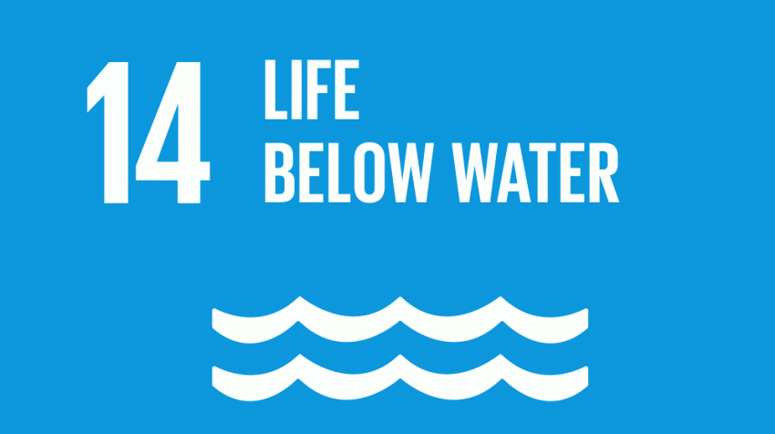
Goal Explanation: The focus of this goal is to conserve and sustainably use the oceans, seas and marine resources for sustainable development. Localizing this goal to Bucksport would mean conserving and protecting the resources in the Pee Dee and Waccamaw rivers.
Introduction:
Again, from NOAA’s CCAP Land Atlas we collected the data of wetland gains and losses over the time period between 1996 and 2016. Horry County has lost 5.32% of its total wetland area during this period. 74.75 square miles of Palustrine forested wetlands were lost. Palustrine forested wetlands are marshes and swamps that are some of the most productive habitats in the world, important for biodiversity and mitigating flooding. Below is the map provided by NOAA showing the areas of wetland loss in Bucksport.

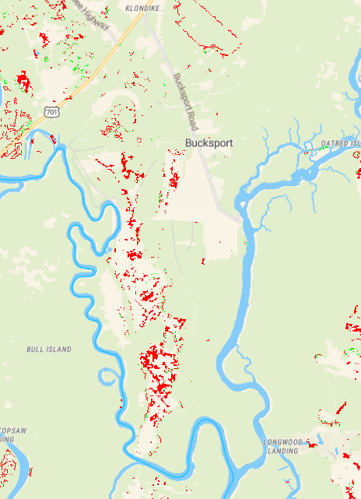

In the Waccamaw Wildlife Refuge, striped bass, American shad, blueback herring, and two endangered sturgeon species are among migratory fish species that live part of their lives in saltwater and swim up rivers to spawn (American Rivers, 2021). It is important to protect the Waccamaw and Pee Dee Rivers to ensure the survival of these endangered fish and fish that depend on them for migration and reproduction.

Targets and Data:
14.2 - Protect and Restore Ecosystems This SDG target would be applicable to Bucksport in relation to protecting the existing wetlands and restoring the wetlands that have been degraded or lost due to development. The health of the wetlands surrounding the community is arguably the biggest factor in preventing further flood risk to Bucksport. Research into the addition and maintenance of wetlands and vegetation in the area could be quite beneficial as they provide a buffer against flooding. (Hitchcock, 2021) In deep pool wetland areas, floating and submerged aquatics are recommended. For shallow pools, herbaceous plants are recommended. And the recommended plants for areas of upland soil are herbaceous plants and shrubs. Only native species should be planted. The planting strategies are as follows: a minimum of 50 herbaceous plants per 200 feet squared in shallow land area, centipede grass as a buffer, water plants frequently until established, add 4 inches of topsoil (Hitchcock).
SDG Target 14.7 looks at ways to Increase the Economic Benefits from Sustainable use of Marine Resources. The ocean and its tributary rivers provided many benefits in terms of ecosystem services which are crucial to species’ health, including humans. The rivers in Bucksport have the capacity to bring more benefits in terms of their economy as well as implementing Eco-tourism in Bucksport that involves the river would be one example of how to achieve this target. Eco-tourism involves visiting places where the natural environment or culture of the area is the main attraction. There are many benefits of eco-tourism including local economic improvement and growth in appreciation for the nature and culture of the local area. An example of eco-tourism surrounding rivers is the Blackfoot River Valley in Montana. Over the last decade, the community here realized that protecting and restoring their local river encourages recreation, connects the community to the river and creates an economic engine for the region. In 2013, nonresident visitors spent $972.9 million in this region (American Rivers). Bucksport has very unique ecosystems and natural attributes surrounding the Waccamaw River, so implementing ecotourism in a similar way to this region in Montana could bring great economic benefit to Bucksport while simultaneously bringing greater appreciation and value to the community as a whole.

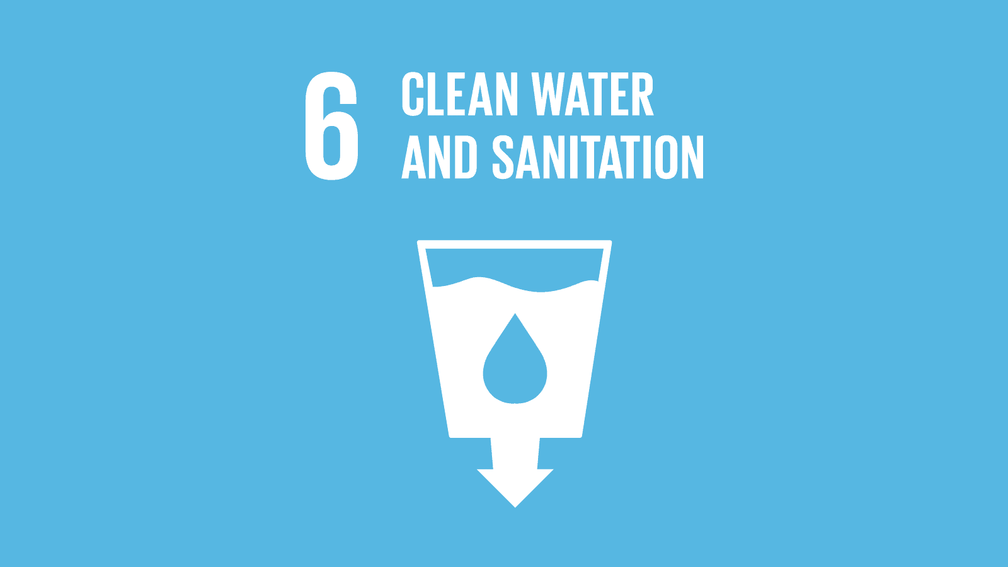

Goal Explanation: The focus of Goal 6 is to ensure availability and sustainable management of water and sanitation for all people.

Introduction
The community of Bucksport along with the rest of Horry County sources its water primarily from the Waccamaw River. The Grand Strand Water and Sewer Authority (GSWSA) is the major water supplier company for the county. Surface water is pumped from Bull Creek, located just south of Bucksport and is then treated at GSWSA’s Bull Creek Regional Water Treatment plant which is also located in Bucksport. Sourcing water from the rivers places a great importance on the water quality of these rivers. Water quality indicators include, but are not limited to, pH, turbidity, conductivity (dissolved solids), and dissolved oxygen. PH is a measure of how acidic or basic the water is, with a measure of 7 being neutral. Low or acidic pH’s can indicate pollution. The recommended range given by the EPA for municipal water suppliers is between 6.5 and 8.5. Dissolved salts and inorganic chemicals conduct an electrical current in water, so conductivity is also a useful measure of water quality. Significant increase in conductivity could indicate pollution, as well.
Turbidity is a measure of the number of suspended particles in the water that can come from soil erosion, runoff, discharges, stirred bottom sediments or algal blooms. A turbidity reading below 5 NTU appears clear, while a reading of 55 NTU will start to look cloudy, and a reading over 500 NTU will appear completely opaque.
Dissolved oxygen is another important indicator of water quality. It is essential for the survival of fish and other aquatic organisms. Oxygen dissolves in surface water due to the aerating action of winds. Oxygen is also introduced into the water as a byproduct of aquatic plant photosynthesis. When dissolved oxygen becomes too low, fish and other aquatic organisms cannot survive. Oxygen levels also may be reduced when there are too many bacteria or algae in water. DO levels below 3 milligrams per liter (mg/L) are of concern and waters with levels below 1 mg/L are considered hypoxic and usually devoid of life (EPA).
The Waccamaw Watershed Academy supplies information about these water quality indicators. From the time span of June 6, 2020, to August 25, 2021, the median measurements of these indicators are as follows: 6.30 pH, 4.89 NTU (turbidity), 70 µS/cm (conductivity), and 5.13 mg/L (dissolved oxygen). These values signify adequate water quality, but water quality is subject to impacts from flooding and storms. Stormwaters can introduce pollutants and toxins into the water in the form of runoff from agriculture or residential developments.
Targets and Data:

We are looking at how to achieve targets 6.3 and 6.6 to maintain water quality in Bucksport. 6.3 strives to Improve Water Quality, Wastewater Treatment, and Safe Reuse. Keeping track of water quality in the Waccamaw River is a great first step in reaching this target, which is being done by the Waccamaw Watershed Academy. The next and most important step in ensuring future water quality is to focus on the goals that prevent further flood risk.
6.6 Protect and Restore Water Related Ecosystems is another target for Bucksport to work towards. Water related ecosystems include “mountains, forests, wetlands, rivers, aquifers, and lakes” which are “vital to providing social and economic benefits for people. The declining condition of the ecosystems directly impacts water availability as well as other essential services such as biodiversity, food production and flood control” (Coope, et al, 1). This goes along with Life Below Water’s 14.2 indicator that would urge Bucksport to protect and restore degraded wetlands and forests to prevent flooding in the community while also improving the economy.

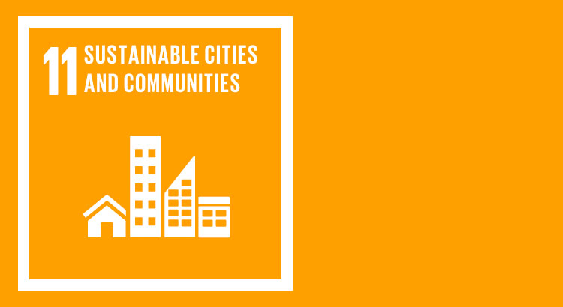
Goal Explanation: Sustainable Development Goal number 11 focuses on making cities and human settlements sustainable, resilient, safe, and inclusive of all persons.
Introduction: Bucksport has repeatedly been affected by flood events without the proper aid to rebuild and rebuild sustainably. One reason rebuilding is difficult has to do with the fact that more than half of the properties in Bucksport are heirs property. Heirs property is property passed down through generations without written documentation, such as wills and deeds. When applying for aid from natural disasters, it is difficult to show ownership without documentation (Heirs Property Retention Coalition). Another reason rebuilding is a challenge is because of the frequency of flooding occurring in the area. There is not enough time in between storm event to rebuild properties and allow the community to recover. This also demonstrates that the systems in place to deal with flooding are not equipped to handle the current levels and frequency of the floods.
Targets and Data: Target 11.1 - Safe and Affordable Housing is to ensure access to safe, affordable, and adequate housing, along with basic services. Target 11.5 - Reduce the Adverse Effects of Natural Disasters is to lessen the number of deaths and people affected by disasters. It is also dedicated to decreasing the direct economic losses related disasters. Water-related disasters are included in this target, as well as focusing on the protection of poor and vulnerable people. An updated resilience plan would be essential in reducing the effects of natural disasters. Flood mitigation and viable roadways during disasters would be beneficial to the community. An in-depth study of the people and environment would give Horry County insight on problems unique to Bucksport. It may also reveal solutions that have not been explored previously. A current Flood Resilience draft proposed by the county is one way both targets can be reached. Bucksport is explicitly mentioned in the plan and are one of the areas considered a vulnerable community (Horry County, 2021).
The current draft focuses on impervious infrastructure as the solutions to the flooding, such as concrete roads. The plan does include flood maps, but hydrologic studies will be needed in order to truly know how to help the Bucksport community. There is mention of contact with the community, but based on our interactions with community members, not all of the community is reached pertaining to county related meetings.
The plan does not include green infrastructure. Green infrastructure is infrastructure that is resilient while managing environmental impacts that would benefit the community. Green infrastructure is also cost-effective. An example of green infrastructure is a rain garden. Rain gardens are small, shallow areas with plants that collect stormwater runoff. They are meant to allow water to flow naturally and be absorbed into the ground (Environmental Protection Agency). The current draft should include green infrastructure as solutions instead of focusing on concrete-based solutions. Current solutions for Bucksport in the Flood Resilience Plan do not have empirical data from Bucksport to support that the solutions would be applicable and lasting. We would advise that the draft be updated to include specific needs of vulnerable communities impacted. Part of the Flood Resilience Plan includes buy-out programs that Horry County would offer (Horry County, 2021). This may be seen as a way to get people back into safe homes outside of the flood zones. Further survey data and community engagement needs to be conducted to better reflect the needs and desires of the residents, combined with accurate and current scientific data.

IPBES
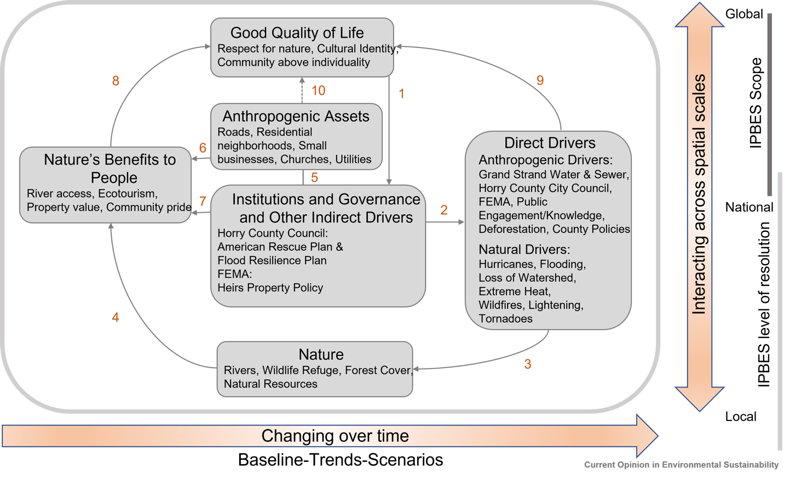
This conceptual framework diagram, first created by IPBES (Intergovernmental Panel on Biodiversity and Ecosystem Services), was edited to outline the connection between nature and residents of the Bucksport community. The natural components of Bucksport primarily consist of the Great Pee Dee and Waccamaw rivers, which surround the community and contains an abundance of wildlife and biodiversity. The anthropogenic assets consist of built infrastructure, health facilities, knowledge, technology, and financial assets. There is a variety of benefits of nature to the people of Bucksport, with the main benefit being access to rivers. The main institutions and governance of the community include Horry County Council and FEMA and other indirect drivers include policies and plans. Direct drivers are defined as forces of human-and naturally- induced stresses to ecosystems at multiple spatial and temporal scales (usgs.gov). Each of these aspects combined can be used to determine a good quality of life. According to the IPBES conceptual Framework article, good quality of life consists of multiple factors “access to food, water, shelter, health, education, good social relationships, physical, energy and livelihood security, equity, cultural identity, material prosperity, spiritual satisfaction, freedom of choice, action and participation in society”.

Disaster Risk Reduction
The Sendai Framework on Disaster Risk Reduction is an agreement between 187 countries to reduce disaster risks that involve loss of lives, livelihoods, health, economic activity, environmental assets, and cultural importance. This goal will be executed by implementing “integrated and inclusive economic, structural, legal, social, health, cultural, educational, environmental, technological, political and institutional measures that prevent and reduce hazard exposure and vulnerability to disaster, increase preparedness for response and recovery, and thus strengthen resilience” (Sendai Framework). Political involvement must be present for this goal to be achieved. State level governments, local governments, the private sector, and non-state entities must collaborate for the plan to be enacted effectively.
Along with the Sendai Framework, the Sustainable Development Goals were created to target problems and solve them with sustainable solutions. These solutions are meant to balance the aspects of the environment, economy, and society with each other. There are 17 Sustainable Development Goals, and 3 of those relate to the Sendai Framework. Goal 1 is to end poverty, in all its forms, everywhere. Goal 11 seeks to make cities and human settlements inclusive, safe, sustainable, and resilient. Finally, Goal 13 is to take action to combat climate change and its effects. The Sendai Framework has indicators to measure and monitor the progression of the implementation of the Sustainable Development Goals. There are 5 indicators. The first of which is the number of deaths, missing persons, and people affected by the disaster per 100,000 people. This indicates poor management in the areas of all three Sustainable Development Goals 1, 11, and 13. The next indicator is the direct loss from disasters in relation to the global gross domestic product. This indicator relates to Goal 1, to end all poverty. Losing global GDP to disasters shows that the country may have issues with poverty. Another indicator is direct economic loss from disasters, as well as damage to critical infrastructure and disruption of simple services. This indicator is related to Goal 11 and reflects that the city affected was not in fact safe or resilient. The fourth indicator is the number of countries with national and local risk reduction strategies. The last indicator is the proportion of local governments that adbot and implement local disaster risk reduction strategies that are in line with the Sendai Framework for Disaster Risk Reduction. The fourth and fifth indicators relate to all three Goals, 1, 11, and 13. Government policies in relation to sustainability reflect what societies have and lack in resilience (Sendai Framework).
In relation to Bucksport, Hurricane Florence was looked at specifically to collect measurements since community members expressed that this hurricane had worse flooding than those in the recent past. Hurricane Florence is the event that residents recognize as having flooded more than usual than previous storms. The flooding from Hurricane Florence lasted days after the storm had already passed. Flood waters from North Carolina were deposited in the Intercoastal Waterway and traveled down into South Carolina. The Waccamaw river beat previous flood records by 4 feet, cresting at 22.1 feet. In Horry County, there was $607 million dollarsworth of damage. The amount of money lost in Horry County indicates a problem with poverty, Goal 1, within the county. 11,836 homes had moderate to severe flood damage. 455,000 people had to be evacuated from their homes after the storm. While there were few deaths, the sheer number of people affected by the flooding demonstrates that the county is not resilient enough to deal with severe flooding. This is related to Goal 11 and 13, sustainable infrastructure and climate change. About one thousand homes and businesses along the Waccamaw river were affected (National Weather Service 2019). Almost half of the properties in Bucksport have a 26% chance of being severely flooded. Severe damage to infrastructure demonstrates that the community needs new infrastructure that will be resilient in future flooding. This reflects where the community is in relation to Goals 11 and 13, sustainable infrastructure and climate change. The risk of properties flooding in Bucksport continues to increase (NOAA (National Oceanic and Atmospheric Administration)). There is no clear amount of how many businesses in Bucksport were affected. However, roads flooding around the town cut off access from aid and any outside chance of economic activity.
Bucksport itself does not have its own resiliency plan. Horry County has recently made its Flood Resilience Master plan draft public this past September. The Horry County Flood Resiliency Plan will affect areas located along the Waccamaw and Pee Dee Rivers as well as the Intercoastal Water Way. The resiliency plan is meant to produce strategies for reducing flood risks in the previously mentioned areas. The amount of federal and local funds being designated for this plan is $400,950. A buyout program has also been created, which has been approved for $13 million in funding.
Within the section of the Horry County Flood Resilience Master Plan Draft titled “Policy and Project Considerations,” policy development, resilient neighborhood design strategies, resilient infrastructure considerations, and community engagement/planning are examined. Although the Master Plan draft heavily includes the Bucksport community, the policy and project considerations may not be entirely beneficial to the community. Raising freeboard levels is a main objective of policy development, but this would only impact future infrastructure rather than preexisting infrastructure.
The buyout program is also included within the policy development. This program focuses on purchasing homes that have been severely impacted by flooding. Many members of the Bucksport community have a rich family and social history surrounding the area, so they would not wish to sell their homes. Therefore, this would not be a feasible option. However, other policies and projects included in the master plan draft, such as the preservation of the floodplain, creation of riparian and wetland buffers, and expanded tree preservation standards, could prove beneficial to the Bucksport community. Respectively, the plans for each policy/project entail adopting stricter floodplain boundaries, establishing a buffer composed of trees and shrubs to surround rivers, and the required preservation of 10% of predevelopment tree canopy. Each plan would help in reducing the impact of flooding. Overall, there are many proposed benefits contained within the master plan draft, but not all will be beneficial to the Bucksport community.
Recommendations for the Future
- Lifting the roads that flood in these communities - use NOAA (National Oceanic and Atmospheric) flood viewer to justify
- Affordable housing that is flood safe - use Social Vulnerability data to justify
- Broadband facility for computers and Internet with ability to have high def zoom capability for education and pandemic-related needs - look for broadband capability and educational levels for community to justify, Providing a space for telehealth, transportation
- Reforestation - use floodwater commission report to justify
- Bucksport - develop Gullah tourism, eco-tourism

Bucksport has one main road that goes from Highway 701 to the marina, Bucksport Road. This road connects all the other roads in town to the highway. A major issue the town faces is that the road is vulnerable to flooding, the hazard levels of which can be seen in the Flood Exposure Mapper from NOAA below. This presents a big problem as it can literally cut the town off from getting aid or evacuating during a serious flood. As the mapping also shows, many of the other roads in the community are at risk of flooding as well. The best use of emergency funds would be to lift the roads and to improve drainage systems like ditches.
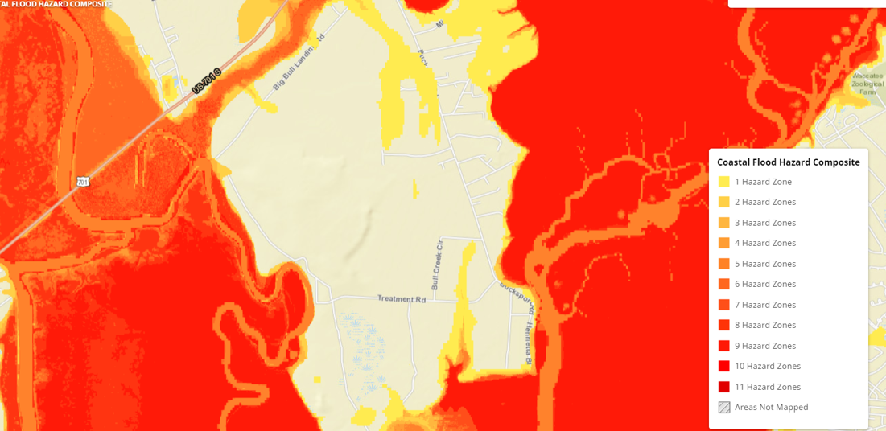
The vulnerability index is a tool used by the CDC to map and identify areas that may need government support due to some sort of hazardous event. Bucksport is a part of Horry County which has a Social Vulnerability Index rating of 0.594 (0 being low vulnerability, 1 being high vulnerability). This classifies the area as having a moderate to high level of vulnerability. Considering the size of Bucksport, its proximity to the waterways causing flooding, and the lack of aid so far, it is fair to assume that the community would have an even higher vulnerability rating than the rest of the county. This information signals that the county should be allocating funds to help provide the citizens of Bucksport with affordable housing built to withstand any flooding that may occur.
The pandemic has put a lot of emphasis on the importance of being connected via the internet and other services. COVID has also shown us that there are many areas, particularly rural and low-income ones, that need to have those services improved and expanded upon. A portion of the Coronavirus Relief Fund (CRF) has been set aside to do just that in South Carolina. Bucksport has not been identified as one of the areas in need by the ORS staff research. It would be worth pursuing, as improved broadband for the town would allow better communication for things such as telehealth, teleworking, and distance learning for education. Adding a facility for the community to make use of the broadband would also be prudent, perhaps establishing a sort of internet café at the community center for example.
As suggested by the South Carolina Flood Commission, reforestation should be considered to help provide a buffer against flooding. (South Carolina Floodwater Commission, 2019) Forests and trees can prevent flooding in several ways, including reducing runoff and reducing the erosion and sedimentation of the waterways. Trees also provide a natural buffer against flooding as the presence of the roots naturally obstructs the path of the water and keeps the soil from washing away. To put it simply; the more forest that is present, the more water will be absorbed and not contribute to the flooding. Land without trees, particularly land that has been covered by impermeable surfaces like parking lots or buildings, absorbs far less water and makes areas more prone to flooding.
Considering Bucksport has an extensive and valuable history of Gullah Geechee culture, it is important to keep that as a main aspect to move forward with in the future. Working with Furman University students Sydney Spires, Jeanna Cline, and Meghan Salm we developed the idea of promoting Gullah Geechee Tourism along with preservation of the history and culture. Projects to work on in the future are a Gullah Geechee Community Day, an artistic project, and a video outlining the importance of preserving this culture. The town is also near the Waccamaw National Wildlife Refuge, allowing easy access to over 26,000 acres of pristine wilderness. This makes the area a perfect spot for eco-tourism, as the closeness of the river and refuge could make Bucksport a good place to stay for people who wish to explore the area and enjoy the nature around them.
Your final sustainability assessment should contain the following sections:
- Introduction/Conclusion 5/5 well done

2. Statement of your unit of analysis and the scales that impact your community 5/4- more delineation of the stakeholders and their level, ie, county – Horry; local- betterment of bucksport assoc…..; still didn’t mention the specific stakeholders and there was no mention of hate assoc or even a thank you as a footnote.
3. Framework – explain a bit about the UN SDGs and why you use them in your analysis; explain
how you frame the SDGs (the ppt you created in class) and why 10/10
4. Methodology – methods and tools used and the timeline (ie, August through Nov 2021); please
acknowledge assistance from Alex from Furman, for example. 5/4- lack of interviews; be sure you state the meth- interviews, observations, etc… see your reading on researching sust for examples. A clear explanation is still needed
5. An evaluation of all of the goals and targets you list in your framework with an accompanying
narrative of how your community is/is not meeting those goals and targets 25/25- MUCH improved!
6. Draw systemic and integrated connections among and between goals (ie, think of the IPBES
diagram from our Oct 28 work) 5/5
7. Include how equity, peace, and justice are part of your analysis and where they impact your
framework and community through evidence 10/9- no data on heirs prop; no data on SDGs and equity report re: SC that we used in class; equity report is still not cited here
8. Be sure to include disaster risk reduction (ie, the Sendai Framework) and how it integrates into
your analysis (think the section from Oct. 19) 10/10 well done
9. Include empirical evidence (scientific studies and tools, interviews, observations, original
documentation, photos, videos) and cite it throughout in-text via parenthetical citations 10/7- citations are not Chicago method; go through the entire document and cite properly, please. This is important because readers will look for your sources. That is what validates your report. Please be more careful here.
10. Use the SDG Goal logo squares to begin a discussion of each SDG in your model (see the
Pittsburgh report for style example here: https://sdgs.un.org/sites/default/files/2020-
12/Pittsburgh%20VLR%202020%20Final%20Draft.pdf)
11. Your analysis of where your community is in relation to the SDG targets and indicators you have
selected. 5/4- you don’t say where the community is in each section as related to the targets; how are they doing?
12. Recommendations for the future 5/5- needs Development
13. Chicago method citation in text, bibliography at the end
14. Diagrams, graphs, pictures strongly encouraged
15. Professional presentation of the document
16. Cover page with list of author names alphabetically, or in order of writing participation if it is not
equal; photo or image for the cover page
17. Validate all statements with data, please (ie, triangulate as best you can)
18. Excellent grammar, structure
19. Be sure you edit the document prior to turning it in.
20. #13-19 = 5/4- fix citations

77/100- great work so far; keep going and validating your statements with empir evidence
92/100- please fix everything I note and send to me ASAP. I will be sure to publish your work once this is done. Thank you and congratulations on great work!

Citations
“Bucksport, South Carolina.” Best places to live in Bucksport, South Carolina, 2021. https://www.bestplaces.net/city/south_carolina/bucksport.
Bucksport, South Carolina.” Bucksport, South CAROLINA ECONOMY, 2021. https://www.bestplaces.net/economy/city/south_carolina/bucksport.
“Bucksport, South Carolina.” Bucksport, South Carolina (SC 29527) profile: population, maps, real estate, averages, homes, statistics, relocation, travel, jobs, hospitals, schools, crime, moving, houses, news, sex offenders. Accessed November 18, 2021. https://www.city-data.com/city/Bucksport-South-Carolina.html.
“CCAP Landcover Atlas.” NOAA- Office for Coastal Management. Accessed October 31, 2021. https://coast.noaa.gov/ccapatlas/.
“CDC's Social Vulnerability Index (SVI).” Centers for Disease Control and Prevention. Centers for Disease Control and Prevention. Accessed November 19, 2021. https://svi.cdc.gov/map.html
“Census Profile: Bucksport, SC.” Census Reporter. Accessed November 19, 2021. https://censusreporter.org/profiles/16000US4510000-bucksport-sc/.
Coastal Flood Exposure Mapper. Accessed November 19, 2021. https://coast.noaa.gov/floodexposure/#-8807537,3987116,15z.
Coope, Joe, and StellaJoy Director Active Remedy Ltd. “The Sdgs Target Protection of Water-Related Ecosystems, but How Do We Measure Progress?” Water, Land and Ecosystems, November 20, 2020. https://wle.cgiar.org/thrive/2017/11/13/sdgs-target-protection-water-related-ecosystems-how-do-we-measure-progress#:~:text=Water-related%20ecosystems%2C%20including%20mountains%2C%20forests%2C%20wetlands%2C%20rivers%2C%20aquifers%2C,such%20as%20biodiversity%2C%20food%20production%20and%20flood%20control.

“Conway Boat Marina & RV Campground.” Bucksport Marina, January 4, 2020. http://bucksportplantation.com/bucksport-marina/.
“Custom Soil Resource Report for Georgetown County, South Carolina, and Horry County, South Carolina.” Web Soil Survey. USDA, October 27, 2021. https://websoilsurvey.sc.egov.usda.gov/WssProduct/xvzt23s22zck2ahtdgl4vwve/GN_00000/20211027_18252006468_1_Soil_Report.pdf.
Diaz, Sandra, Sebsebe Demissew, Julia Carabias, Carlos Joly, Mark Lonsdale, and Neville Ash. Rep. The IPBES Conceptual Framework - Connecting Nature and People, 2015. https://ipbes.net/sites/default/files/downloads/pdf/Diaz_et_al._2015_IPBESConceptualFramework.pdf.
Environmental Protection Agency. “Green Infrastructure: What Is Green Infrastructure?” EPA. Environmental Protection Agency. Accessed November 20, 2021. https://www.epa.gov/green-infrastructure/what-green-infrastructure#raingardens.
“Eulonia Series.” USDA Soil Series, September 2004. https://soilseries.sc.egov.usda.gov/OSD_Docs/E/EULONIA.html.
“FEMA Closes the Gap That Has Kept Many Black Families in the South from Receiving Disaster Assistance.” Yrt News, September 2, 2021. https://yrtnews.com/fema-closes-the-gap-that-has-kept-many-black-families-in-the-south-from-receiving-disaster-assistance/.
“Flood Resilience Master Plan.” horrycounty.org, 2021. https://www.horrycounty.org/portals/0/docs/resiliencyproject/10.01.21FloodResilienceMasterPlanDRAFT.pdf.
“Goal 11 | Department of Economic and Social Affairs.” United Nations. United Nations. Accessed November 20, 2021. https://sdgs.un.org/goals/goal11.
“Goal 13 | Department of Economic and Social Affairs.” United Nations. United Nations. Accessed November 19, 2021. https://sdgs.un.org/goals/goal13.
“Gullah Geechee Cultural Heritage Corridor Commission.” Gullah Geechee Cultural Heritage Corridor, n.d. https://gullahgeecheecorridor.org/thegullahgeechee/.
Hitchcock, Daniel. “Natural and Engineered Wetlands for Stormwater Management.” Tennesee.edu. Accessed December 7, 2021. https://ag.tennessee.edu/watersheds/Documents/9.%20Wetlands_hitchcock_final.pdf.

“Indicators: Dissolved Oxygen.” EPA. Environmental Protection Agency. Accessed December 7, 2021. https://www.epa.gov/national-aquatic-resource-surveys/indicators-dissolved-oxygen.
“Lakeland Series.” USDA Soil Series, September 2004. https://soilseries.sc.egov.usda.gov/OSD_Docs/L/LAKELAND.html.
Ropp, Kathy. “Bucksport Marina Trying to Recover.” MyHorryNews.com, November 9, 2018. https://www.myhorrynews.com/news/local/bucksport-marina-trying-to-recover/article_50fc7cec-ddea-11e8-9a2d-6f38089cbf33.html.
“Sendai Framework.” UNECE. Accessed October 19, 2021. https://unece.org/sendai-framework.
United Nations. “United Nations Official Document.” Sustainable Development Goals. United Nations, September 25, 2015. https://www.un.org/ga/search/view_doc.asp?symbol=A%2FRES%2F70%2F1&Lang=E.
“U.S. Census Bureau Quickfacts: Horry County, South Carolina.” United States Census Bureau, 2020. https://www.census.gov/quickfacts/horrycountysouthcarolina.
US Department of Commerce, NOAA. “Hurricane Florence: September 14, 2018.” National Weather Service. NOAA's National Weather Service, May 7, 2019. https://www.weather.gov/ilm/HurricaneFlorence.
“Western Fisheries Research Center.” Drivers of Ecosystem Change | USGS.gov. Accessed October 31, 2021. https://www.usgs.gov/centers/wfrc/science/drivers-ecosystem-chan
Waccamaw Watershed Academy. “Volunteer Water Quality Monitoring Program Database Access.” Accessed September 9, 2021. http://bccmws.coastal.edu/volunteermonitoring/index.html.
“Welcome to the Waccamaw.” arcgis.com. American Rivers. Accessed September 9, 2021. https://www.arcgis.com/apps/Cascade/index.html?appid=83e32138edac46b0abd6d2e93d4463ba.
“Waccamaw - Waccamaw - U.S. Fish and Wildlife Service.” U.S. Fish & Wildlife Service. Accessed September 10, 2021. https://www.fws.gov/refuge/Waccamaw/.

“2020 Report Market for Heritage Tourism Gullah Geechee ...” Accessed December 7, 2021. https://ncgrowth.unc.edu/wp-content/uploads/2021/04/2020_Gullah_Geechee_Corridor_Heritage_Tourism_Study-1.pdf.

