Appendix 1 – symposium evaluation summary
Total Symposium Attendees | 174
Total Evaluation Responses | 148
ID Books Posted | 106

Please rank each of the following
 | Very Poor | Poor | Average | Good | Very Good
Quality of Presentations | 0 | 0 | 0 | 14 | 134
Quality of Live Demonstrations | 0 | 0 | 1 | 26 | 121
UWS Site and Facilities | 0 | 0 | 1 | 15 | 132

Would you be interested in any other Native Bee programs in the future? | YES (%) | NO (%) | UNSURE (%)
 | 94 | - | 5

Appendix 2 – online survey data summary
- Questionnaire for Phase 2 seminars, five sites, 112 attendees, 52 responses.
The graph below summarises the responses to the questions,
How would you rate your knowledge of Australian native bees?

Are you willing to participate in the Bee monitoring program in your community garden?
Yes – 81%, No – 19%
- Results from survey monkey responses (58 responses)
When asked
Would you like to see similar projects conducted throughout Australia?
93% answered yes
How are you involved in the project?

How would you rate your level of knowledge on Australian native bees, before and after the project?

Appendix 3 - Summary of engagement
Based on the online survey, 22% of respondents attended more than one educational session (Phase). And based on the symposium evaluation data 70% of the attendees had not attended any of the Phases. According to the online survey 72% of respondents engaged in the Facebook group only. Based on these data the following table outlines the estimated number of individuals engaged through the Bee Aware of Your Native Bees project.
TABLE 1: Individuals Engaged via Activity
Activity | Individuals engaged
Phases 1 – 5 | 205
Symposium | 146
Facebook group members | 596
Total | 947

Activity | Overall potential engagement through project
Phases 1 – 5 | 263
Facebook group members | 828
Symposium (including staff) | 186
ID Guide book | 500
Youtube viewings | 485
Total | 2,262

Appendix 4 – maps of project reach
Map of regions where project has reached people though face to face educational sessions or social media.
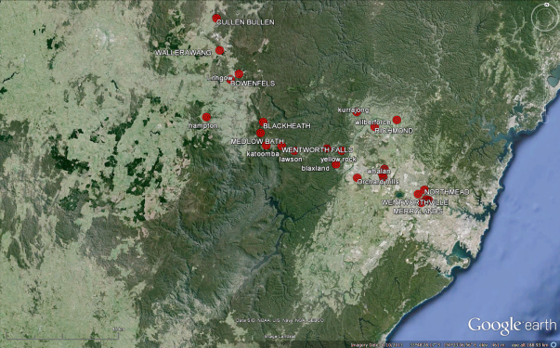
Figure 1 Regions within the LGA site target areas
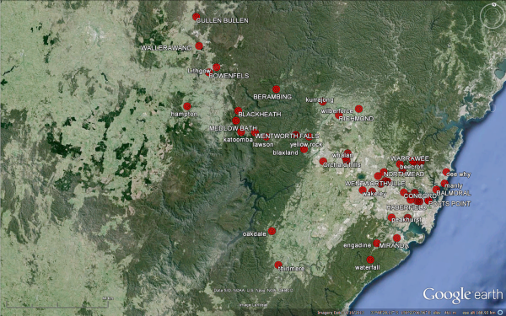
Figure 2 Regions where social media participants reside within the Sydney basin
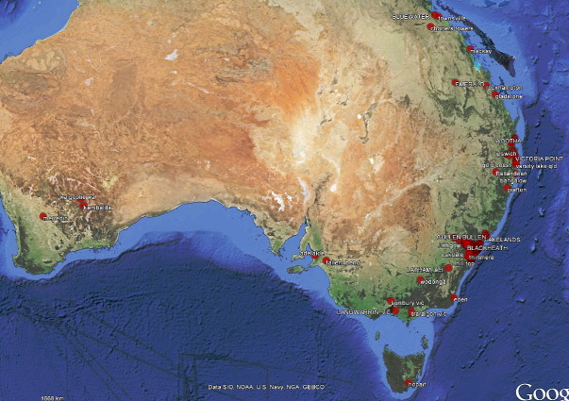
Figure 3 Reach of project throughout Australia
Appendix 5 – site insect activity observed
Site | Bee species (n) | Other Insects (n)
Blue Mts | 3 | 3
John Irving | 6 | 2
Pioneer Village | 2 | 2
Mamre House | 4 | 8
Eskbank House | 3 | 1
Total No. bees identified during project (with FB) | 28 | Created another FB group

