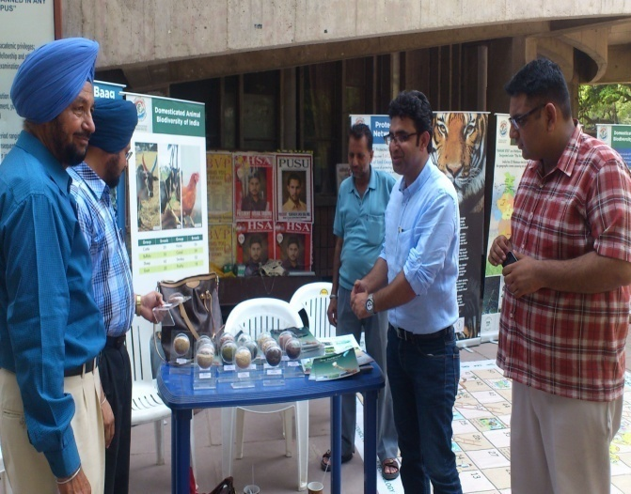 | 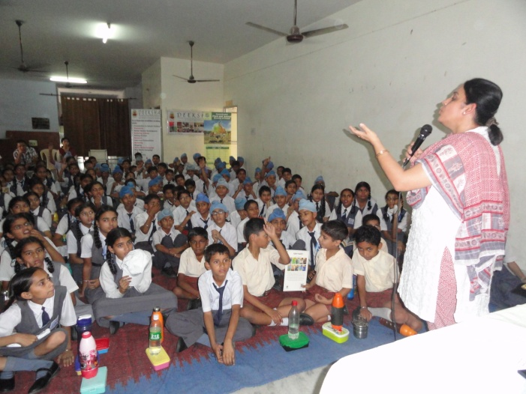
Exhibition at Students’ Centre, Panjab University, Chandigarh | IBD Day Celebration at Sant Isher Singh School, Mohali

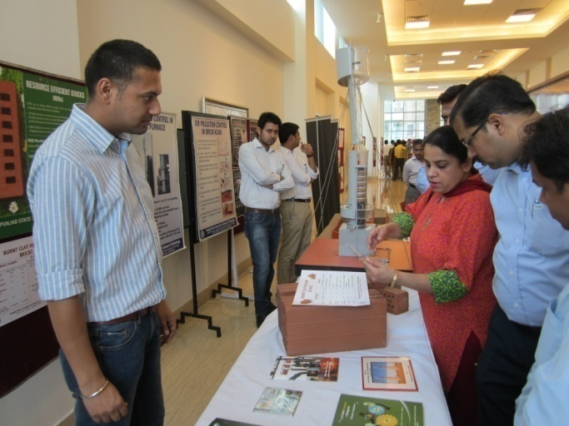 | 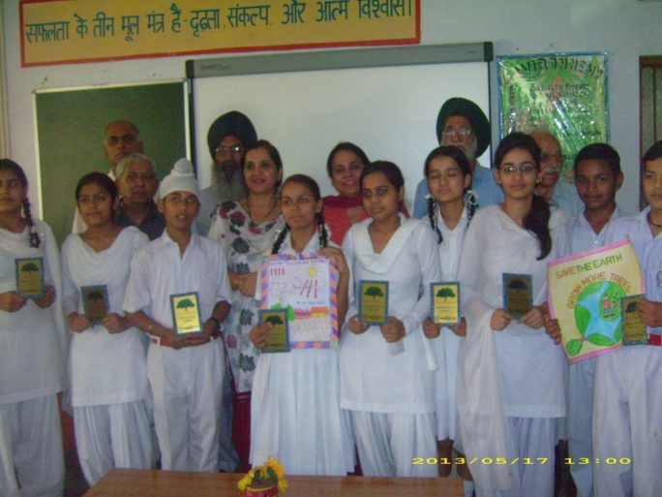
Exhibition at Indian School of Business (ISB), Mohali | Celebration at Shastri Model School, Mohali

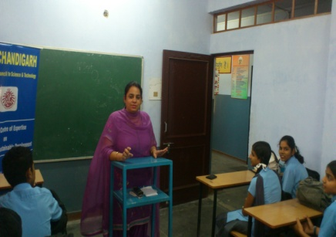 | 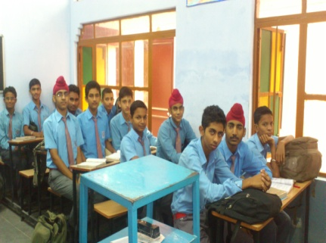
Ozone Day Celebration at Shastri Model School

