2012 RCE Award Application on Education for Sustainable Development Initiatives

Category 1
Contribution to innovative multi-stakeholder learning and educational processes for sustainable development.
This category recognizes creative projects, activities and initiatives that foster multi-stakeholder learning to improve sustainability practices in a specific context. Principles, values and practices of sustainable development underpinning emerging learning and educational processes should be clearly described. The projects could also deal with development of competencies and capabilities of local partners (e.g. teachers, NGOs, representatives of local communities, higher education institutions, governments, businesses) for addressing sustainability.

It is also worth considering project qualification under Category 6
(Application of innovative networked governance strategies)

Section 1
Seeds of Promise (SoP) is a 501c3 organization formed and built within a marginalized community in Grand Rapids, MI. Along with over 50 endorsing partner organizations, SoP has developed a community based, sustainable neighborhood initiative with the intent to positively transform the social, environmental and economic conditions for children, families and businesses.
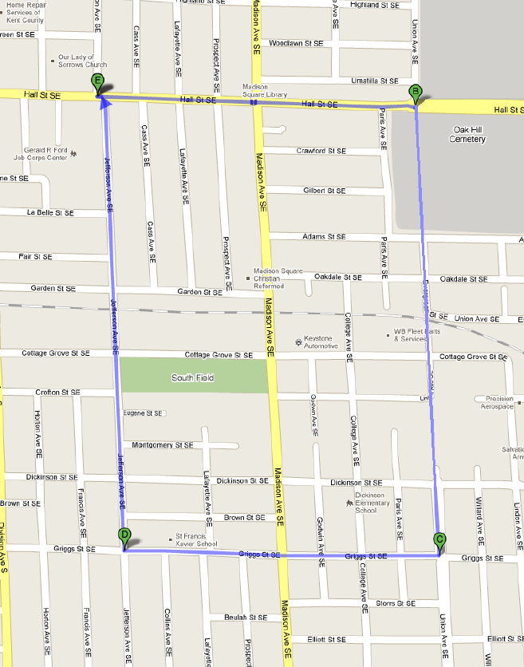
The focus of our activities, programs, and initiatives has been within an inner City of a Grand Rapids neighborhood whose residential population is 1800 and has its borders Jefferson to Eastern (West to East) and Hall to Griggs (North to South). The demographics include an estimated: 70% African American residents; 25% Latino and Hispanic residents; and a poverty rate of 35%.
The Seeds of Promise residents, as with residents of many inner city neighborhoods, face a number of daily issues and challenges including:
- Employment opportunities
- Health, wellness and nutrition concerns
- Access to community capital and resources
- Neighborhood revitalization and rebuilding of a safe community
- Youth leadership development
- Educational attainment opportunities for local residents, families and children
- Access to a local housing
Seeds of Promise is a faith directed, grassroots neighborhood initiative, dedicated to meeting the expressed resident needs and wants (“inside out”) and empowering local residents to become community decision makers through leadership and training programs.
A key driving force is empowering urban communities to build resident-directed, community based, self-sustaining, continuous community improvement through collaboration with community stakeholders to transform their neighborhood. This is an opportunity for community leaders to acknowledge and appreciate businesses and the private sector, as well as NGO’s and non-profit organizations within the public sector, who can take a leadership position to drive transformational change, addressing these systemic issues in our communities through social entrepreneurship and innovation.
Section 2
The SoP is a living, learning, laboratory focused on developing an integrated urban community strategy that can be replicated in other urban settings and communities. The SoP also models the integration of sustainability and community vitality in social, environmental, economic and community impact areas. Other key principles which guide the SoP project include: asset-based community development, empowerment coaching and continuous process improvement.
Seeds of Promise has three main objectives: self-governance, empowerment of residents and life skills training. Resident leaders will be provided with leadership development training and stipends for creating community improvement programs in employment, education and the environment.
The Seeds of Promise initiative provides hope for all residents including their families and their children- hope that others in Grand Rapids will stand by them and help them meet their expressed needs and wants by rebuilding their lives and families. SoP operates on tried and tested applied community and sustainable development processes. We also operate on guiding principles that we all embrace and support:
- Compassion for others, enabling them to achieve a better quality of life
- Service and a servant-hood heart for others
- Stewardship of available resources
- Restoration of families, relationships and the overall neighborhood
- Creative and innovative system approaches resulting in urban neighborhood renewal
- Relationship building
- Transparency and accountability
- Mission:
  - Help facilitate and transform the neighborhood by promoting collaboration and community stakeholder partnerships; applying sustainable development best practices; building local resident leadership and trust; deep listening to neighborhood and resident voices; meeting the needs and wants expressed by the neighborhood; and empowering the neighborhood community to achieve its goals.
- Vision:
  - A sustainable neighborhood community that fully meets the needs of its current and future residents as measured by a high quality of life, abundant servant leadership and equal educational opportunity. Its compassionate leaders will continuously seek to create a balance in the community’s economic vitality, social responsibility and environmental stewardship.
This Vision will be achieved by:
- Residents that are fully achieving their personal, family and community goals as measured by a high quality of life, an abundance of servant leadership and equal education and employment opportunities
- Community leaders who are effective, compassionate, and continuously seeking to create a balance between social, economic and environmental stewardship
- The neighborhood that demonstrates the principles of sustainable community development – actively inclusive and safe, well managed, environmentally sensitive, well designed and built infrastructure and homes that are integrated with the broader community’s resources and benefits, well served and fair for everyone

- Commitment to self-governance – given the increasing rate and complexity of challenges for an urban neighborhood, a parallel improvement strategy was selected to best ensure that the neighborhood’s rate of improvement could exceed the impact of increasing challenges. The following stages would be utilized to facilitate achievement of self-governance and rapidly improving community vitality:

  - Stage #1 – Seeds Steering Team, which is composed of resource organization leaders, initiate community listening processes to identify immediate needs and goals that can be responded to while residents are building their self-governance system and improvement strategy
  - Stage #2 – Seeds Steering Team and Resident Leadership Team share leadership in managing the community’s improvement strategy and resource delivery within the community (current stage)
  - Stage #3 – The Resident Leadership Team is directing its self-governance and managing its improvement strategy and resource utilization. The Seeds Steering (Support) Team remains alongside the Resident Leadership Team providing as needed support.

We have been focusing our efforts on the children and families of Dickinson Elementary School. A partnership with Grand Rapids Public School has been formed that will enable the Dickinson School to remain open after school hours in the Fall of 2012, so that additional programs and activities can be offered for residents, families and children to meet their expressed needs and wants.
The desired outcomes for Seeds of Promise include:
- Improved educational attainment (social impact)
- Increased job and wealth creation (economic impact)
- Neighborhood revitalization (economic impact)
- Rebuilding of a safe neighborhood (social)
- Increased housing options (social)
- Establishment of a empowered resident driven community governance structure (social impact)

Section 3
SoP is shaped by three basic guidelines 1) Those who live in the community direct the strategy 2) Those who serve the community align with the community’s strategy 3) The community’s strategy needs to be self-sustaining; outside ‘help’ is appreciated and utilized to accelerate impact.
There are over 50 endorsing partner organizations within Seeds of Promise. Each partner has signed a non-legal binding agreement that acknowledges that their organization is willing to commit to the guiding principles of Seeds of Promise, partner and work with other endorsing partner organizations to meet the needs of the Seed of Promise residents, and openly share the progress of services provided to Seeds of Promise through the collection of data and information and timely reporting of key performance measurements.
A few of the key Seeds of Promise partner organizations include:
- City of Grand Rapids: the City has 28 neighborhood associations within its boundaries that are each run by individual “block captains”. Seeds of Promise is a new grassroots transformational neighborhood model that is built on the guiding principles of sustainability and will be governed by empowered residents. The City is looking to replicate the SoP model within other parts of the City.
- Grand Valley State University: The University has 8 colleges with key support from the colleges of Education; Public and Non-Profit Administration; Interdisciplinary Studies; and Nursing. Seeds of Promise provides undergraduate and graduate students for hands on experiential learning opportunities in areas such as social justice; tutoring; and poverty alleviation. Currently there are a number of students from local colleges; GVSU, GRCC and Calvin who serve at Seeds of Promise.
- Grand Rapids Public Schools (GRPS): Seeds of Promise has focused its educational attainment efforts on local residents and families with children that attend the Dickenson K-6 School that has ~250+ children. GRPS and Seeds of Promise formed a partnership that will allow the school to remain open after hours from 3-9pm on week days and partially on Saturday so that students, families, and community residents can receive additional classes and training in needed skills and leadership development. This after school initiative can serve as a model for after school programs.
- Kellogg Foundation: The Kellogg Foundation recently awarded Seeds of Promise a three year, $300,000 grant for the development of a grassroots community governance structure and leadership capacity building for ~40 local Host Neighbor residents. The goal for the grant is to transition all the decision making over to the local Host Neighbors who have already developed their own job description. This new transformative decision making model will enable local residents to receive leadership training, basic skills enhancement, computers and local WIFI connections.
- Service Providers: Many private and public sector organizations will provide their services including: Fifth Third Bank; Blue Cross Blue Shield; Grand Rapids Plastics; Cascade Engineering; Home Repair Services; Help Build Communities and others.
- Core Research Partners: Grand Valley State University (triple bottom line sustainability), Grand Rapids Community College (job training and development), Calvin College (environmental sustainability).
Section 4
The most innovative aspect is the transformational, grassroots “bottom up” approach to developing a sustainable neighborhood versus traditional, “top down” neighborhood models of the past.
Our project has contributed the most in the areas of local community empowerment and in continuous development of sustainable livelihoods. The training of future “Host Neighbor” leaders will lead to a new governance structure that enables residents to make informed decisions in conjunction with local service providers.
The unique, long-term sustainability outcome areas currently addressed include: creation of new jobs and development of neighborhood capital; health, wellness, and nutrition programs; improved access to housing; and improved educational attainment levels.
Critical success factors include the trustful relationships developed with local residents; willingness of Host Neighbors to commit to a new, more sustainable lifestyle; willingness of partner organizations to collaboratively provide services in new delivery systems; creation of shared, cultural, and social capital sources; willingness of leaders in the public and private sectors to address quality of life issues through social entrepreneurship; and funding from the Kellogg Foundation.
There are a number of ongoing issues and concerns for the SoP including: the need for increased employment in the neighborhood at a rate faster than we are able to fill; inability of the SoP to currently pay market wages for those working in the organization; changing management and organizational needs of the SoP; and long-term stability of an organization currently based on volunteers.
Major institutional barriers include the need for increased collaboration and building of trustful working relationships among private, public, academic, and service sectors. Many institutions have been organizational leaders for specific programs in a community, but have not worked together towards a goal of developing a self- sustaining community. Development of ongoing education, communication and support are a part of the process to overcome these barriers.
Section 5
Seeds of Promise is a place based sustainable neighborhood model that can be replicable and transportable over time. It is important for a community based initiative to recognize and appreciate the value in collaboration and cross-functional relationships. Support from within and from other area organizations as well as governing bodies are required in all aspects of the process. Collaboration and support in this process are continuous necessities required to grow shared responsibility, stewardship for the environment and improvement of the neighborhood and community.
The key is that if cities are to be sustainable, then the cities must also have sustainable neighborhoods. The City of Grand Rapids and Seeds of Promise are working closely together to develop a sustainability impact report for the neighborhood that will demonstrate the collective impact of the sustainability programs including short term efficiencies and progress as well as long term value creation.

