Birmingham Pub Bombings Preliminary Research
Birmingham Crown Court Trial (1975)
- Background information
  - Following the Birmingham Pub Bombings, five Irishman were arrested whilst traveling via train out of Birmingham. A sixth man was arrested shortly after in Birmingham. All six men had a history of IRA support and a previous criminal record.
- Confessions
  - All six men were coerced into confessions, according to their personal accounts, through extensive physical violence expressed by the arresting police department, in addition to emotional and verbal manipulation tactics
    - It was decided at the trial that the men were lying about the threat of violence inflicted upon them
Birmingham Crown Court Trial Appeals
- 1976 all six men appealed
  - Appeal was rejected
- 1981 all six men sued West Midland Police for violent injuries sustained to them from the department during the investigation
  - Thrown out by Lord Denning
- 1987, following new scientific evidentiary discoveries, the Home Secretary referred the case back to the Court of Appeals
  - Continued to uphold the original conviction decisions
- 1991, following the new evidence of the original police notes had been ‘extensively re-written’ (Archives Hub)
  - Men were finally freed and absolved of all convictions
Government/Political Interference
- West Midlands Police
  - Morecambe/Lancashire Police Station
    - Falsified evidence throughout investigation and interrogation
      - Officers offered tobacco for cigarettes to two of the men, Power and Hill, outside of the police station around 6:00am the morning following the bombings and proceeded to then perform a Griess test swab their hands for the presence of Nitrate around 6:30am
        - The results of the two men offered cigarettes were deemed positive (see test result table on figure 2)
        - Following further investigation at off-site expert facilities, no confirmation was given on the hand samples in regards to being positive for explosive material
          - ‘Mr. John Yallop, forensic chemist who testifies in explosives cases, deemed these tests inconclusive and has reservations regarding the evidence against the accused
        - It was concluded following this, that these same compounds that were tested, we found to be in tobacco smoke
        - No conflicting variables of the tests conducted on the six men were brought up in the trails, they were taken at face value as positive tests
      - The above information, in combination with physical violence, was used to manipulate and coerce all six of the men into signing confessions
      - Following the confessions, they were then beaten again upon entering the prison system by the wardens
Conviction Conclusion
- Given the testimonies of coercion, violence and manipulation, in conjunction with the inconclusive and conflicting forensic evidence proposed within the trail and in the subsequent appeals, the six men should have never been convicted
- Clear police corruption has been involved within every aspect of this case

Figures:
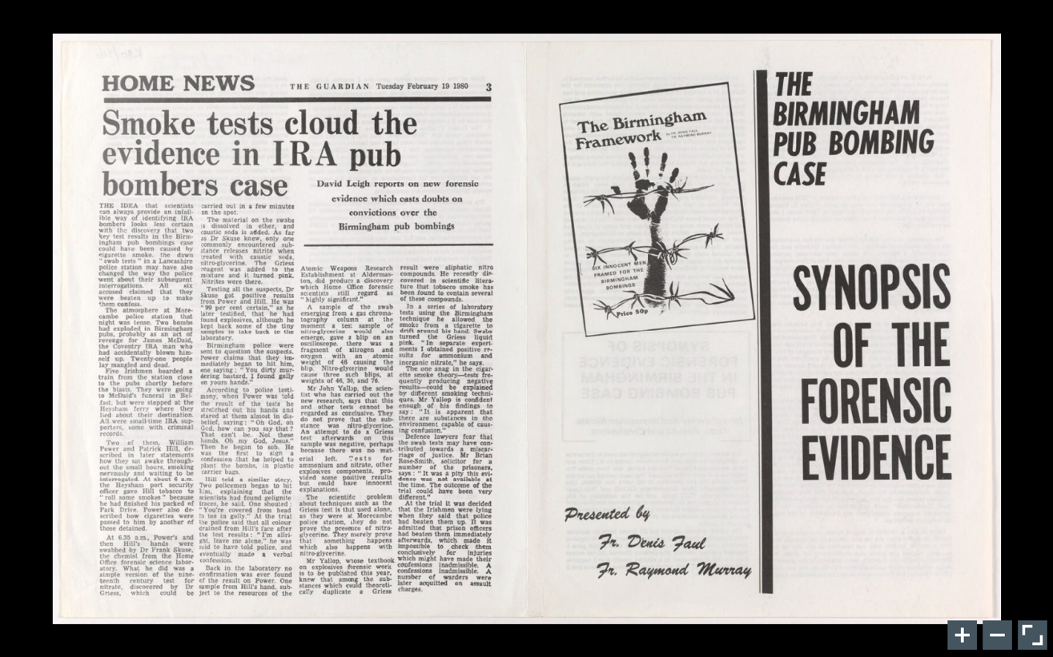
Figure 1 - Source:
The Birmingham Pub Bombing Case Synopsis of the forensic evidence. Imperial War Museums. (n.d.). Retrieved April 4, 2022, from https://www.iwm.org.uk/collections/item/object/1500051326
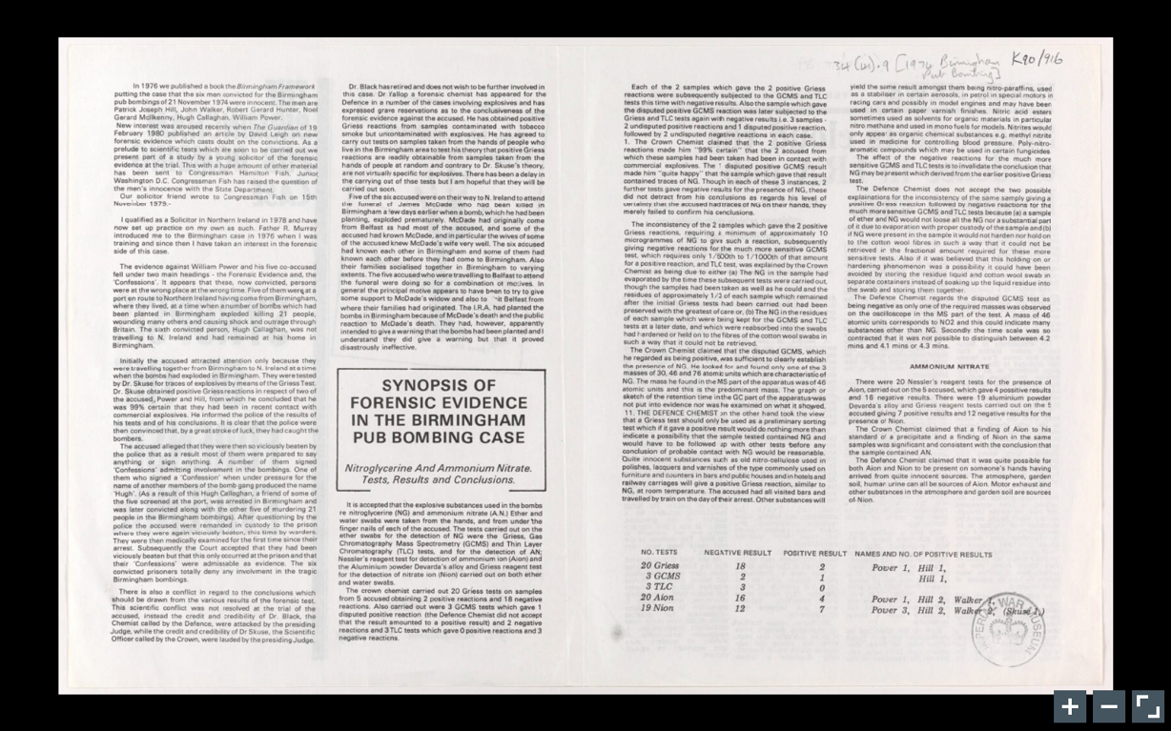
Figure 2 - Source:
The Birmingham Pub Bombing Case Synopsis of the forensic evidence. Imperial War Museums. (n.d.). Retrieved April 4, 2022, from https://www.iwm.org.uk/collections/item/object/1500051326
Sources
- Birmingham Six Case. Miscarriages of Justice Campaigning - Records of Chris Mullin MP - Archives Hub. (n.d.). Retrieved April 4, 2022, from https://archiveshub.jisc.ac.uk/search/archives/60bbc820-ba84-32cc-bfea-92eb25b48028?component=fbe3b34b-f226-3abf-b5b1-e81bde8005e2
- Guardian News and Media. (2011, March 12). The birmingham Six: Have we learned from our disgraceful past? The Guardian. Retrieved April 4, 2022, from https://www.theguardian.com/theguardian/2011/mar/12/gareth-peirce-birmingham-six

