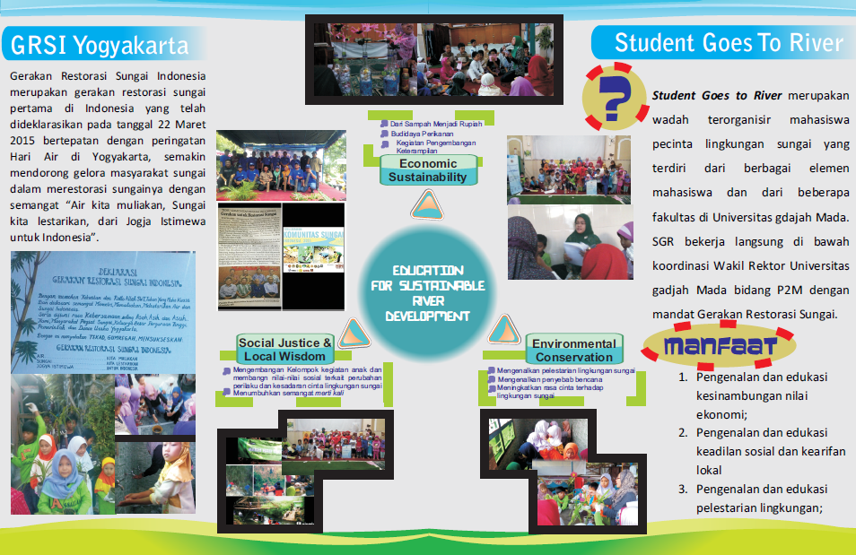
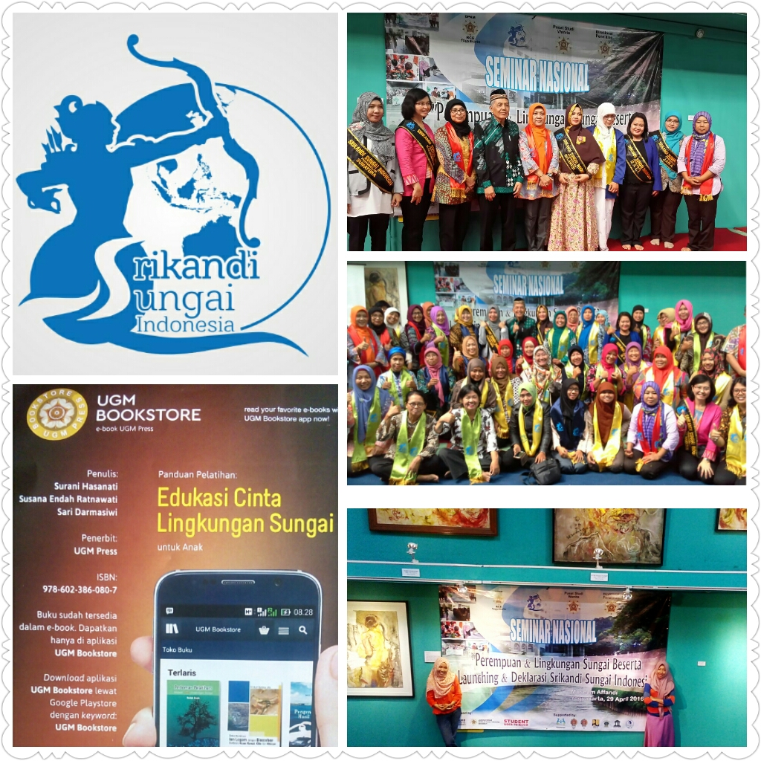

REFERENCES
No | Name | Position | Mobile Number
1 | Prof. Dr. Suratman, M.Sc. | Vice Rector on Research and Community Services, Universitas Gadjah Mada, Indonesia | +6281392772254
2 | Dr. Tri Winarni S.P. | Head of Women Studies Centre, Universitas Gadjah Mada, Indonesia | +62811293475
3 | Arida Oetami | Head of Bereau for Women Empowerment and Child Protection, Yogyakarta Special Region Government | +6281328563579
4 | Prof. Dr. M. Baiquni, M.A. | Head of Development Geography Department, Regional Laboratory | +628122722102

