REPORT OF THE NIGERIAN RCE YOUTH LEADERSHIP RETREAT
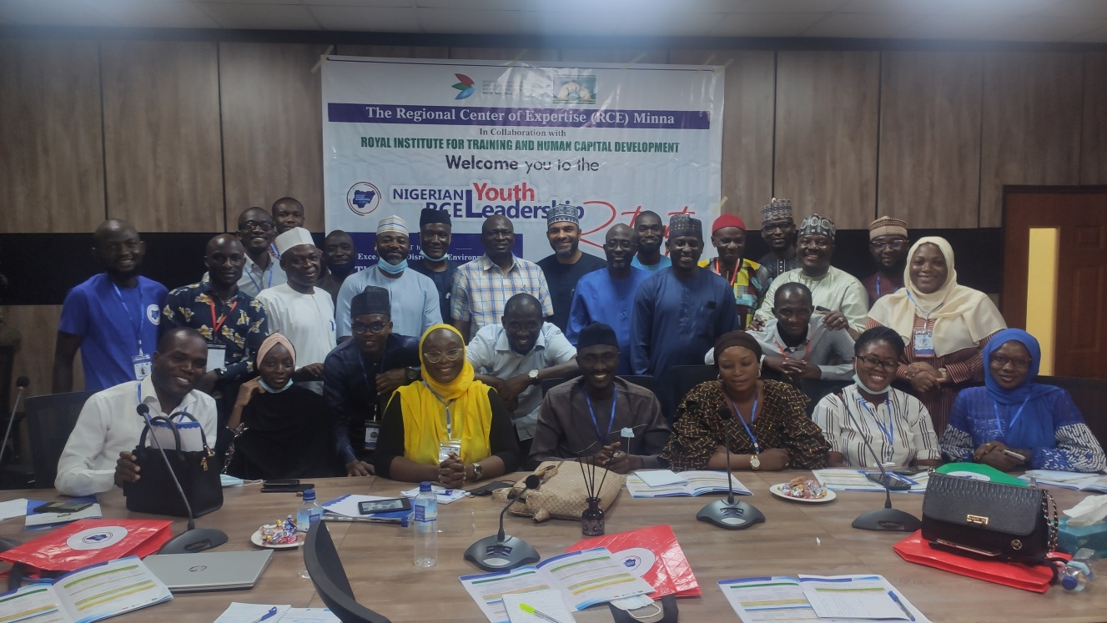
Photo Credit: RCE Minna
THEE REGIONAL CENTRE OF EXPERTISE (RCE) MINNA
In Collaboration with
ROYAL INSTITUTE FOR TRAINING AND HUMAN CAPITAL DEVELOPMENT
Nigerian RCE Youth Leadership Retreat
Theme: Excelling in a Disruptive Environment: The place of Technology, Innovation and Partnership.
Niger, Nigeria
October, 2021
INTRODUCTION
The Regional Centre of Expertise (RCE) Minna in collaboration with Royal Institute for Training and Human Capital Development (RITHCD) organised the first Nigerian RCE Youth Leadership Retreat. The workshop was a 3 days programme covering Leadership, Environmental Sustainability, Volunteerism and Financial Literacy. The programme has as its Theme: Excelling in a disruptive Environment: The place of technology, information, innovation and partnership (TiiP).
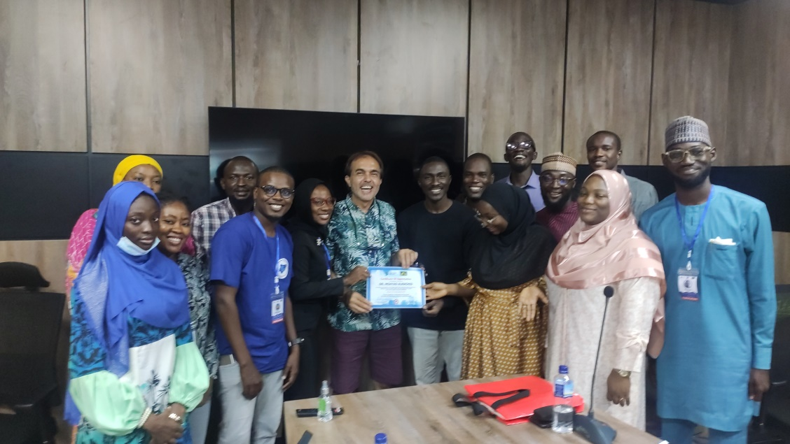
Photo Credit: RCE Minna
The general objective of the retreat is to build the capacity of youth towards responsive and responsible leadership at the community, National and global levels.
However, the specific objectives are:
- To entrench in the participants the concept of responsible leadership and selfless community service.
- To strengthened Youth engagement in building resilience in their communities through training in areas of Volunteerism and Community Development.
- To create a network of youth of like minds across the country through shared knowledge and opportunity for interaction during the period of the workshop.
- To empower youths on TiiP in 21st century Leadership quest.
The Workshop took place at the Royal Institute for Training and Human Capital Development facility, Zuma Resort. The Institute is situated on a large expanse of well landscaped environment, within Zuma Resort, directly beside the famous Zuma Rock along Abuja-Kaduna express way, Suleja, Niger State.
FACULTY MEMBERS
The programme brought together seasoned professional from the academia, government and private sector. They include Professor Charles Hopkins- UNESCO Cahir at York University, he spoke on the Priority Areas of the 2030 Agenda as it affects education and the youths in a fast globalizing world , Professor Patricia McCarney- President and CEO of the World Council on City Data (WCCD) who spoke on Cities: Challenges and Opportunities, Professor Akpezi Ogbuigwe- African RCE Adviser, Professor G. N. Nsofor Chairman Board of Research RCE Minna spoke about Youth as Environment Vanguards in the Fight Against Climate Change, Elo Inyeinengi-Etomi is the Founder and Creative Director of Mona Dance School (MDS), Port Harcourt, Rivers State, Nigeria she talked on Raising a Purpose Driven Youth Population offering Creative Solutions to Global Challenges through Performing Arts, Ms. Rossana Poblet of UN-Habitat, Mr. Solomon Karani Imujaro GIS Expert with UN-Habitat they dwelled their presentation on the Integrated Development Plans (IDP) for Minna and Suleja and how the youths should be involved in the co-designing of vision for cities of the future.
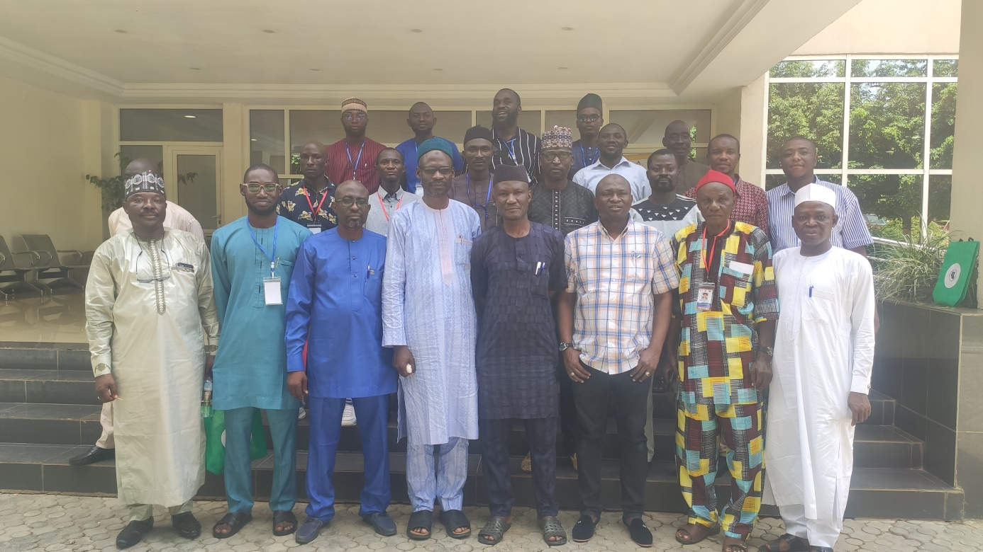
Photo Credit: RCE Minna
Mallam Muhammad Nuruddeen Lemu presented Personal Development and Leadership the Director of Research and Training, Dr Halilu Shaba Ahmad Director-General of the National Space Research and Development Agency, Dr Muhammad Mustapha Gambo, Manager Policy, Research and Partnerships at Shelter Afrique in Kenya who spoke on The Role of Youth in Enhancing the 4th Industrial Revolution in Africa, Professor Muhammad Bashar Nuhu Director Centre for Human Settlements and Urban Development (CHSUD) at Federal University talks on Personal Change Reform as a Catalyst for Youth Empowerment and Mallam Saidu Takuma Chairman Board of Directors Development Initiatives of West Africa that spoke about Youth and Leadership Development.
PARTICIPANTS
Participants were drawn from various RCEs acknowledged in Nigeria; four RCEs were represented including RCE Ogun, RCE Zaria, RCE Kano and RCE Minna (the hosting RCE). Also, invitation was extended to youth across the country that has demonstrated leadership in their organisations. Participants were made to register through a Google form designed to capture their motivation and case presentation. In the end, 62 applications were received and only 16 participants were selected.
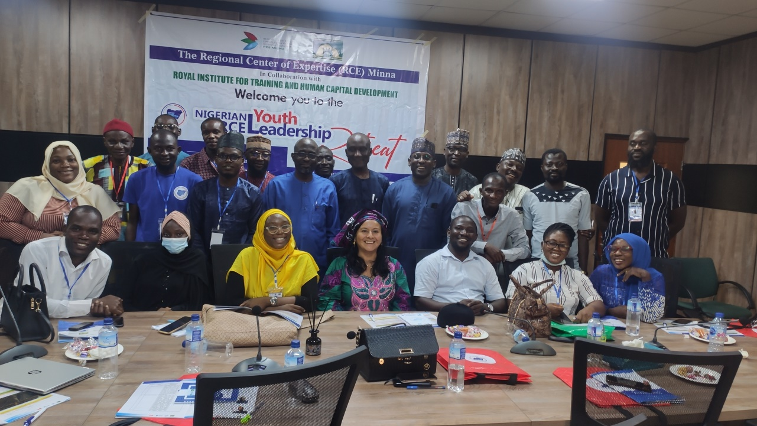
Photo Credit: RCE Minna

ACTIVITIES
Participants arrive at the venue of the event on Friday afternoon the 17th September, 2021 and were registered and lodged into their accommodations. The evening session features introduction and opening sessions by faculty members and students, followed by two presentations. The following day features series of activities such as presentation, group work, case presentation by participants.
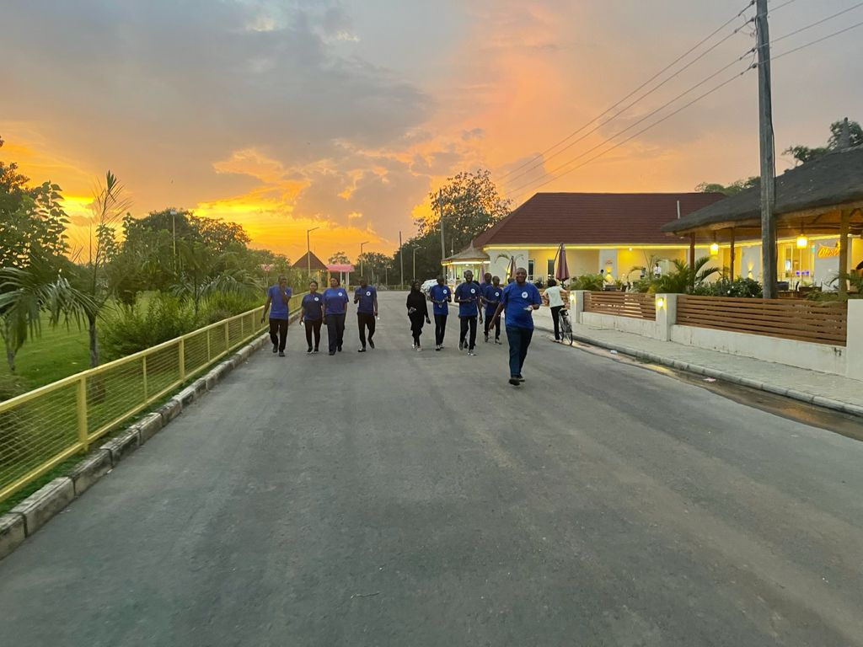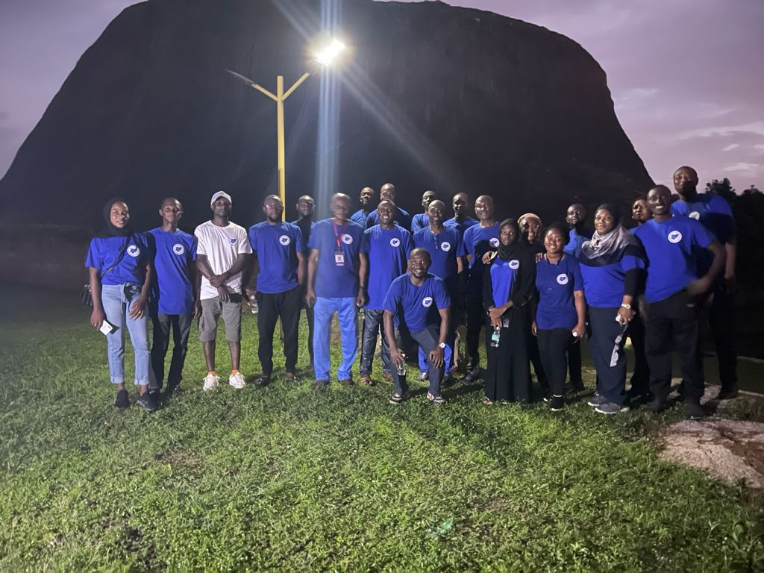

Photo Credit: RCE Minna
A walk to the Foot of the Mountain to have a feel of the resort and the last day of the event featured closing remarks goodwill messages, A Moment of Reflection (AMORE) by participants and certificate presentation.
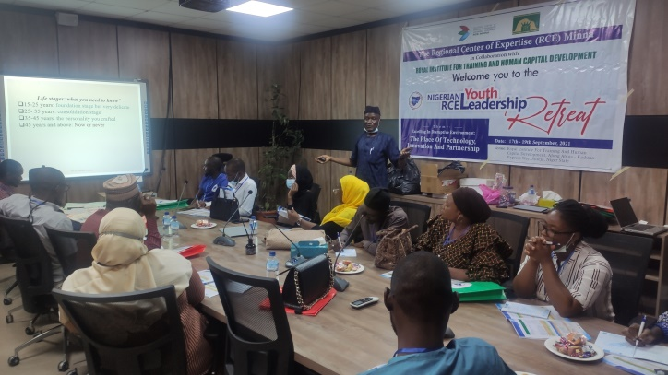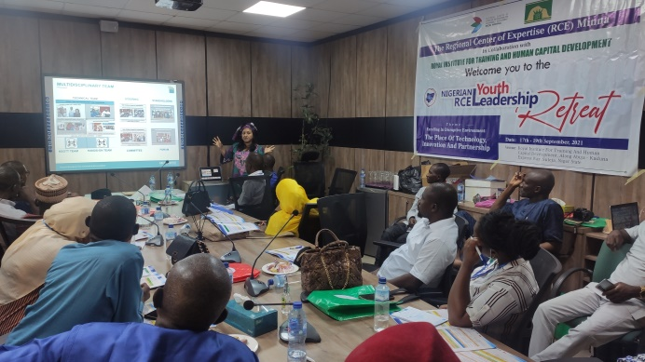
Photo Credit: RCE Minna
MAJOR OUTCOMES
The retreat provided an opportunity for the youth and faculty members to interact and kick start a conversation about the need for a paradigm shift from redundancy to a more proactive and purposeful drive towards achieving the desired development in our various community, hence, the following major outcomes were recorded:
- The need for young people to understand and join the conversation around global challenges, regarding the issues of affordable housing, infrastructure, climate change and levels of inequalities.
- The need to remove the mindset of scarcity and competition between various generations and deep-dive into the curiosity of creating a future of "shared collaborative abundance".
- Young people should also explore the option of collaborative action within their cycle as against the urge to always come up with new start-ups, NGOs and Advocacy groups. This will enhance their outreach and aid in providing short, medium and long term sustainable solutions in their communities.
- The Youth should as matter of importance equip themselves with necessary skills to excel in the fourth industrial revolution in Africa; they must be prepared to take opportunities available for their generation, this will happen irrespective of their field of study. They must equip themselves with a skill to overcome the challenges of unemployment and poor governance.
- The need for young people to explore volunteering opportunities even before concluding their studies in the university so as to obtain work experience and build their capacity for the development of their communities.
- The effects of climate has become devastating and it has become mandatory for youth to take deliberate action towards mitigating the effects of climate change and (planting of trees, encouraging reuse, reduce and recycling, enlightenment campaigns) and speaking out so government can pass laws that will safeguard our climate and environmental.
- Young people must be open to new ideas and mentorship that will make them take better and more informed decisions through the use of verified data to understand the causes of global challenges and how it can be solved both locally and globally.
- The programme serve as an opportunity for shared knowledge for the participant and faculty members, a lot of important lessons were shared across all sectors, and this has afforded participants the opportunity to learn from both the faculty members and my peers alike.
NEXT STEPS

CONCLUSION
Generally, the retreat serves as an eye opener and has triggered conversation around policy, governance, social development and human capital development among others. The future is invariably set for the youth especially with the explosive growth in IT/Technology but the youth equally need to utilise and align the potentials with core social values & ambitions for a sustainable growth.

