Lake Victoria Catchment Environmental Education Program (LVCEEP)

Project Report 2013 – 2017

- INTRODUCTION:
The ESD LVCEEP (Lake Victoria Catchment Environmental Education Program), Uganda is a part of the regional program working in the Lake Victoria Basin in Uganda, Kenya, Tanzania, and Rwanda; along the Mara River Basin in Kenya and Tanzania; the Katonga River Basin in Uganda through Nature Uganda; and the Kagera River Basin in Rwanda. The programme is also working in urban and peri-urban areas in cities adjacent to Lake Victoria to include Kampala in Uganda, Mwanza in Tanzania,and Kisumu in Kenya.
In Uganda, the project implemented in the RCE greater Masaka, lake Victoria Basin, particularly in the lower catchment districts, that are south of the equator (i.e. Masaka, Lwengo, Kalungu, Bukomansimbi, Lyantonde, Sembabule, Rakai, Gomba, Kalangala). The project equips people with knowledge and skills in sustainable development, making them more competent and confident while at the same time increasing their opportunities for leading healthy and productive lives in harmony with nature and with concern for social, economic and cultural diversity. It targets the children in schools (primary and secondary), youths and other community members, both men and women.
The main goal of the ESD LVCEEP program is to secure the ecological integrity and sustainability of the Lake Victoria Catchment Area for the benefit of its inhabitants and biological diversity. The purpose of the program is to empower catchment communities, schools and regional partners with knowledge, motivation, and abilities for the sustainable use and management of natural resources.
The program uses ESD as a strategy to build capacity of students, youth groups, and communities to promote sound environmental management and conservation of natural resources at the same time as empowering communities to improve their livelihoods through the Whole School Approach to implement ESD.

  - Supported LVCEEP groups

The project has worked and supported a number of groups i.e. 03 teacher training collages, 03 secondary schools, 28 primary schools, 15 youth groups, 16 Community Based Organizations (CBOs), and 03 ESD villages, all these found in the districts of Gomba, Masaka, Kyenjojo, Kyegegwa, Kampala, and Wakiso.

  - Interventions: The project supported the schools, groups and communities with a number of items that helped in carrying out of ESD activities. The summary of these is distributes as in the table below

Items | Quantity | Number of benefiting groups
 |  | Teacher training collages | Secondary schools | Primary schools | Youth groups | CBOs | ESD Villages
Watering cans | 165 | 3 | 3 | 28 | - | - | -
Bee Hives | 64 | - | - | - | 1 | 4 | 1
Chain Link | 28 (rolls) | 1 | 1 | 18 | 5 | - | -
Fish Fries | 2000 | - | - | - | 2 | - | -
Water tanks | 20 | 1 | 2 | 12 | 2 | - | 1
Tree seedlings | 15000 | 3 | 3 | 28 | 3 | 7 | 4
Manure | 1000 (kgs) | - | - | 1 | 3 | 7 | -
Hand washing facilities | 90 | - | - | 9 | - | - | -
Chicken feeds | 6000 (kgs) | - | - | - | 4 | - | -
Chicks | 2200 | - | - | - | 2 | - | -
Stove solar panels | 68 | - | - | 3 | 4 | - | -
Piglets | 70 | - | 1 | - | 2 | 1 | -
Charcoal / Briquettes machines | 02 | - | - | - | 1 | 1 | -
Sewing machines | 08 | - | - | - | 1 | 2 | -
Tents | 19 | - | - | - | 6 | - | -
Plastic chairs | 1900 | - | - | - | 6 | - | -
Wheel barrows | 44 | - | - | 20 | 2 | - | -
Slashers | 230 | - | - | 21 | 2 | - | -
Hoes | 230 | - | - | 21 | 2 | - | -

1.3 Whole School Approaches (WSA) used in LVCEEP schools
THEME | ESD Indicator | Observed WSA Practices | Achieved Percentage
SCHOOL CULTURE AND ETHOS | School culture | 26 ESD model schools have developed a structured routine for ESD related activities such as  cleaning the school, garbage collection and disposal and smoking pit latrines,  Teacher-pupil  Briefings on school assembly, caring for crops in kitchen gardens through water and weeding.  •Pupils have since developed a culture walking on walk-ways in respect lawn grass and nature;  recited environmental creeds and slogans composed by their teachers; saved energy and resources  i.e. electricity, water and fuel; practiced nutrient cycling, mixed farming, kitchen gardening,  Recycling and plenty of self-reliance skills.  Teacher-pupil briefings on school assembly, caring for crops in kitchen gardens through water and weeding.  •Pupils have since developed a culture walking on walk-ways in respect lawn grass and nature;  recited environmental creeds and slogans composed by their teachers; saved energy and resources  i.e. electricity, water and fuel; practiced nutrient cycling, mixed farming, kitchen gardening,  Recycling and plenty of self-reliance skills. | 83%
 | ESD Policy | There is leadership in 20 ESD schools with a number of management policy or at least an ESD plan.  Ndegeya PTC , Kabulasoke PTC and Holy spirit Kyakatara Primary School were undertaking ESD action planning | 64%
 | School community  partnerships | School-community partnerships are visible in 25 schools through a number of efforts.  Some of which included;  • Participating schools have organized community cleaning days. Ndegeya Core PTC and Kabulasoke Core Teachers College regularly organizes clean-up exercises for their adjacent town centre.  • Kisambya Primary school pupils participate in cleaning the nearby community well through  slashing the grass  • Model schools are reaching out to neighboring schools in an effort to sensitize them & support them in undertaking conservation efforts. | 80%
 | Learning for  sustainability | Integrated learning and learning environments is visible in 28 ESD model schools.  •Pupils have the ability to make connections between various environmental interactions and human environment interaction.  •Teachers in St. Augustine Kalungu skillfully applied concepts into actions and practical examples during the teaching and learning process.  •Through the WSA, pupils have exhibited a good understanding of ESD depicted by their creative write-ups. They express their views in posters, poems, essays, message tags encouraging Healthy habits or discoursing environmental malpractices. | 90%
 | Participatory  Leadership &  management | 26 schools had operational Parents Teachers Associations (PTAs), School Management  Committees (SMCs) that guided the planning and supervision of the school programmes.  • Regular pupils-teachers meetings are conducted in the school to chart the way forward for the school with regard to academics, ethics and discipline.  • At St Paul Kitovu, Mugongo, SDA Nanziga, Holy Spirit Kyakatara Primary Schools, action and strategic plans have been developed where ESD components have been fused for implementation. | 83%
PUPILS’  VOICES | Pupil’s  Participation  and  Empowerment | 29 Model schools demonstrate presence of pupil’s voice in action exemplified through elections of student representatives such as prefects and house captains.  Existence of student council in Teacher Training Colleges (PTCs),secondary schools; and existence of school clubs and associations such as Environment club ,Wildlife club,  , Young Farmers and Nature Club.  • Kaihura primary school and other’ School Clubs: Environment Club or Nature Club were used as an avenue for environmental  Conservation efforts. Membership comprised of students  - Advocacy for sustainable use of the environment has been done through art and composition Advocacy for sustainable use of the environment has been done through art and composition | 93%
 | Inter –school  and interregional  competitions | 28 LVCEEP schools have participated in a number of local and cross boundary competitions where they have achieved awards such as ESD Day, Earth Hour and Environment day.  • Pupils of St. Anthony Kayunga, Blessed Sacrament Kimaanya Primary and Secondary schools, Rwentuuha primary school, Nsinde primary school, Kiburara Primary school, won the inter-region competition that has remained a memorable pride. | 90%
TEACHING  AND  LEARNING | Quality  Teaching | In 27 ESD schools, there is overall paradigm development of education for self-reliance demonstrated by various activities practiced by both pupils and teachers in the school  This included: demonstration of gardening, demonstration of livestock keeping especially pigs, deliberate effort to educate children on useful and endangered plants, and income generating activities and projects implemented in the school setting. | 87%
 | Diversity | There is clarity of unity in diversity in both teachers and pupil in 30 ESD Schools  There are persons from  different tribal groupings, religious affiliations and gender in all schools | 96%
 | Support  services to the  learners | Teachers in 27 ESD schools often talk to the students on issues of HIV/AIDS given the challenges that the epidemic already has inflicted on the families and communities in the country.  • Talking sign posts on the various school compounds encouraged abstinence as a strategy to  avoid contracting HIV/AIDS  • Teachers (female) talk to girls on their body changes especially on how to take care of their  Menstrual cycles and stay safe. | 87%
 | Active/  Participatory  Learning | 28 ESD model schools displayed interest in developing a learner who fits in the society i.e. they were educating the learners to fit into the communities they come from rather than educating them out of the communities.  This is demonstrated by several initiatives that the learners got engaged in  including:  • Trenches dug on flat lowlands to control soil erosion  • Simulations of mountainous and contour farming accompanied with clear descriptors such as “…we have to put grass bands to trap the soil and prevent it from being eroded by running water on highlands.”  • Improvised sacks for dust bins  • Water harvesting tanks and ponds for irrigation and water provision in the school.  • Continuous greening initiatives visible in the intervals of tree planting as evidenced by the varying heights of the trees and ages.  • Wetland conservation demonstration plots  • Tree and vegetable nursery beds observed.  • Ethno-botanical knowledge passed through the herbal garden  • Recycling site for plastics.  • Rudimentary localized incineration of plastics and sanitary towels.  • Existence of controlled free range chicken enclosures.  Hands-on experience in digging and planting in the school gardens. At Ndegeya PTC  students dig the college land in preparation for planting and have planted a school banana garden | 90%
 | Values and  Attitudes | In 27 ESD Schools, teacher’s delivery of instruction had ignited learner’s exploration of the present and the future.  Evidence of pupils making connections between the present and the future were visible from the records in the schools.  A t Kisojo Primary schools messages were visible e.g. “Avoid throwing, report anyone who trespasses, and Pick the rubbish you come across.”  Understanding of ESD was depicted by their creative write-ups in the classes, and their views hanged in posters, poems, essays, message tags encouraging healthy habits or discoursing environmental malpractices | 87%
PROFESSIONAL  DEVELOPMENT  OF STAFF | ESD Training | 30 ESD Schools engage in seminars, workshops and meetings that were attended by both male and female teachers.  • Non-teaching staff including cooks and school caretakers has also undergone ESD training organized by Nature Uganda and WWF.  • Newly recruited teachers at Mugongo, Kisambya, St. Paul Kitovu and Kiyimbwe Primary Schools indicated that the teaching environment, practices, ambience were different from their previous placements.  • Teachers use the environment for teaching and learning.  • Trained teachers in model schools who have undergone such training and have been transferred to other schools, have been reported to carry the ESD message to their new schools.  • Teachers are also engaging in sustainable activities at their homes through having small kitchen gardens as well as undertake various income generating activities to subsidize their income. | 97%
PARTNERSHIPS  WITH THE  COMMUNITY | Links with  Parents,  Governors  and School  Boards | 30 ESD model schools had operational Parents Teachers Associations (PTAs), School Management  Committees (SMCs) that guided the planning and supervision of the school programmes including  ESD activities  • Parents of Kiburara and Nsinde Primary Schools contribute food items during open days  • School-community visits were evidenced by the photo-albums in the community and schools  • Parents provide rewards offered to pupils who have excelled at school or at home | 96%
 | Links with the  Community | In 28 ESD schools’ meetings (PTA, SMC, BOG) and events (Sports Day, Environment day), these model  schools have acted as information and technologies dissemination centers in the communities where they are located; Several initiatives attest to this fact including:   Demonstration beds are present in schools.   Schools participate in exhibition including display of teaching materials made from recyclable waste materials such as soft drink plastic straws.   Demonstrations on how to make composite manure are regularly conducted on farm and in class. | 90%
 | School –  Community  Integration | 28 ESD Model schools have developed various activities as part of linkages with the community.  These  were mainly school-community outreach activities that included:   Cleaning the community facilities such as roads, community well and trading center   Community sensitization   Community mobilizing   Collective resource generation   Outreach schools | 90%
 | Education  week and  Open days | In 25 ESD school events such as Open days, Environment Day, Model schools have exhibitions where displays of various school projects including photographs are exhibited to the public.  Theme days act as avenues for sensitizing the community on environmental education as well as ESD. | 80%
THE SCHOOL  ESTATE | School  Resources  Management | In 27 ESD schools, a diverse range of rain-water harvesting strategies have been implemented by the schools and youth and the communities.  Water storage tanks had been constructed and while others were donated and  Connected to roof gutters to trap rainwater from roof tops. This water was used for a myriad of  Purposes including: cooking, cleaning, irrigating and watering domestic livestock. Besides  Harvesting rainwater, students were also taught on how to appropriately use and conserve water.  • Some schools have fitted energy saving bulbs that reduce the power consumption.  • Improved cook stoves constructed using locally available materials such as clay; click bricks and mortar were present in the school kitchens. The support staff (cooks) reveals that these stoves use less firewood, emit less smoke, conserve heat and allow the cooking area to be maintained clean. | 87%
 | Waste  Management | In 30 ESD schools, waste management is a common practice in the model schools. St. Joseph Maya Primary School had innovative waste collection points, which were made of old jerricans hanged on trees in the school compound and outside each class block.  • There is regular collection, sorting and disposal of waste into three pits, one for decomposable waste, inorganic waste and hard material such as metals.  • Creativity in utilizing the waste materials and turning them into resources and saleable products.  Ndegeya PTC, Nanziga SDA, St. Paul Kitovu, Kiburara primary school and Kabulasoke PTC indulged in recycling plastic bottles and polythene bags to develop a variety of teaching and learning aids. | 96%
 | School  Compound | In 25 ESD schools innovative mechanisms to address health and sanitation of pupils have been initiated.  • Primary schools have strategically located tippy taps and soap outside pupils pit latrines to enable them wash hands after visiting areas of convenience.  • Model school compounds are well attended to with plastics and other refuse materials well-disposed in respective containing areas. Cut grass was heaped in a pit waiting for compositing | 80%
 | School Build  & Restoration | 26 Schools have embarked on various greening initiatives within the school compound  Masaka, and Kyenjojo LVCEEP schools and St Joseph Maya and SDA Nanziga in Kampala peri - urban had woodlots within the compound. Kisojo Primary School had tree nurseries. Fruit trees were also seen in the schools | 83%
 | School  Grounds | Model 25 ESD schools could be termed as ‘Talking compounds’.  Schools have messages on display with indications that communicated scientific, moral and advisory messages. | 80%
 | Talking  School  Compounds | 26 ESD School compounds had informative messages on display boards with educative messages.  Messages such as  We have one living planet, Reduce foot prints and adopt handprint, Practice organic farming, Use  energy-saving bulbs, Eat quality not quantity and Manage waste properly.(Ndegeya PTC, Kabulasoke PTC, )  The 4 R’s: Re-use, Re-fuse. Re-cycle and Reduce (Kisojo primary School)  ESD in progress (Kisojo Primary School)  •Trees planted for message delivery to the pupils and community.  •Flowers and grass in the school compound was designed to illustrate certain concepts/images being taught in class. Kisojo had a demonstration plot illustrating control of soil erosion through contour farming. | 83%
MONITORING  AND  EVALUATION | Participatory  monitoring | In 29 ESD Schools Monitoring and Evaluation of the LVCEEP is done at different levels  Nature Uganda regularly  visits both schools and communities and donate tree seedlings for planting  • Head teachers regularly check Schemes of Work and Lesson Plans for teachers to monitor  integration of ESD in the teaching  • Nature Uganda in collaboration with Core Team organize for workshop/ seminars for new and  old teaching staff to provide regular updates on conservation efforts  • The outreach staff of Ndegeya PTC ,Center Co-coordinating Tutors (CCTs) supervise  implementation of ESD in their respective centers | 93%
 | Youth Participation | 9 LVCEEP Youth in ESD villages have developed various activities as part of monitoring and linkages with the ESD schools, community, and local governments.  Nkobazambogo, TDI, Butiiti and Ffe Katukole youth have also embarked on various Small scale and medium enterprises/ initiatives. | 69%

2.0 DETAIED REPORT SUMMARY
Enrolment in the ESD Schools; ESD schools had data such as enrolment, drop outs, examination among others for years 2013- 2015, displayed in staff rooms and general school notice boards.
Students on a research field study

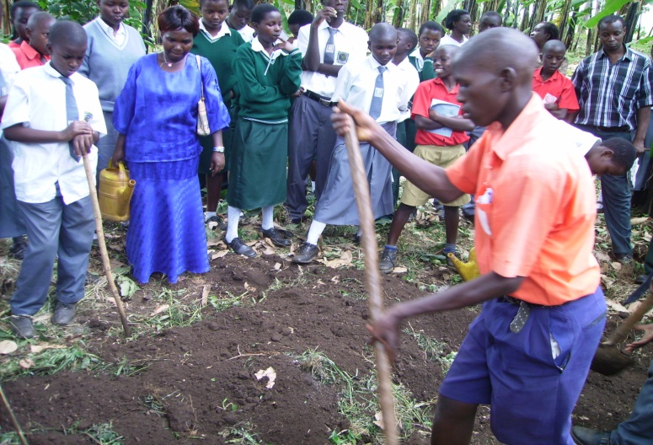
Organic manure making

2.1 Community/Youth participation and ownership
Communities have positive views about their own contribution to ESD, community greening of schools and household practices of ESD
The community organizations such as the Youth groups and community groups implementing the ESD Initiatives are legally registered as CBOs for legitimacy and recognition by the government. The youth groups are at different levels of growth some at the nascent stages of development with each facing challenges of cohesion, consistency and commitment.
The groups are owned, led and managed by the communities who elect their leadership. A good number of the groups such as Kyemengo Agahikaine youth, Butiiti youth, Ffe Katukole Nkobazambogo youth, Kaswa Zinda youth, are a result of old groups.( Kisambya Community, Butiiti community, Kaswa Zinda community ) respectively. Which had done successful implementation of the projects, and the new ones grew as outreach projects of the old. The schools have remained the centre of ESD initiatives of community engagements. The groups undertake different eco-friendly activities some focus on organic farming, handcraft, fish farming, tree planting , agricultural market information, bee keeping, HIV and AIDS sensitization, environmental conservation and water catchment preservation among others as prioritized by the communities.

- ESD best practices that have been achieved in LVCEEP schools
Education for Sustainable Development is a pivotal aspect of the LVCEEP

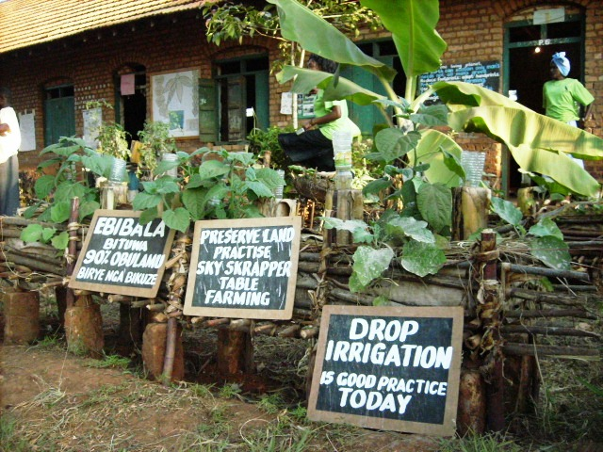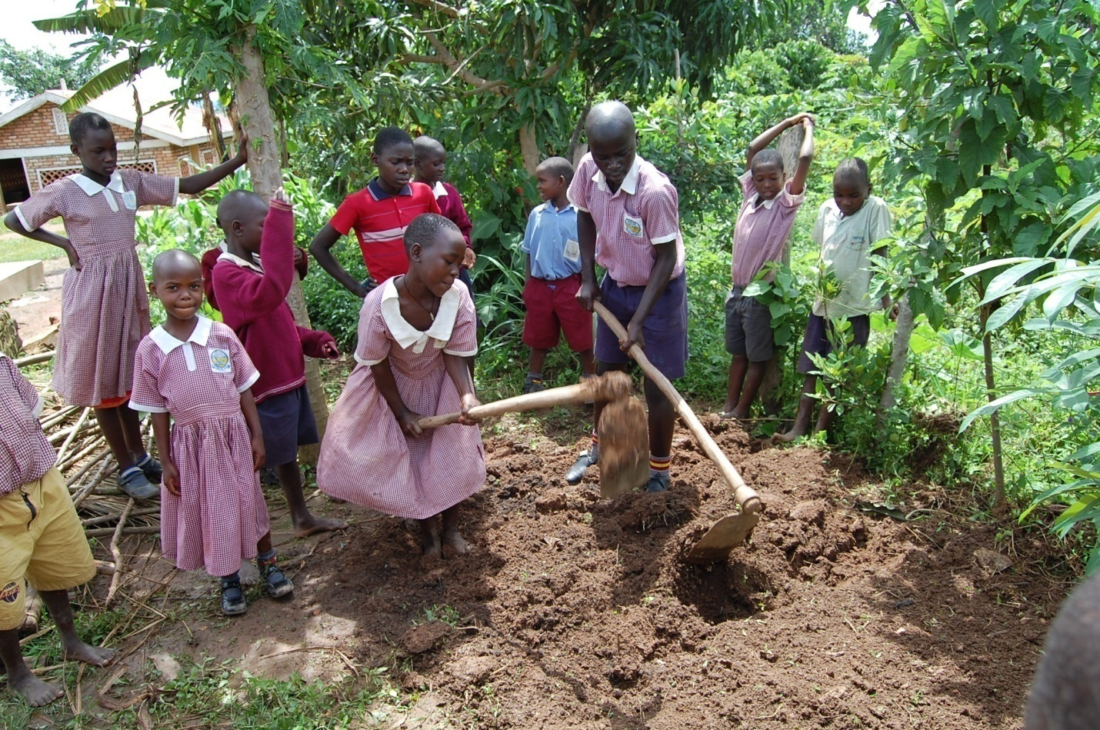
“Talking compound” with messages that promote learning for sustainability and school gardens

3.1.1 Agriculture practices

Tree planting or greening initiatives
A lot of effort has been injected into tree planting activities as a way of translating knowledge into sustainable practices. Visible woodlots around the school compounds can be seen. These woodlots consists of eucalyptus, pines, thunder arrestors; Emisesere and Emikookowe plants
The teachers observe that the school use eucalyptus wood for preparing student meals and owing to the availability of locally available wood fuel students are no longer required to bring firewood on weekly basis. The school administrators also note that this had reduced the costs incurred on fuel wood purchases. It is further anticipated that the pines trees will in the future provide income to the schools when they mature.
Fruit trees have been planted in schools and especially in Kisambya P.S, Ndegeya PTC, and St. Anthony S.S. Kayunga which are developing school orchards. This goes a long way to increase the forest cover in the Lake Victoria Catchment area. Other greening initiatives include: planting of grass within the school compound. Mugongo, St Joseph Maya have used the compound as a teaching and learning aid and has proceeded to design the grass into various shapes used for teaching.

3.1.2 Mulching
Diverse preparation and use of mulch is common. In the schools, crop residues, grasses, farmyard manure, and compost are used for mulching purposes.

Besides using mulch, students are taught how to make compost as an important ingredient in mulching. They note that where compost and grass mulch had been used crop productivity are high, trees are luxuriant and green, highly reduced erosion, and weeds are fewer.

3.1.3 Nutrient cycling
The teachers note that there is usually food remains from student meals (primarily maize meal and beans). The community members usually collect these food remains to tender their pigs. After noticing the profitability of this venture; St. Paul Kitovu Primary School decided to establish a pigsty in the school. Consequently, the students eat food and the left over plus kitchen waste, is fed to the pigs, the pigs provide dung, the dung and urine is used in compost manure production and the compost manure is used in the mulching of crops that provide food for the students. This practice is what is called nutrient cycling and is an important component of sustainable production systems.

3.1.4 Crop management
Students practice a variety crop management practices such as inter-cropping beans and maize, fruit growing multiple cropping including alley cropping and use of cover crops such as beans. Some of these practices are implemented unconsciously and they have developed into success stories for teaching and learning as well as food sources.
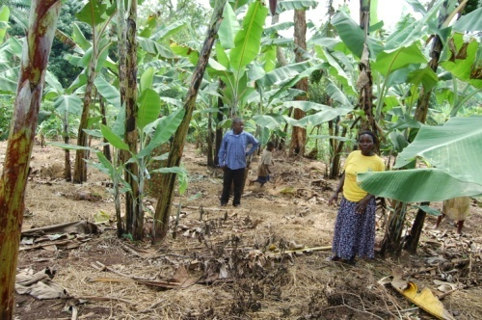

Banana plantation at Butiiti Youth Group

3. 1.5 Kitchen gardening
In the school compounds small plots of vegetable crops, beans, bananas, and maize have been established. These are mainly used to supplement teacher’s meals and sometimes, student meals. Lessons end into food production. To further demonstrate innovative kitchen gardening in small space areas, polythene bags have been filled with soil and compost and planted with vegetables. Teachers of the model schools also adopt having kitchen gardens at their homes to especially grow vegetables. They admit that they no longer incur cost of acquiring vegetables.
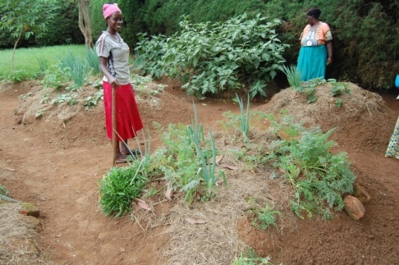

Kitchen gardens at Bakyala Kwagalana Community

A diverse range of rain-water harvesting strategies is implemented by the schools and farmers. Water storage tanks have been constructed connected to roof gutters to trap rainwater from roof tops. This water is used for a myriad of purposes including: cooking, cleaning, irrigating and watering domestic livestock. Besides harvesting rainwater, students are also taught on how to appropriately use and conserve water. Students, teachers and support staff alike are in agreement that this water saves time that would have been used in fetching water; it minimizes runoff from the school compound, reduces chances of drinking unsafe and contaminated water, reduces the costs of accessing piped water and minimizes challenges of water scarcity during the dry season. In-situ rainwater harvesting using percolation ponds, moisture conservation pits and micro-catchments are also used in the school gardens.

3.1.6 Energy management and utilization
Utilization of energy saving bulbs: Some schools have fitted energy saving bulbs that reduce the power consumption. The school administration note that since the transformation to energy saving bulbs, the costs incurred on accessing electricity had slightly gone down. Money would then support other causes.

3.1.7 Utilization of improved cooking stoves
Improved cook-stoves constructed using locally available materials such as clay; clay bricks and mortar are present in the school kitchens. The support staff (cooks) reveals that these stoves emit less smoke, conserve heat and allow for the cooking area to be maintained clean.
Meanwhile the administrators observe that they now spend less on purchasing firewood. The head cook at Kayunga SSS revealed that prior to installation of these improved energy saving cook stoves; they could use one truck load per week of firewood. However today, the same truck load can be used up to four weeks. Similarly, the head teachers of St. Joseph Maya and Mugongo P/s report that before the introduction of the energy stove, the school used to incur UGX 600.000 per term in the purchase of firewood, however with the new energy saving stove they have only spent UGX 150,000, only a quarter of the initial cost.

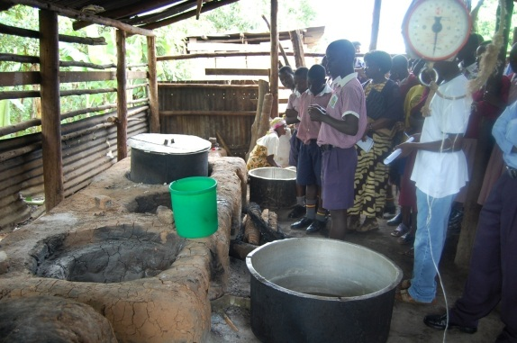

Use of energy saving stoves in schools

3.1.8Waste collection, sorting and disposal
Waste management is a common practice in all the schools. Ndegeya PTC, St. Anthony SSS Kayunga, St Joseph Maya Primary School have an innovative waste collection point, which is made of sack mounted on pieces of wood and are strategically located outside each class block. Pupils reveal that they occasionally sort garbage that is generated from their school environment. Bio-degradable garbage such as leaves and grasses, food remains, banana and cassava peelings are put together for compost making. While plastics and other polythene materials are also separated and burned in the improvised incinerator. The sorted garbage is dumped as per its category in respective pits.

3.1.9 Waste recycling
Teachers and pupils are creatively utilizing the waste materials and turning them into resources and saleable products. They apply art and craft skills to develop teaching and learning materials such as mobile cards fixed in bottles; number charts made using bottle-tops, word charts made using letter cut-outs from milk packets and other polythene types. Some of these waste materials are used for other purposes such as plastic-bottle-irrigation.

3.1.10 Community participation
There is closer cooperation and collaboration between LVCEEP schools and the community.
Kisojo Primary School, St Paul Kitovu, St. Anthony Secondary School and Ndegeya
Primary Teachers College continues to provide material support to the schools for example the water tank at Kisojo. Model homes of Kisojo Women and Men Organic Farmers Association (KWAMOFA) demonstrate some agricultural practices to pupils of Kisojo. School-community links are mainly modeled in Kisojo and have fifteen Eco Tourism Sites.

Youth Income Generating Initiatives by Kaswa Zinda youth, TDI Youth, Nkobazambogo youth Mpugwe, Ffe Katukole youth, Butiiti youth and Makungula youth members included: commercial crafts; seedlings, herbal tea , herbal soaps, production from Rosemary plants – the members have learnt to grow, harvest, process and pack their produce for sale
Children from different families develop interest, positive attitudes and skills and are always willing to voluntarily offer a hand, for example, to clean the pigsty, clean the trading centers and have trained other young in proper recordkeeping to show the quantity of products and profits from sales. They have albums showing their activities with the youth, schools and community. Kyemengo Agahikaine Youth Group is involved in fish farming and fruit growing.
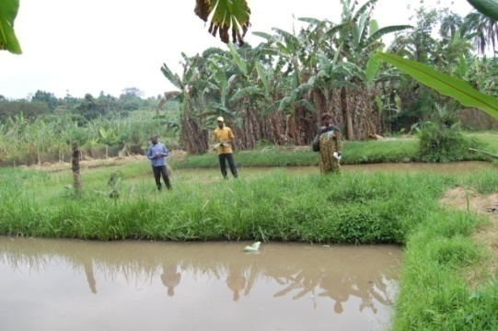
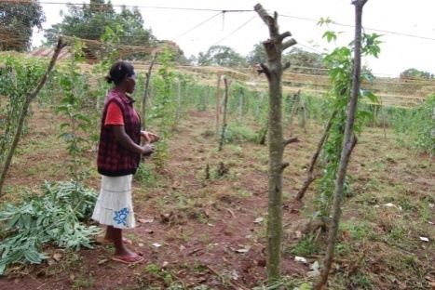

Fish farming and fruit growing by Kyemengo youth group

The best ESD practices exhibited in model homes include:
• Proper rubbish disposal and well watched sanitation; the tippy tap and an innovative latrine cover that is lifted using feet.
• Coffee nurseries, Orchard with avocado, guavas, mangoes, delicacies like Ntutunu, nsaali, matooke (endangered species of wild fruits) indicating conserving efforts
• Use of solar energy and bio-gas technologies portrayed that modernity can be attained without harming the environment as a way to save the planet for future generations.
• Water harvesting initiative [underground and above ground tanks]

3.1.11 ESD Smart Compounds
What is clearly noticeable in the compounds of LVCEEP schools is that ordinary flower gardens have been turned into kitchen or food-crop gardens. The primary schools demonstrate ability to live productively on small acreages of land on top of a series of visible actions; the compounds portray a series of environmentally friendly routines, messages, practices and unpronounced cultures right at first sight. Education for Sustainable Development is quite evident by the use energy-saving bulbs and stoves. The school plants sitting on acreages of barely four acres ably sustain the lives of about 600 inhabitants on average, including staff and pupils with minimal expenses on health since the children have self-knowledge of the local herbs for ailments like malaria, coughs and colds which are common among pupils in the age bracket of 5 to 15 years. Varying sizes of trees indicate a continuous endeavor to afforest the school compounds. The schools also have an enduring living, exhibition of proper substance farming methods in the demonstration kitchen gardens even during the drought, due to the irrigation skills using drip-system with recycled plastics. In the LCVEEP schools, children, have learnt to live sustainably in that they maintain finger prints to care for the environment and minimize, footprints. The most vivid example is that they feed their pigs on food remains from the kitchen and use the dung to process composite manure for the crops around the school. Mixed farming is also practiced, to make cost-effective use of the small plots of land; some kitchen gardens had a variety of vegetables in patterns that are also appealing to the eye. For example, elevated lines or curves of onion alternated with spinach or sukuma wiki. The practical activities skill the hands of the pupils and they are enabled to own what they do by transferring the same practices to their homes. Planning for small land to obtain high returns is in place.

3.1.12 Utilization of Indigenous knowledge
Schools such as Ndegeya PTC, Kabulasoke PTC, are maintaining herbal gardens. In these gardens important ethno-botanical plants are planted, such as: Ddimilyambwa; Kibwankulata for burns; Kiyondo for
Natural hedge at St. Anthony SSS, one of the kitchen onion gardens in the compound of Kisojo illustration-situ water trapping method, Nursery bed in Kisojo compound wounds; Mululuuza, Kigagi (Aloe Vera ) both used to treat malaria; tobacco (curative herb for snakebite); Kawunyira (treats worms). Parents and teachers help children to appreciate and promote their cultural heritage. The herbal gardens are used for teaching and some of the medicinal edible plants are cooked for source by the teachers such as sour berries. Teachers learn some names of medicinal plants from pupils. One of the students in St. Anthony made this complement, “Nature treats well” implying the antitoxic nature of herbal medicine.

3.1.13 Health and Sanitation
Some schools have set up innovative mechanisms to address health and sanitation of their pupils. Butale P/s, Kisojo Primary schools have strategically located tippy taps and soap, outside pupils pit latrines to enable them wash hands after visiting areas of convenience. Pupils use a tippy tap after visiting the latrine.

3.1.14 Formation of registered CBOs and School environment Clubs in (ESD Villages)
The project supported formation of CBOs, groups and clubs in schools and communities. These are running and managing different projects including (both environmental protection and income generating activities); tents and chairs hiring, catering and decoration services, piggery production, bee keeping and honey processing, art and craft, waste management and recycling, indigenous knowledge promotion, tree nurseries, among others.
3.1.15 Water harvesting using fellow cement and underground tanks – the underground tanks are made using locally available materials
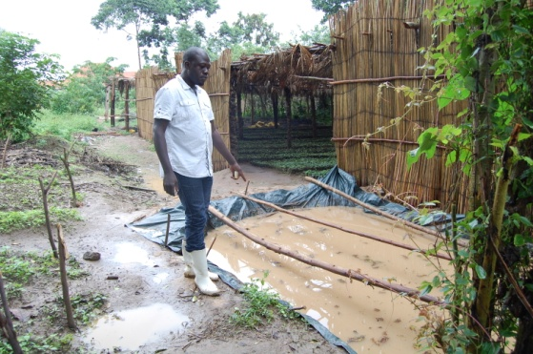
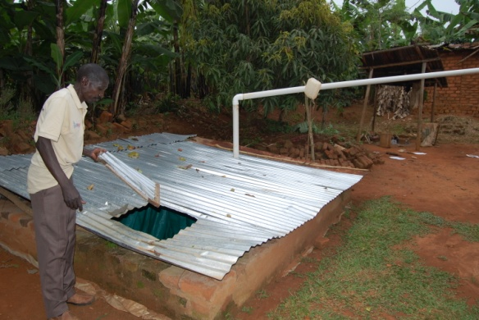

Mr. Jjumba Joseph of Tukolerewamu Group shows his locally made water harvesting tank and Mr. Kayongo shows the runoff water harvesting pond for watering the coffee nursery at TDI

3.1.16 Advocacy and involvement in local governments
Several members of the youth groups and communities have taken up the ESD message to the local leaders at different local government levels. Some have also gone as far as contesting to get on the local government councils at sub county and district levels. Nyantungo Youth Group, Bukunda youth Group and Keweerimidde Kyabakuza are some of the groups with members who are contesting.

4.0 Challenges faced by the WSA in LVCEEP schools and communities/Youth
The WSA as employed by the LVCEEP project has had a share of its successes but also experiences a number of challenges.

4.1 A number of challenges were observed in LVCEEP schools, communities and youth groups. These challenges range from administrative, perception to socio-cultural and economic as, below:

Teacher transfer constituted both a challenge and unique opportunity. In schools where teachers are transferred from; head teachers grappled with situations of ensuring that newly recruited teachers fitted into the ESD and whole school approach dispensation. Meanwhile schools that receive already trained teachers have experienced initiation of ESD activities.

“Indispensable public figures” in parts of Masaka, particular individuals are on that list of reckless dumping as well as wetland reclamation. These individuals are well known local “tycoons”.

Lack of a shared vision by some schools towards the practice of ESD and whole school approach, as some teachers’ remark “ask so and so…” there is a facial expression that is left to the imagination of an outsider to infer the meaning.

The education system mounts pressure to complete the syllabus cited as a more pressing and urgent issue with teachers. Consequently, teachers’ pay close attention to issues that are examinable leaving the general life issues out.

“Business as usual syndrome” whereas it is clear that some teachers try their level best to integrate ESD in their teaching and learning through scheming, lesson planning and lesson delivery; others scheme, but never lesson plan nor teach as their scheme of work indicate. A rather silent argument keeps creeping that the ESD requires a lot of time in preparation, organization and resource mobilization. This obviously raises issues of teacher mastery of pedagogical methodology and their ability to adapt and be flexible.

Community and Youth empowerment; old ESD community groups and the ESD youth groups are challenged by advocacy and lobbying skills to enable them express their needs at different forums at the Districts and National levels.

4.2 CONCLUSION/Recommendations
The recommendations for action are derived from field observations, analysis of data and discussions conducted with various stakeholders. The recommendations range from general to specific although they have not been presented in any chronological order.
- Generally, there is need for continued support to the institutions that are running the LVCEEP activities. This further support should be structured in three ways; first is the technical support relating to the type of trees to plant; structural design for soil erosion benches and contours construction; and land use planning. Second, is financial aspect of the assistance especially that focused at supporting youth/communities and school efforts to reaching the communities; ( Value addition, Community conservation saving schemes) etc, and thirdly, infrastructure development; this should specifically focus at rainwater harvesting so as to address rainfall variability/water scarcity as well as saltiness of underground water and construction of pit latrines.
- Adoption of a landscape approach to implementing the LVCEEP project and project activities. Successes have been registered in schools however schools are limited. The wider challenges and drivers of Lake Victoria deterioration are at landscape level. The school does not have adequate capacity, time and financial resources to reach out to different sections of the community. The schools are training a young generation; whose influence will grow over time but the current deterioration Lake Victoria is driven by those who are practicing poor farming practices. Reigning on this category will reduce likely disillusionment that could build-up among the young generation.
- Continued building capacity of teachers and community members in the line of ESD and whole school approach is a need. Teachers in particular at primary school and secondary school levels need to undergo for refresher or re- training on ESD and the whole school approach. Their grasp of ESD and whole school approach still highly wanting.

4.3 Recommendations 2
The /youth /community to continue to work closely with local governments, and head teachers and ESD core team in LVCEEP to create sustained interest in ESD through continuous training, exposure and exchange program/ Exchange visits .
LVCEEP to continue prioritizing policy and curriculum review to ensure that ESD is mainstreamed in the Community/youth SMEs interventions
It’s vital to use food security as a key theme in ESD so that an immediate gain is seen by all, stakeholders. From this, other conservation and livelihood components such as school feeding program can easily fit in.
There is need to produce future publications in English, Rutooro and Luganda to enable all stakeholders get a uniform concept, but still interpret it in their own context.
There is need to assess the reasons for reduced enrolment in most schools with a view to mainstreaming it as a key ESD indicator for regular monitoring.
There will be Identification of the key challenges faced by each district to be mainstreamed in the next phases. For instance mainstream climate change issues in, because the catchments have been affected most by climate change. There is need for intensive training on team development, environmental conservation, livestock diseases and management, value addition, climate change, environmental advocacy, business planning and linkages to financial institutions.

