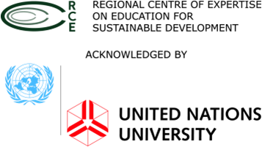
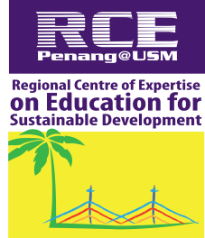

RCE SEJAHTERA YOUTH
UNIVERSITI SAINS MALAYSIA
ACADEMIC SESSION 2018 / 2019

PROJECT TITLE:
KG DEW COMMUNITY MURAL ART
ORGANIZER:
RCE SEJAHTERA YOUTH USM
WITH PARTNERSHIP:
REGIONAL CENTRE OF EXPERTISE ON EDUCATION FOR SUSTAINABLE DEVELOPMENT (RCE ESD) PENANG, USM
VENUE :
KAMPUNG DEW, TAIPING, PERAK
DATE:
15,22&30th OF SEPTEMBER 2018

1.0 OVERVIEW
The Mural Art Project is part of a community engagement and is important to improve the image of Kg Dew which are famous known of their fireflies. The mural reflect on local contexts of fireflies are created in cooperation with citizens and RCE Sejahtera Youth committee. Community art especially mural, is a strong and effective tool to educate the community and tourist about fireflies. Through this programme, the volunteers can contribute to sustainable use of public spaces and it helps to improve the local identity, leading to increase in economic performance.

- OBJECTIVES
  - To educate, engange and enhance communities about firefly through public wall art.
  - To recognize voluntary activities of young people with a view to acknowledge their personal skills
  - To enhance and cultivate civic responsibilities to volunteers and the community.

- TENTATIVE

Place : Kg. Dew, Taiping, Perak
Time : 7.00 am – 7.00 pm
Time | Activities
7.00 am | Depart from USM
9.00 am | Briefing to volunteers
9.30 am | Wall painting activity
1.30 pm | Rest
2.30 pm | Wall painting activity
7.00 pm | End

4.0 PARTICIPATION
This programme involve group from :

  - RCE Sejahtera Youth committee USM
  - Students from USM
  - RCE members

5.0 BUDGET

INCOME TOTAL  (RM/UNIT) | EXPENSES PRICE NUMBER TOTAL  (RM) (UNIT) (RM)
DONATION  RM 300  TOTAL INCOME RM 300 .00 | TRANSPORTATION  Van 80 3 240  Toll 50 1 50  MEALS  Dinner 5 10 50  PAINTING EQUIPMENT  Colour 23.90 6 143.4  TOTAL EXPENSES RM 483.40

6.0 REFLECTION

Public murals became popular because they were easy to understand and they belonged to everybody in community. This mural art project also help the community to improve their economic development, with the goal of increasing tourism by making the place more attractive destinations for visitors. It was a way to show the identity of Kampung Dew and visitors can learn about the fireflies by visiting this mural. Through this project, it would indirectly encourage creative talent and also strengthen tourism sectors.

7.0 CONCLUSION

This Mural Art Project was held for the first time by RCE Sejahtera Youth committee and the Kg. Dew community. In order to preserve murals, video footage of mural drawing and creation are effective. We hope the project will be realized as it will be an important effort in promoting Fireflies tourism at Kg. Dew to the community, the public and other target groups.

