KBAD-A Real Time Opportunity for Sustainability Education
During Covid-19
Prof. Selina Nargisª, Dr. Muhammad Rehan Dastagir^{*b}, Dr. Ferdous Ahmed^{c}, Dr. Sayma Akhter^{d},
Prof. Mohammed Ataur Rahman^{e}
All authors are from IUBAT Institute of SDG Studies, IUBAT, Bangladesh
ªselina@iubat.edu, ^{b}rdastagir@iubat.edu, ^{c}ferdous.ahmed@iubat.edu, ^{d}sayma.akhter@iubat.edu, ^{e}marahman@iubat.edu
Abstract: In achieving Sustainable Development Goals, the university holds a leading position. However, throughout the year long pandemic attachment between university and student has moved towards a more virtual platform. It has become a great challenge for both students’ and educational institutions to continue education through online platform. Facing the challenges of pandemic IUBAT successfully continues the online educational program. KBAD-Knowledge Based Area Development, a UNU (United Nations University) Flagship project has proven effectiveness in building links with IUBAT to students across the country. This program is to produce at least one technical graduate from 87,963 villages of Bangladesh. Door to door proper guidance for higher education is provided in the remote villages with financial assistance and interest free loans for the meritorious and needy. Since 2010, a total 9,381 students have graduated and another 11,699 are currently studying under KBAD from 535 out of 550 Upazilas and Thanas across the country. In the year of 2018, Merit Scholarship has been given approximately BDT 164.9 million; Interest free loan approximately BDT 20 million; Special Scholarship BDT 0.66 million with a total sum 185.56 million BDT or 2.2 m USD. Generally, 15% (Fifteen) more scholarship has been given to female students to ensure gender equity. There is no other such university sponsored scheme/program for financial loan available in the country. In the period of COVID-19, an additional 15% (fifteen) tuition fee waiver has been given to all, admission fee reduced 50%, a 6 USD fund transferred to the students to avail mobile data. Students have graduated with technical and ESD (Education for Sustainable Development) skills as it is a mandatory practice of this university. This nationwide education promotion made it a sustainable campaign outreaching the majority of remote villages of the country and encouraging technical education to the underprivileged group of the society along with the urban students. This unique program complies with SDG goals 4.3, 4.4 and 4.7. These goals ensure equal access of affordable, technical, tertiary and sustainable education to all leaving no one behind. KBAD is a model to eradicate educational discriminancy in a nation by removing financial barriers in tertiary education.
Key words: Sustainability Education, KBAD, Education Loan, Equal Access of Tertiary Education, Mentoring Rural Students
1.0 Introduction: Tertiary education is the highest level of education of a country. Tertiary education plays a crucial role in knowledge creation, innovation and intellectual leadership. However, the tertiary education in private institution is very expensive except for public universities that has limited number of seats. In Bangladesh there are 53 public universities and 107 private universities of University Grant Commission ( UGC) approved [1]. Majority of private universities (51 in number) are located in Dhaka division. As most of the private universities are located in the capital city, access to education for rural and less advantaged have limited scope to be accommodated in pursuing higher education in private universities. In considering the nature of expense of higher education, Sustainable Development Goal 4 has been proposed by United Nations [2] mentioning the equal access education in SDG 4.3: “By 2030, ensure equal access for all women and men to affordable and quality technical, vocational and tertiary education, including university” and in SDG 4.4 and 4.7: increase number of youths with technical and ESD skills.
To achieve SDG-2030 of an affordable and quality education, IUBAT has been working for a decade since 2003 through a project named KBAD [3]. This education program acting on rural community to build the link with university and reshaping the image of university as a common property in 21st century. Along with providing proper guidance and specialized undergraduate curriculum, KBAD has education financing scheme to support meritorious and needy students. Thus, IUBAT is a pioneer and leading (WURI Ranked 43rd) tertiary institution assuring quality education accessible for all [4]. This education financing scheme is also sustainable on contrary to present education loan program of national banks financing the higher class of the society [5].
2.1 Knowledge Based Area Development: The number of Gross Enrollment Rate(GER) of Bangladesh in tertiary is much lower than other Asian countries in Fig. 1[6]. Public funding in tertiary education is 20% of the total national education budget. Though the tertiary education enrollment is in rise in the country however, only 30% of provided by universities and 60% of provided by colleges under National University.
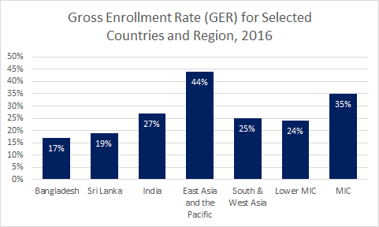
Fig. 1: Gross Enrollment Rate, 2016
Bangladesh is a country of very high population density. Over 166,477,462 [7] people live on a 147,570 sq. km. with limited natural resources, the country has to capitalize its human resources. IUBAT university mission is to develop human resource by producing quality graduates. KBAD is a program proposed and designed by Professor M. Alimullah Miyan in 2003. He was the founder Vice-Chancellor of IUBAT. KBAD to produce at least one graduate from a village. There are 87,963 villages in the country. The mechanism of KBAD is acting like “garlic bonding” working well in the socio-economic structure of a South Asian country Bangladesh where the family bondage is very strong. An educated graduate will develop and improve the mindset of the family members to a greater extent and become the model in the village inspiring potential students to pursue higher studies. This will also alleviate fear and distance for higher education in rural community and bring them in.
2.2 Mechanism of KBAD: KBAD works in three steps. Firstly, the Outreach program in distant part of the country, Secondly, Mentoring the student with specialized curriculum, Thirdly, Education Financing.
2.2.1 KBAD Outreach: A University Education Extension Unit (UEEU) is there to ensure the outreach program across the country. The role of UEEU is to provide guidance on higher education to rural students to overcome their fear of higher study. Speaking up about the importance of higher education in different colleges in seminars. Aside to holding seminars the role of this unit is to accustom the local college principals and parents about the importance of providing their wards the necessity of higher education. This works as a bottom up approach of spreading messages to the roots of the country rather than to urban middle class only. As a result, IUBAT as a top university of the country accommodates higher number of rural students (80% of its student population) in the country.
2.2.2 Mentoring: Bangladesh is a country where the primary students’ enrolment is 98% [8]. This has been a great success of the Government, yet the quality of primary and secondary education has a long road ahead. Teaching quality, faculty training, teaching materials are not up to the mark in the schools. There lies a considerable weakness in English, Bengali, Mathematical and Creative Thinking skills among the secondary students. This is the reason many rural students are afraid to go to tertiary education and not getting enough confidence to cope with. The KBAD program assures the students and tutors them with providing relevant courses before initiating the major courses at university. Rural students are generally weak in English, Mathematics, Professional Attire, Computer Literacy, Etiquette etc. To the newly enrolled students IUBAT first provides living rules and customs as a course named as ART (Art of Living). The inclusion of several English and mathematics courses in the undergrad curricula also seemed very much effective as most of them have poor basic knowledge on these courses.
2.2.3 Education Financing: A total 50 million BDT or 589485 USD fund was created to conduct the KBAD operation. In this program a highest CGPA (Cumulative Grade Point Average) student gets full 100% scholarship and additional 15% tuition fee waiver is provided to female students. There is also financial assistance available for the meritorious and needy students. KBAD undergoes a rigorous interview of the applicants for the financial assistance to find out the study motivation, needs and merits of the students. Unlike educational loans of the commercial banks it does not emphasized on the return capacity or the parental income of the applicants. The students do not need to pay back during their study period at university, even they get two years’ additional time to pay back interest free loan. Thus, KBAD alleviates the financial barrier in higher education for the poor students of the villages across the country.
3.0 Achievements of KBAD: Under the KBAD program 8,890 graduates and 491 post graduates have been studied during the year (2008-2019). Each year nearly 1000 students get scholarship, tuition fee waiver or financial assistance from KBAD. In the period of COVID-19, an additional 15% (fifteen) tuition fee waiver has been given to all, admission fee deducted 50%, a 6 USD fund transferred to the students to avail mobile data for online class. A total 1.5 crore Taka or 177,200.85 USD has been granted in the pandemic time. Table-1, showed financial support to the poor students:
Table-1: Financial support for needy students in 2018
Financial Support | Amount in BDT (millions)
Merit Scholarship (Tuition fee waiver) | 164.9
Loan (Interest free) | 20.0
Special Scholarships 71 (No of students) | 0.66
Total | 185.56 m BDT  2.2 m USD
The Table-1 shows the financial support by KBAD program to the needy students. The total amount 185.56 million BDT or 2.2 m USD in the year 2018 that is a considerable amount of education financing by a university. This is for uplifting a backward community towards skilled manpower. This will ultimately comply with the SDG 4.3 and 4.4.

Fig 2: Gender equity among students of IUBAT
An additional 15% scholarship for female students had positive results on promoting gender equity at IUBAT shown in Fig. 2.
IUBAT offers degree program on Agriculture, Business, Engineering, Economics, Tourism, Nursing, English. Fig. 3 shows employability status of IUBAT graduates showing that majority of them became skilled and technical work force of the country where 16% of them pursuing higher education in home and abroad. An educated human resource is playing vital role in shaping the country in the time of economic transition of the country when Bangladesh declared as a lower middle income country [9]. The country needs more quality, technical graduates to build up different sectors with a high performance.
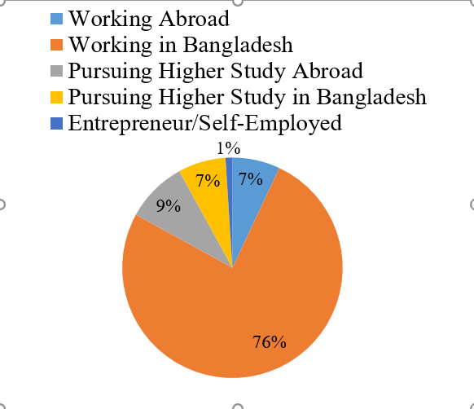
Fig. 3: Employability status of IUBAT graduates

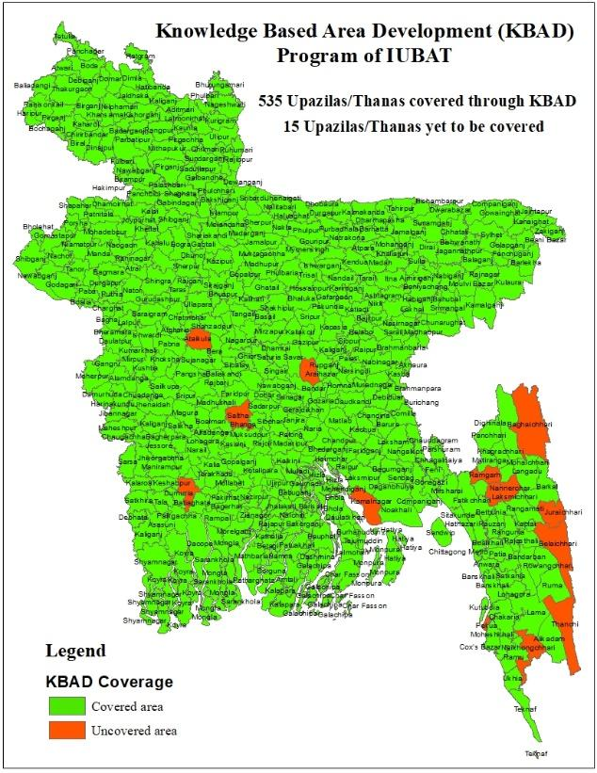
Fig 4: Area coverages of the KBAD having students studied at IUBAT

The Fig 4 showing the countrywide access of KBAD program motivating students of the rural community in higher studies. The figure showing 535 Upazilas/Thanas have been covered out of 550. The decade long ( 2003-2021) program has been successful to complete up to administrative unit of the country, Upazila. Though aim of the program is to cover the lowest administrative unit, villages. The UEEU is working on to fulfill all the villages. It is to be mentioned that there are 87,963 villages in the country. This program is recognized as a UN Flagship Project of United Nations University in the year 2013 for spreading Education for Sustainable Development(ESD)[10].
4.0 Education Loan: Commercial banking vs KBAD: In Bangladesh education loan is not yet functioning satisfactory [5]. The reasons behind this are student’s security deposits, capability of the parents to return. Banking sectors also considers education loan risky as they don’t have students’ database and the low employability of graduates.
On contrary, KBAD has a high loan return over 90%. There is close association between student and IUBAT and the university is maintaining the students’ database. It neither requires the security deposit nor the high parental income. It’s completely for the poor and meritorious students. The student has to return after two years of graduation. All these has the lesson that education loan should be conducted either by the educational institution or by national education bank in developing Bangladesh.
5.0 Conclusion: Bangladesh is passing a major transition of socio-economic state and the government is highly committed of SDG targets. The intake of students in the tertiary level has been increased though the quality and affordability of education is under consideration. IUBAT received its recognition in quality education at home and abroad; and showed a pathway to achieve the accessibility of higher education to all through KBAD program in overcoming the societal and financial constraints. This will become a model for the world to make university education as a common property and works in reverse direction of the elitist concept of university. This was the vision of Professor Miyan.
References
[1] University Grants Commission, 2018. List of Public Universities. Available online at http://www.ugc-universities.gov.bd/private-universities, accessed on 08/08/2021.
[2] United Nations, Sustainable Development Goals. Available online at https://sdgs.un.org/goals, accessed on 08/08/2021.
[3] Miyan, M.A., 2018. Knowledge Based Area Development, A Step Towards Community Self- Reliance. 9th Edition. Published by IUBAT, Dhaka, Bangladesh. Available online at https://www.iubat.edu/kbad/
[4] World’s Universities with Real Impact (WURI) in ethical values category, 2021. Available online at https://www.wuri.world/top-50-ethical-value-2021, accessed on 08/08/2021.
[5] The Financial Express, 2020. Why student loans still don’t work in Bangladesh? Available online at https://www.thefinancialexpress.com.bd/views/reviews/why-student-loans-still-dont- work-in-bangladesh-1606711718, accessed on 08/08/2021.
[6] Bangladesh Tertiary Education Sector Review, 2019. Skills and Innovation for Growth, Report No: AUS0000659, 2019 The World Bank, Washington, USA. Available online at http://hdl.handle.net/10986/31526, accessed on 08/08/2021.
[7] Worldometer, 2021. Bangladesh population. Available online at https://www.worldometers.info/world-population/bangladesh-population/ accessed on 06/08/2021
[8] UNICEF Bangladesh Country Programme for 2017-2020: Country Programme Document and Strategy Notes. Available online at https://www.unicef.org/bangladesh/en/more- opportunities- early-learning/quality-continuity-primary-education, accessed on 08/08/2021.
[9] Gimenez, L., Jolliffe, D., Sharif, I., 2014. Bangladesh, a Middle Income Country by 2021: What Will it Take in Terms of Poverty Reduction? World Bank, Washington, DC. USA. Available online at https://openknowledge.worldbank.org/handle/10986/18668, accessed on 08/08/2021.
[10] Global RCE Network, Education for Sustainable Development. Available online at
https://www.rcenetwork.org/portal/, accessed on 08/08/2021.

