European RCE Meeting
Vannes, France
28 - 31 August 2018
B
Form B: ESD Project Summary Sheet

Please fill out this form and send to the Global RCE Service Centre (rceconference@unu.edu) by 23:59, Friday, 1 June 2018 (JST) along with Form A: Request for Financial Support and RCE Profile Form.

Kindly note that case presentations will take place during the meeting. Please prepare a PowerPoint presentation for your session during the meeting.

We invite presentations on projects based on the ESD initiatives as milestones for achieving SDGs at the European RCE Meeting under the following theme:

Overarching Theme: ESD and the SDGs : how can RCEs coordinate both of them to achieve the SDGs?

Criteria:
- Address how your project is contributing to the implementing of SDGs through education.
- Demonstrate engagement of multiple stakeholders, including participation and support of local communities
- Demonstrate contribution to theme
- Analyze impacts in terms of how projects have brought positive changes to the communities (if applicable)
- Discuss ways of further scaling up, mainstreaming and deepening ideas and actions of the project (ways forward)
- Report on an ongoing or future project
- Scaling up of ESD and sustainable development activities in the region with reference to the UNESCO’s Global Action Programme and SDGs.

Please submit this form along with the relevant materials for your project, whether that be a case study, curriculum document, or some other output. We ask that you keep your responses here as concise as possible. This information will be posted on the website of the Global RCE Network unless otherwise requested. Please inform the RCE Service Centre (rceconference@unu.edu) if there are any responses you would not like made public.

Basic Information
Title of project (should be concise and within approximately 25 words)
Submitting RCE
Contributing organization(s) (Individual RCE member organizations – minimum of 2 contributing organizations)
Focal point(s) and affiliation(s) (Name, organizational affiliation, e-mail)
Format of project (manuscript, PowerPoint, audiovisual) |  |  |  |  |  |  | Language of project
Date of submission (or update, if this is an update of an existing ESD project)
Web link (of the case study or lead organization if available for more information)
Additional resources
Does this project link to any education and/or sustainable development policy or policies? If yes, please provide the name of the policy or policies.
If so, at what level is the policy operating (please place an “x” in the appropriate box or boxes)
*If more than one policy, please indicate which one is operating at which level
Local |  | Subnational |  |  | National |  |  | International

Geographical & Education Information
Region (Africa, Americas, Asia-Pacific, Europe)
Country (where site(s) or activities described in the case study are located – if multiple, please list all participating countries)
Location(s) (subnational units and/or cities within the country or countries – leave blank if specific location(s) cannot be identified)
Address of focal point institution for project
Ecosystem(s) (please place an “x” in all appropriate boxes)
Forest |  | Grassland |  | Agricultural |  | Fresh water |  | Coastal
Dryland |  | Mountain |  | Urban/Peri-urban |  | Other (Please specify) |  | Wetlands
Level of Education for intended audience (please place an “x” in all appropriate boxes)
Primary |  | Higher |  | TVET |  | Youth (Informal)
Secondary |  | Teacher Ed. |  | Community |  | Other (Please specify)
Socioeconomic and environmental characteristics of the area (within 50-100 words)
Description of sustainable development challenge(s) in the area the project addresses (Within 50-100 words)

Contents
Note: The following fields are used for information about activities described in the project or the production of the project itself, and contents may vary depending on the nature of the case project. For example, a project about on-the-ground teaching or training may include the rationale, objectives etc. for the activities; a case study about an ESD-related policy may describe the policymaking process; or a toolkit may address particular practices used within ESD. Please make an effort to fill as many fields as possible.
Status (“ongoing” or “completed”) |  |  | Period (MM/YY to MM/YY)
Rationale (why activities or policies described, or information shared through the educational practices/material are needed – within 100-200 words)
Objectives (goals of activities or policies described, teaching or learning outcomes – within 50-100 words)
Activities and/or practices employed (within 50-150 words)
Size of academic audience (approximately how many learners did the material from this project reach?)
Results (within 100-150 words)
Lessons learned (factors in success or failure, challenges and opportunities – within 50-100 words)
Key messages (‘elevator speech’ about project - within 50 words)
Relationship to other RCE activities (if the project is related to any other RCE collaborative activities, regional plans, working groups, etc.)
Funding (any relevant information about or acknowledgement of funding of activities or projects described in the case study)
Pictures (please include up to three pictures of the project sent through as individual high resolution JPEG files – 1.5-2.0 MB in size – 300dpi)
File name of picture (Example: photo.JPEG) | Caption for picture (Example: Learning to sort plastic waste) |  |  | Photo Credit (Example: J. Smith)

UN Sustainable Development Goals (SDGs) (https://sustainabledevelopment.un.org/sdgs) and other themes of Education for Sustainable Development (ESD)
Please place an “x” in the “direct” or “indirect” boxes next to any of the UN Sustainable Development Goals and/or other themes of Education for Sustainable Development (ESD) to which the work described in this project contributes as appropriate. Note: please mark only those that the ESD project actually has made or is making a contribution, not those to which it could make a potential contribution in the future.
SDG | Description | Direct | Indirect
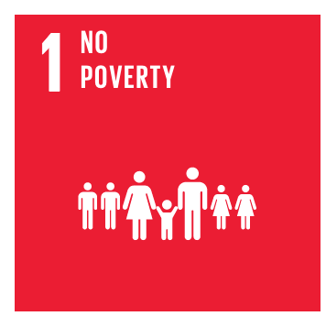 | End poverty in all its forms everywhere
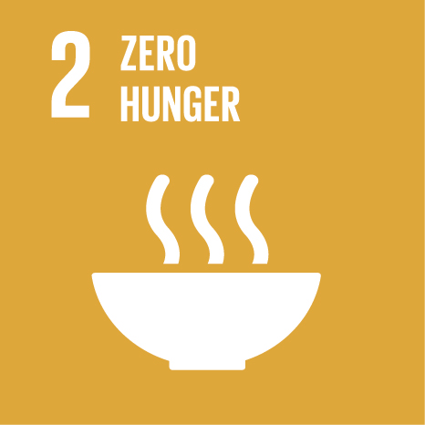 | End hunger, achieve food security and improved nutrition, and promote sustainable agriculture
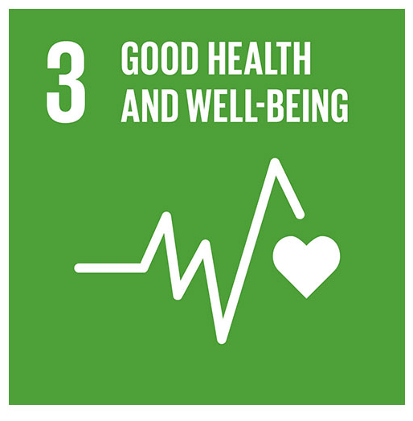 | Ensure healthy lives and promote wellbeing for all at all ages
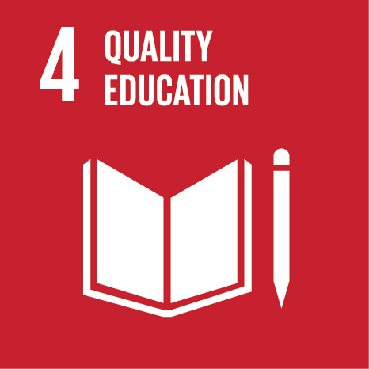 | Ensure inclusive and equitable quality education and promote lifelong learning opportunities for all
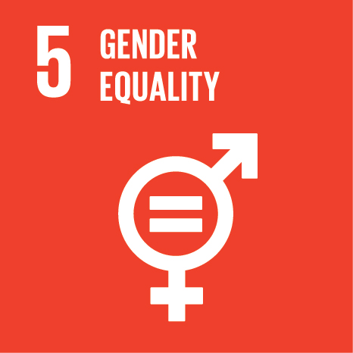 | Achieve gender equality and empower all women and girls
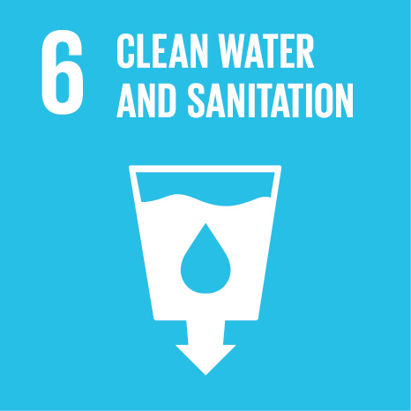 | Ensure availability and sustainable management of water and sanitation for all
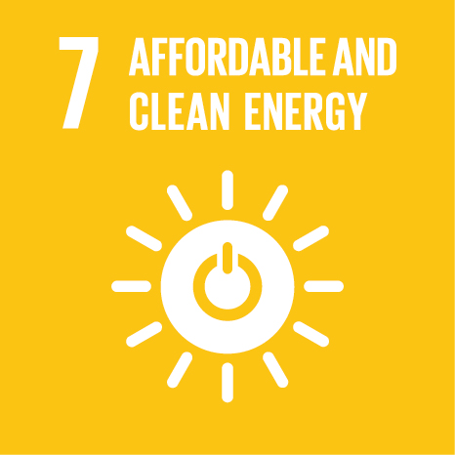 | Ensure access to affordable, reliable, sustainable and modern energy for all
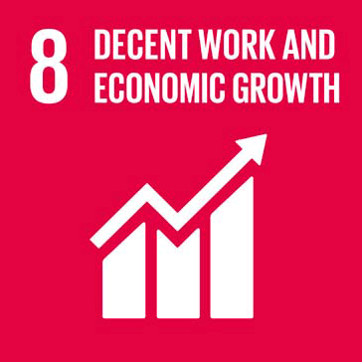 | Promote sustained, inclusive and sustainable economic growth, full and productive employment, and decent work for all
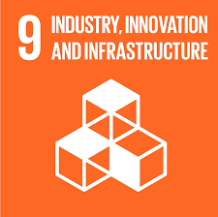 | Build resilient infrastructure, promote inclusive and sustainable industrialisation, and foster innovation
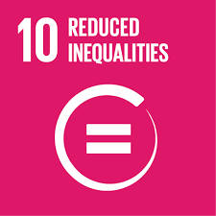 | Reduce inequality within and among countries
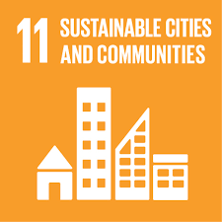 | Make cities and human settlements inclusive, safe, resilient and sustainable
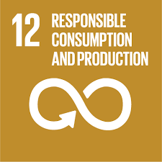 | Ensure sustainable consumption and production patterns
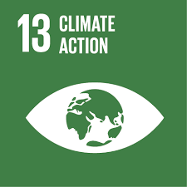 | Take urgent action to combat climate change and its impacts
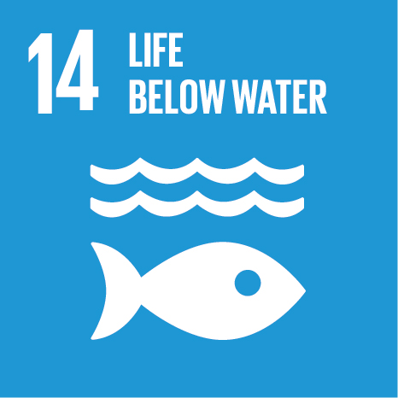 | Conserve and sustainably use the oceans, seas and marine resources for sustainable development
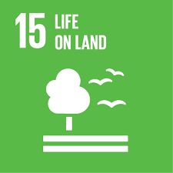 | Protect, restore and promote sustainable use of terrestrial ecosystems, sustainably manage forests, combat desertification and halt and reverse land degradation, and halt biodiversity loss
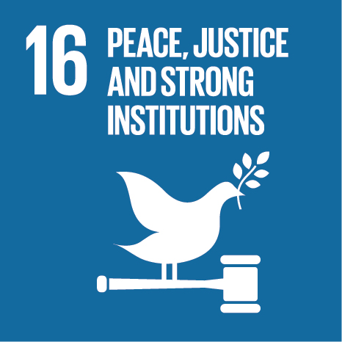 | Promote peaceful and inclusive societies for sustainable development, provide access to justice for all and build effective, accountable and inclusive institutions at all levels
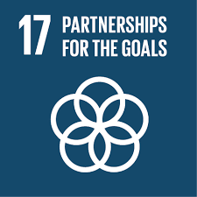 | Strengthen the means of implementation and revitalise the global partnership for sustainable development
Icon (to be developed) | Theme | Direct | Indirect
 | Disaster Risk Reduction
 | Traditional Knowledge
 | Agriculture
 | Arts
 | Curriculum Development
 | Ecotourism
 | Forests/Trees
 | Plants & Animals
 | Waste

Global Action Programme (GAP) on Education for Sustainable Development – Priority Action Areas (https://en.unesco.org/gap/priority-action-areas)
Please place an “x” in the “direct” or “indirect” boxes next to any of the GAP Priority Action Areas to which the work described in this project contributes as appropriate. Note: please mark only those that the ESD project actually has made or is making a contribution, not those to which it could make a potential contribution in the future.

Priority Action Area | Description | Direct | Indirect
1 | Advancing policy
2 | Transforming learning and training environments
3 | Building capacities of educators and trainers
4 | Empowering and mobilizing youth
5 | Accelerating sustainable solutions at local level

