(DRAFT 29.10.2020)

Online Seminar Series:

Europe and China: Global Trendsetters in Sustainable Development?

This seminar series is aimed for experts, academia and the general public interested in sustainable development. The series is structured into four online sessions that focus on the (1) internationally agreed global goals and their implementation in the COVID-19 era, (2) the European Union and China as global trend setters in sustainable development, as well as transforming (3) China´s and (4) Germany´s economies and societies towards sustainability. The topics cover economic, social and environmental aspects.
Each seminar can be attended as a singular event. Participants who attend four sessions and pass an online test will be able to earn a certificate of achievement.

Abstract
The 2030 Agenda for Sustainable Development, adopted by all United Nations Member States in 2015, provides a shared blueprint for the sustainable development of the people and the planet. At its heart are the 17 Sustainable Development Goals (SDGs), which are an urgent call for action by all countries. Together with the Paris agreement, which is set to limit global warming to below 2 degrees, the SDGs form a framework for international cooperation and for a global partnership.

COVID-19 emphasizes global risks and showcases how interconnected the world is. As a result of the current crisis, most governmental recovery plans emphasize sustainability or greening. The European Union’s overall aim is to be the first climate neutral continent by 2050. China has announced to target climate neutrality by 2060.

The European Green Deal, a comprehensive growth strategy by the European Union, aims to make Europe’s economy, regions and societies sustainable. For this purpose, the EU is providing its member states and regions with over 100 billion € in funding. In China the broad concept Ecological Civilization (生态文明) and has been rooted in the constitution.

China and the European Union, including its 27 member states, count for more than 30% of the world’s economic output. Thus, the sustainable trade, finance and development policies formulated in Brussels and in Beijing have far reaching consequences also for setting the international standard.
Whether or not these global, regional and national goals and policies can be accomplished, will be decided at the local level. Many cities have taken a nationwide leading role in localizing and developing sustainable solutions in urban living labs. Also less densely populated towns and rural areas’ contribution to these global sustainability goals are essential. These areas are not only housing half of the world’s population, they are also the source of food, energy, clean water and air.
Despite increased public awareness, new policies and funding opportunities, many challenges remain. As the Climate Action Tracker (CAT) showcases, only a handful of countries are on track to fulfilling the Paris agreement. Neither China nor any EU country are among them.

Programme (Draft)

First session
Title: COVID-19 and the SDGs: A Chance or a Threat?
Time: 18:30-20:30 (China), 11:30-13:30 (Central European Time), Tuesday 17.11.2020
Guest speakers:
- Opening Remarks: Dr. Susanne LUTHER, Director Institute for International Cooperation, Hanns Seidel Foundation
- Ms. Xiaoxiao Milz-Chen, Senior Manager, CSR & Sustainability at FlixBus, Germany
- Dr. Rüdiger KÜHR, Head of United Nations Institute for Training and Research (UNITAR) Office in Bonn, Germany
- Prof. Dr. Shinobu Yume YAMAGUCHI, Director of United Nations University – Institute for the Advanced Study of Sustainability (UNU-IAS), Japan (TBC)
- Mr. Niclas SVENNINGSEN, Manager Global Climate Action Team, United Nations Framework Convention on Climate Change (UNFCCC)

Moderator: Mr. Janne LEINO, Chief Representative Hanns Seidel Foundation (Zhejiang Office, China), Vice Director RCE Hangzhou
Translation: Chinese/English

Second session
Title: The European Union and China as global Trendsetters in sustainable Trade and Finance
Time: 18:30-20:30 (China), 11:30-13:30 (Central European Time), Tuesday 24.11.2020
Guest speakers:
- Tudor-Petru FABIAN, Policy Advisor to Member of European Parliament Iuliu Winkler (EPP), Vice-Chair on Committee on International Trade, Member of the Delegation for Relations with China
- Dr. Christoph NEDOPIL WANG, Founding Director of the Green Belt and Road Initiative Center, Senior Research Fellow at the International Institute of Green Finance (IIGF), Central University of Finance and Economics (CUFE) Beijing

Moderator: Mr. Jan DRESEL, Resident Representative Hanns Seidel Foundation (Moscow, Russia)
Translation: Chinese / English

Third session
Title: Implementing Ecological Civilization in the post-COVID-19 era (TBC)
Time: 18:30-20:30 (China), 11:30-13:30 (Central European Time), Tuesday 01.12.2020
Guest speakers:
- Speaker from Ministry of Ecology and Environment (TBC)
- Speaker from a Chinese University
Moderator: Dr. PAN Yaozhen, Zhejiang International Studies University
Translation: Chinese / English
Fourth session
Title: Localizing global sustainability goals: Best practices from cities and rural areas in Germany
Time: 18:30-20:30 (China), 11:30-13:30 (Central European Time), Tuesday 08.12.2020
Guest speakers:
- Representative of a German city
- Mayor of a German township
Moderator: Ass. Prof. QIAN Lingyan, Tongji University (TBC)
Translation: Chinese/ German / English (TBC)

Registration and certification
(Registration information will follow)

Certification
By registering to all events and after successfully completing an online test, which is based on the seminars, the Hanns Seidel Foundation and RCE Hangzhou, a registered institute at the Zhejiang International Studies University and acknowledged by the United Nations University, will issue a certificate of achievement.
(Registration information: What needs to be done)

Organisers
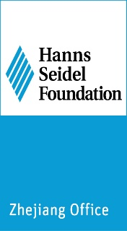
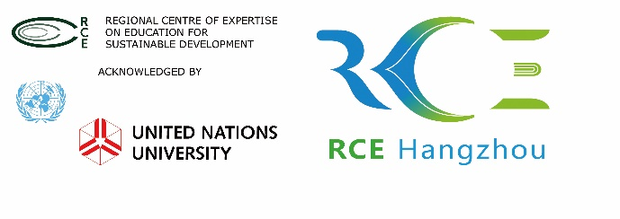

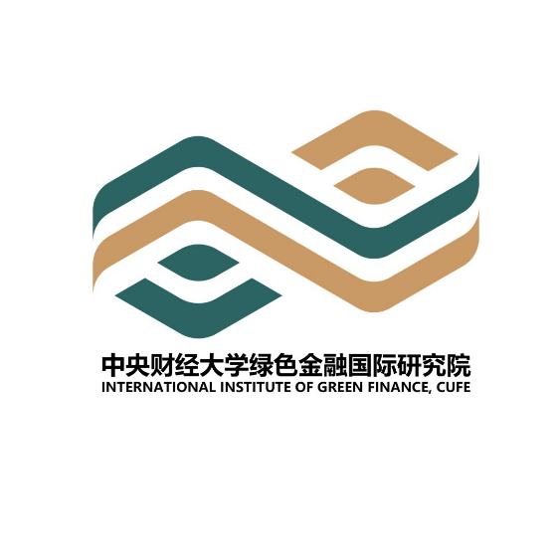
Co-Organizers and Partners

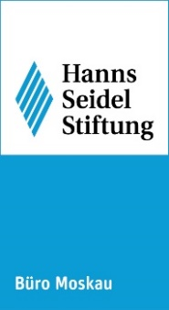
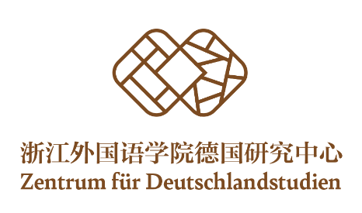

Contact
Ms. FU Weijia, Project Manager Hanns Seidel Foundation (Zhejiang Office, China)
Tel. +86 0571 85293220
Fu@hss.de

Further reading material (will be updated)

- Asian Development Bank, Ecological Civilization in the People’s Republic of China: Values, Action, and Future Needs, https://www.adb.org/sites/default/files/publication/545291/eawp-021-ecological-civilization-prc.pdf, 23.10.2020
- Climate Action Tracker: https://climateactiontracker.org/ , 22.10.2020
- Chinese Ministry of Ecology and Environment, The Belt and Road Ecological and Environmental Cooperation Plan: http://english.mee.gov.cn/Resources/Policies/policies/Frameworkp1/201706/t20170628_416869.shtml , 22.10.2020
- European Commission, EU Green Deal: https://ec.europa.eu/info/strategy/priorities-2019-2024/european-green-deal_en , 22.10.2020
- European Commission, Urban Europe - statistics on cities, towns and suburbs https://ec.europa.eu/eurostat/statistics-explained/index.php?title=Urban_Europe_%E2%80%94_statistics_on_cities,_towns_and_suburbs , 23.10.2020
- United Nations (UNFCCC) - Paris Agreement, https://unfccc.int/process-and-meetings/the-paris-agreement/the-paris-agreement , 23.10.2020
- United Nations – Sustainable Development Goals, https://www.un.org/sustainabledevelopment/sustainable-development-goals/ , 23.10.2020
- Voytenko, Y., McCormick, K., Evans, J. & Schliwa, G., Urban Living Labs for Sustainability and Low Carbon Cities in Europe: Towards a Research Agenda. Journal of Cleaner Production. http://lup.lub.lu.se/search/ws/files/6405418/8258003.pdf, 23.10.2020

