Environmental Volunteering: An Effective Tool for Implementing Education for Sustainable Development in Bangladesh

- Ms Selina Nargis, Professor, IUBAT, email: selina@iubat.edu, Cell: 01819 234557
- Dr. Mohammed Ataur Rahman, Professor, IUBAT, email: marahman@iubat.edu, Cell: 01711 821908
- Dr. Arif Reza, Assistant Professor, IUBAT, email: arif.reza@iubat.edu, Cell: 01712-593256
- Dr. Muhammad Rehan Dastagir^{[a]}, Assistant Professor, IUBAT, email: rdastagir@iubat.edu, Cell: 01517033150

“a” denotes corresponding author

Abstract
Environmental volunteering is an effective tool for implementing education for sustainable development (ESD). It includes behavioral change and different actions including awareness raising activities against environmental pollution, biodiversity conservation, sustainable agricultural practices through organic farming, community health, hygiene and nutritional programs etc. Compared to the developed countries, participation in conventional volunteering activities are relatively low in Bangladesh. However, Bangladesh has a rich history in traditional social volunteering. Since the inception of RCE (Regional Centre of Expertise) Greater Dhaka, the organization has been working to orient and structure environmental volunteering as an integral part of ESD. Initially, the volunteering activities of the centre were mainly concentrated within urban educational institutions but it is now expanded to the urban and rural communities and to some extent globally. It is found that, the role of environmental volunteering is beyond the price range for overcoming the resource barrier.
Keywords: Environmental Volunteering, Education for Sustainable Development, Community, Sustainability, Bangladesh

Introduction:
Volunteering is known as a selfless activity dedicating for a person or community in need. It is a great way to learn more about nature, cultures and traditions; meet new people and gain valuable experiences thus enriching life and enhancing community resources. The reward it offers is enough for personal fulfillment with joy and commitment for the community. Besides personal enlightenment volunteering triggers anyone's scope to gain experience before fully investing their time and energy in anything. This riskless small donations leads to gain experience and networking for any desired social activity. People all around are involved in plenty of volunteering activity such as blood donation, scouting, assistance during events, emergency extended hands etc ^{[1]}
Environmental volunteering is considered as a new dimension of volunteering involving natural and ecological conservation and also creating awareness in the society. People across the world are involved in tree plantation, cleaning roads or ecological famous sites, awareness campaigning on energy saving, hygiene education in the slum area etc. Turkmenistan is a country where maximum population is involved in volunteering. Developed nations have higher tendency to do than the developing ones. Position of Bangladesh in volunteering is 120^{[2]}.
In considering the general motivations affecting volunteering and the specific dimension of environmental volunteering^{[3]}, proposed the following set of six factors motivating volunteers in an environmental context: (1) contributing to community; (2) social interaction; (3) personal development; (4) learning about the environment; (5) a general ethic of care for the environment; (6) an attachment to a particular place. They also proposed that there are five principal modes of environmental volunteer activity: activism, education, monitoring, restoration and (promoting) sustainable living.
Post-2015 sustainable development agenda is to succeed through improving governance, tackling inequalities, and expanding voice and participation that need to be addressed simultaneously. Volunteerism can help by giving voice to stakeholders and by mobilizing people and civil society organizations to contribute in providing solutions. Increased participation needs to be met via huge response from governance actors, the private sector and others who play increasingly pivotal roles in governance and service delivery processes. Opening up opportunities and spaces for volunteerism to realize this potential will require a range of strategies, partnerships and alliances across different levels of governance^{[4]}.
The critical role of volunteerism as a unifying force without which future goals in relation to poverty reduction and sustainable development cannot be realized., Incorporating volunteerism into environment and development programming is crucial for sustainably building the resilience of communities, improving capacity for local self-sufficiency and encouraging changes in attitudes and mindsets that can durably influence policies and local action at the grassroots level. The involvement of diverse actors at national and global levels is, however, crucial^{[5]}.
In comparison to the developed countries, participation in conventional volunteering activities is relatively low in Bangladesh. According to a report from the Charities Aid Foundation, Turkmenistan had the highest proportion of people who volunteered their time in 2013 (53%), followed by Myanmar (51%); but Bangladesh is 14% only^{[6]}. However, Bangladesh has a rich history in traditional social volunteering. From the time immemorial, people of Bangladesh volunteer in disasters like cyclones, tornadoes, floods and fires etc. and also in agricultural works, selflessly. Helping each other is a cultural heritage here. In the early days, besides disasters and emergency time, farmers of Bangladesh used to work voluntarily as a group called “Jogali” for other farmer to support in peak cultivation time without any monetary exchange. However, those practices are gradually diminishing in the modern technological era.
However, understanding the role of volunteering in local and national building program, RCE Greater Dhaka has included environmental volunteering in the ESD curricula for the undergraduate level first time in Bangladesh and the students are being trained on environmental volunteering. Secondly, the IUBAT University, the host institute of RCE Greater Dhaka is cultivating 100+ schools and colleges every year with its benevolent volunteers and transferring ESD knowledge to these educational institutions. Thirdly, this volunteering activity overcomes the barrier of financial constraints of the institution to act for the sustainable development. Every year thousands of selfless educated volunteers are being trained up from those schools and colleges. Fourthly, the RCE is working with national government to expand and promote this volunteering activity through different educational programs at national level.
The major volunteering programs are:

- ESD campaigns and practices for energy and water saving, waste and resource management, 3Rs and pollution control etc; RCE Partners led by Centre for Global Environmental Culture (CGEC), IUBAT
- Environmental Volunteering in Eco-radius of 100+ schools and colleges: RCE Partners led by IUBAT
- Emergency Rescue and Disaster Management; RCE Partners led by RCY (Red Crescent Youth), Chittagong
- Sustainable Agriculture: Organic Farming and Permaculture; RCE Partners led by WWOOF (World Wide Opportunities on Organic Farms) Bangladesh
ESD Campaigns and Practices: The Center for Global Environmental Culture (CGEC), the host organization of RCE Greater Dhaka aims at achieving self reliance for Bangladesh through the promotion of socio-cultural and environmental sustainability and informing people about how to enrich Bangladesh with environmental resources and representing Bangladesh as a land of global learning in socio-cultural forces.

The broad objectives of the CGEC are to create awareness during the crises, conduct training for people in development, and undertake projects for research work and to promote a culture of environmental development, ecosystem management and self reliant sustainability of people, voluntarily. It advocates and puts on practices the environmental ethics, regeneration of eco-resources and resource management, energy efficiency, alternative energy use, renewable energy system and relevant actions. It is felt that inadequacy of skills and sensitivity to environmental issues among the planners and implementers of development works in Bangladesh is the cause of many environmental problems. The objectives of the CGEC which are geared towards establishing a culture of environment ecosystem development are being obtained by providing enlightening motivation, training, education and field demonstration to the people in development through voluntary action. It organizes ESD campaigns for waste management, energy saving, pollution control, biodiversity conservation, save the rivers and wet-bodies, tree plantation and observes national and international days relating to environment, climate change and sustainability shown in Figure I.

Place for Figure I

Environmental Volunteering in Eco-radius of 100+ schools and colleges:

IUBAT University is the central volunteering hub to many primary and secondary schools and colleges. Under the youth mobilization program, IUBAT university campus and its surrounding 100 km diameter area are considered as an active zone of awareness which is materialized by the continuous volunteer engagement of youths in and outside campus, shown in Figure II. The goal of the program is to educate the students of all schools and colleges of this 100 km diameter on ESD practices to produce environmentally conscious citizens fully aware of the values of Sustainable Development Goals (SDGs). The regional centre is organizing annual conference to exchange the views and ideas among the participant schools and colleges^{[7]}.

The annual intake of Environmental Science and Sustainable Development course in the university is around 1500 students. The centre is giving students community development projects where students are mainly working as an environmental volunteer in nearby schools and colleges. The volunteering activity especially focuses on educational campaigning in educational institutions. The students have been trained to take classes there where they select topics to lecture on resource utilization, carbon footprint, biodiversity conservation, environmental pollution, energy savings and waste management etc. Student’s feedback have been collected and analyzed to evaluate their level of knowledge, attitude and practice towards sustainable development.
Figure II: Environmental Volunteering in Eco-radius of 100+ schools and colleges
Figure III: Snapshots from students school volunteering program in different schools

Developing Contextual framework of Environmental Volunteering
The contextual framework of this has been developed by RCE Greater Dhaka, Bangladesh with technical support of RCE Greater Western Sydney (GWS), Australia. Both RCEs have done collaborative research for a long time. Mr. Rafiqul Huq, Manager of the largest environmental volunteering organization of Australia has developed a conceptual paper on environmental volunteering^{[8][9]}. RCE Greater Dhaka is working with RCE GWS to formulate our own guidelines and mode of action. In Figure.-4, Mr. Huq of RCE GWS presenting in RCE Greater Dhaka on environmental volunteering in Australia. We have been taken assistance from United Nations Volunteers of United Nations Development Program (UNDP). Recently they have started volunteering program in Bangladesh^{[10]}. The Fig.- 5, illustrates RCE Greater Dhaka Youth Forum and UNV meeting in IUBAT University campus.

Figure IV: Mr. Rafiqul Huq of RCE GWS presenting in RCE Greater Dhaka on environmental volunteering in Australia

Fig. V: RCE Greater Dhaka volunteer meeting with UNV representative

Red Crescent Youth Volunteers in Disaster:
Red Crescent Youth, Chittagong is a youth organization for adolescents and young members interested in the International Red Cross and Red Crescent Movement is also working with RCE Greater Dhaka. Red Crescent Youth Chittagong (RCY) committed to ensure humanitarian assistance for vulnerable country people. RCY Chittagong volunteers together to serve beside the vulnerable people voluntarily. During the Cyclone 1997, those youth’s participated in a life challenging rescue of cyclone victims and after that the relief distribution and rehabilitation program successfully. In 1998 & 2004 during the flood, Red Crescent Youth, Chittagong contributed fund raising from School, College students who voluntarily contribution their Tiffin money to address the flood affected people of Bangladesh. It continues Community Based Disaster Preparedness Program (CBDP) in coastal belt area shown in Figure 4. Red Crescent Youth, Chittagong plays a vital rule for International Friendship Exchanged Program. At present, it is working in a project Earth Quake Prepared and Response Program (EPRP), Disaster Risk Reduction Program within the guideline of Bangladesh Red Crescent Society & International Federation of Red Cross and Red Crescent Societies (IFRC).

Fig. VI: Rescue operation during land slide in Chittagong Hill Tracts, Bangladesh^{[11]}

Volunteering on Organic Farming: WWOOF

WWOOF is the World Wide Opportunities on Organic Farms by providing opportunities for the organic farm producers to share information, knowledge, techniques and cultural practices among the volunteers and members of the organic farming community around the world. The members of the WWOOF are the WWOOFers, exchange their experiences on organic farming learn new things and also contribute knowledge from/to the other regions as guest WWOOFer and Hosts. It is a volunteer mechanism to re-establish organic farming worldwide for a sustainable agriculture to favor biodiversity conservation and to reduce pollution effects to lives. WWOOF is a worldwide movement linking volunteers with organic farmers and growers to promote cultural and educational experiences based on trust and non-monetary exchange, thereby helping to build a sustainable, global community^{[12][13]} .
WWOOF was started in 1971 in England by Ms Sue Coppard, a London Secretary, with the idea to work on organic farming on weekends to provide access to herself to the countryside for supporting the organic movement. Her idea started with a trial working weekend, which she arranged for four people at the biodynamic farm at Emerson College in Sussex through a contact in the Soil Association. The weekend was a great success and things gathered momentum very quickly and the organization was called “Working Weekends on Organic Farms”, WWOOF. Soon many more organic farmers and smallholders were willing to take people keen to work on this basis (WWOOFers). It seemed that many people were just desperate to get into the countryside. Hosts and workers made new friends and enjoyed the experience of working in common in an exchange of assistance and knowledge. However, the name “Working Weekends on Organic Farms" was changed to "Willing Workers On Organic Farms". But eventually with the worldwide recognition it was renamed as "World Wide Opportunities on Organic Farms" in 2000 to resolve the confusion caused by the word 'work' which usually meant for migrant workers to differentiate from the volunteers of organic farms, the WWOOFers.

Fig. VII: Six location of WWOOF Bangladesh Headquarter and Host farms

WWOOFers are contributing towards a wider organic world and more people are getting interested to join WWOOF as volunteers and WWOOF is expanding worldwide very quickly. Now, WWOOF has expanded to over 317 members in 51 countries listed as independents and 46 countries worldwide with national organizations. WWOOF Bangladesh has started its volunteering activities since 2009. Hundreds of volunteers from home and abroad are working in different host farms every year to learn and exchange knowledge about organic farming and permaculture. WWOOF Bangladesh is an active partner of RCE Greater Dhaka and contributing in ESD activities especially on sustainable agriculture towards organic living; excluding chemical pesticides and fertilizers to reduce pollution for protecting human health and other lives and also for biodiversity conservation^{[14]}.

Impact of Environmental Volunteering:
Environmental volunteering is a driving force for achieving sustainable development goals and an integral part of ESD. This has been included in the ESD course curricula and students are being trained up for environment volunteering. RCE Greater Dhaka provides practical training to 1500 students every year to develop themselves as environment volunteers following proper volunteering guidelines. Their volunteering activities are evaluated on a project basis as a part of the course content.
We have found that this impact is far reaching as a single university is nurturing 100 schools and colleges annually. Proper governmental policy and support will lead the program to all school and colleges in Bangladesh. RCE Greater Dhaka is persistently advocating on this to bring this to the focus of the government of the country.
Overcoming financial barrier, by volunteering can be done in a rigorous manner. Many of the environmental problems occur only because of lack of awareness and attitude towards environment. If every citizen of the world would plant a tree then there would be 7.5 billion trees in the world planted in a year. Environmental volunteering basically works on awareness development and sharing of knowledge. But volunteering cannot work on major capacity development sector. Proper education, training and knowledge share requires a huge amount of financial capital that is difficult to allot by any developing country like Bangladesh. In this respect individual small contribution could play major role to overcome the barrier. An example is the annual school campaign by the students of IUBAT University of environmental course. Here nearly 100 schools are covered by campaigning of the 1500 volunteer students. Here each volunteers donate 200 BDT and total is (1500 * 200) = 300000 BDT nearly 4000 U$. This amount is solely operated by the group of students. They work in a small five member cluster and expend their money by themselves for posters, banners, leaflets, gifts etc. for the school campaigning. We can say that though our RCE did not get any local or foreign funds we are generating small funds by volunteering and operating our 100 school volunteering program. We teach our students “donate in volunteering than donate to street beggars”.
Develop Environmental Leadership, leadership is a vital thing that needs to be developed among youths. Bangladesh is a country where 30% of the population of 160 million people is youth. This trained youth has a lot to contribute in future sustainable nation. Environmental volunteering helps them to connect with community easily and get chance to do for nature. This will bring experience to them and this experience will help them to take decision in future whenever they are in a vital position in the society. The leading volunteer program of the RCE Greater Dhaka helped them to involve with global organic farming, underprivileged schools and colleges, disaster prone areas, health issue of urban slum dwellers. The experience, the youth gather here, is priceless. Environmental volunteering opens the door to gather positive experience to the youths. They also learn that satisfaction in our life depends on serving others.
Recommendation:
In overcoming the financial constraints in developing Bangladesh and playing role for future youth leaders Environmental Volunteering is taken into ESD context in RCE Greater Dhaka in IUBAT. We are recommending that our government should take necessary step to include this in the primary and secondary education curricula. In this case we could extend our cooperation to them. We also recommend that with the local funding of government, our RCE could play role of a resource centre for training and developing environmental volunteering activities and for regional, local and organize international meeting on ESD.
References:

- McDougle, L. M., Greenspan, I., Handy, F., (2011). Generation green: understanding the motivations and mechanisms influencing young adults’ Environmental volunteering. Int. J. Nonprofit Volunt. Sect. Mark. 16: 325–341 (2011), Published online in Wiley Online Library.
- Economist blog (2014), Volunteering [Online resource]accessed on 30/07/2017 online source,https://www.economist.com/blogs/freeexchange/2014/09/economics-volunteering.
- Measham T. G. and. Barnett G. B, (2008). Environmental Volunteering: motivations, modes and outcomes; Australian Geographer, Vol. 39, No. 4, pp. 537552.
- United Nation’s Volunteers (UNV), State of World’s Volunteering report, 2015, United Nations Development Program (UNDP).
- UNV Issue Brief Environmental Sustainability and Volunteerism: Considerations for post-2015 development agenda, January 2014
https://sustainabledevelopment.un.org/content/documents/120020443_UN%20Volunteers%20POST-2015%20Brief%20-%20Environmental%20Sustainability%20and%20Volunteerism%20WEB.pdf
- Scheller, A., 2014 Healthy Living The Countries Where You’ll Find The Most Volunteers.
Source:Huffpost, Dec 02, 2014 http://www.huffingtonpost.com/2014/12/02/volunteering-by-country_n_6221046.html
- Dastagir,M.R.,Rahman,M.A,Hoque,M.A.,2017.“Mobilizing Education for Sustainable Development Program in the Regional Centre of Expertise Greater Dhaka:
IUBAT Whole-Institution approach of Global Action Program.”
IUBAT Review 1 (2): 49-64. iubat.edu/journal.
- Huq, R and Shelly, B., ( 2016) Eco-social capital: A proposal for exploring the development of cohesiveness in environmental volunteer groups, Volume 22 Issue 1: 49-68.
- Green Australia, [Online resource], accessed on 31/07/2017: https://www.greeningaustralia.org.au/news/nsw-community-volunteer-program
- UN Volunteers. (n.d.). Retrieved August 05, 2017, from http://www.bd.undp.org/content/bangladesh/en/home/operations/un-volunteers.html
- Red Crescent Youth, RCY, Chittagong, May 2017 https://www.facebook.com/RCY.CTG/photos/pcb.1520622701316345/1520624221316193/?type=3&theater
- WWOOF (2017) accessed from: http://wwoof.net/
- https://drive.google.com/drive/folders/0B-slDbzopA47UHhTVFRMWDdjWjg
- WWOOF Bangladesh(2017), accessed from web link: http://www.wwoofbangladesh.org/wf_around_world.html

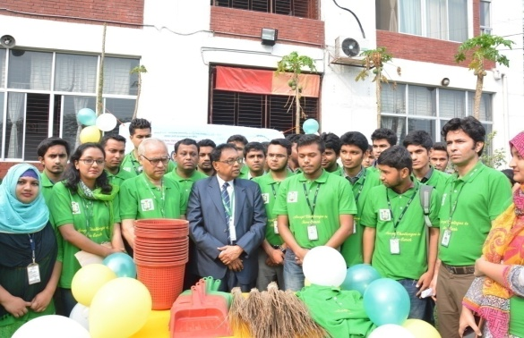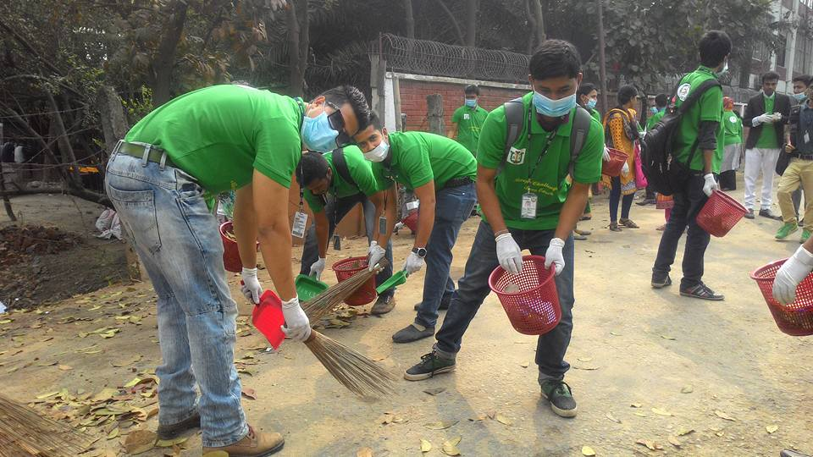
Figure I: In Campus Waste Management campaign organized by CGEC

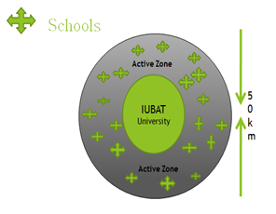
Figure II: Environmental Volunteering in Eco-radius of 100+ schools and colleges

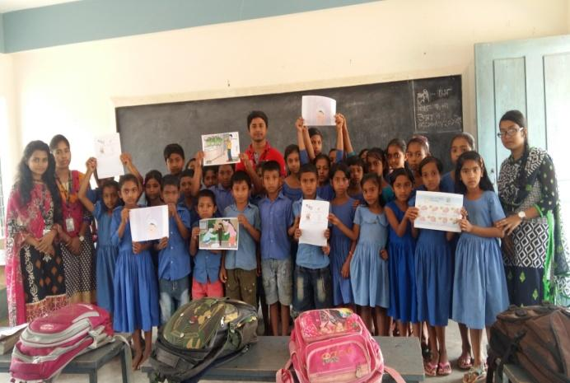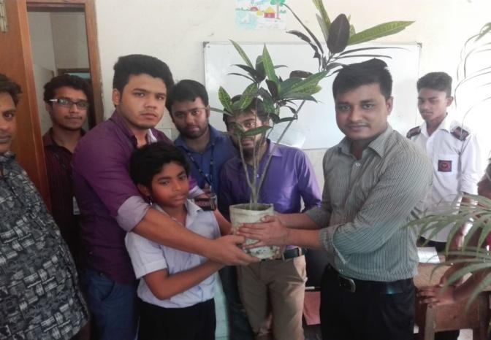
Figure III: Snapshots from students school volunteering program in different schools
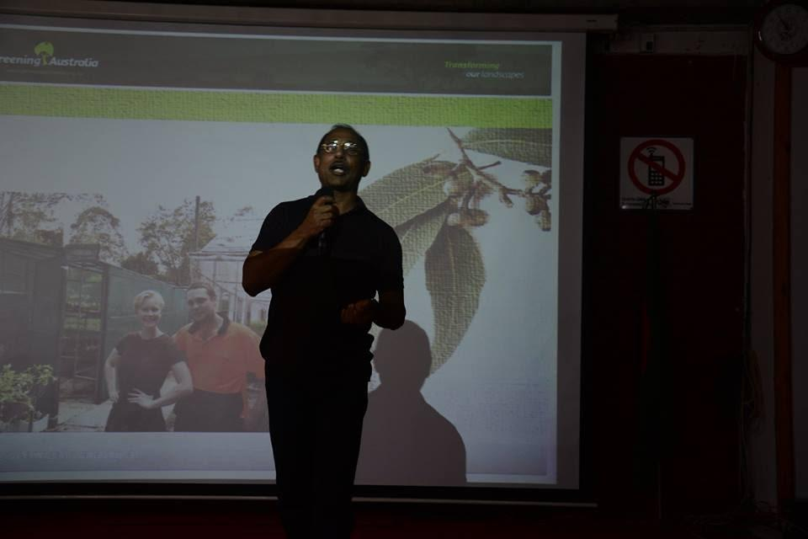
Figure IV: Mr. Rafiqul Huq of RCE GWS presenting in RCE Greater Dhaka on environmental volunteering in Australia

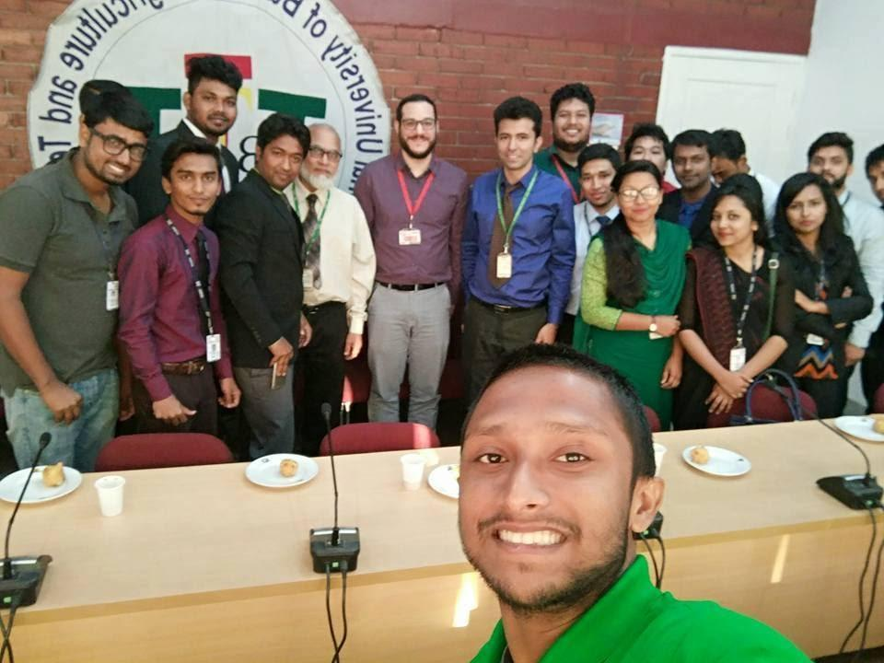

Fig. V: RCE Greater Dhaka volunteer meeting with UNV representative

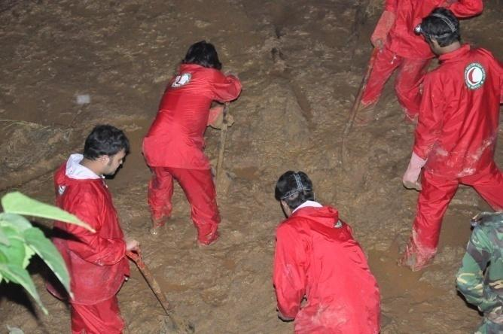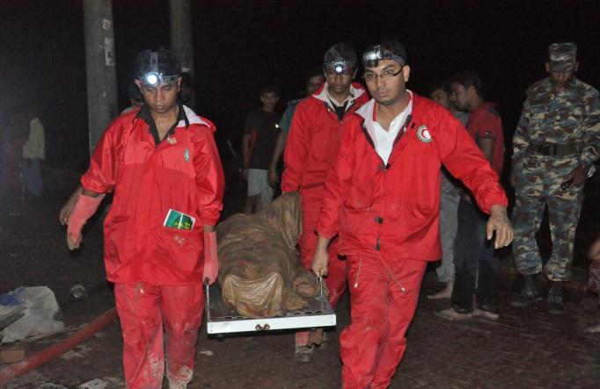
Fig. VI: Rescue operation during land slide in Chittagong Hill Tracts, Bangladesh^{[11]}
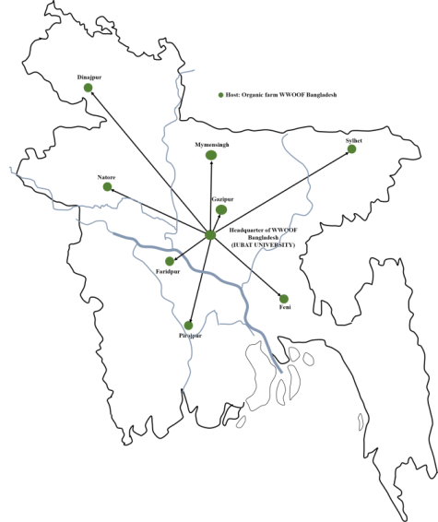
Fig. VII: Six location of WWOOF Bangladesh Headquarter and Host farms

