Environmental Volunteering as an ESD tool towards implementing SDGs in Bangladesh
Professor Mohammed Ataur Rahman, PhD
Coordinator, RCE Greater Dhaka, Bangladesh

Summary

Environmental volunteering is an emerging field in Education for Sustainable Development (ESD). Beside the traditional field of volunteering it includes different activities related to socio-ecological conservation of a nation. Compare to the developed countries, participation in conventional volunteering activities are relatively low in Bangladesh. However, Bangladesh has a rich history in traditional social volunteering. Since the inception of RCE (Regional Centre of Expertise) Greater Dhaka, the organization has been working to orient and structure environmental volunteering as an integral part of ESD. It is actively promoting ESD based volunteering engaging the youths in and outside the country to transform the society. Initially, the volunteering activities of the centre were mainly concentrated within urban educational institutions but it is now expanded in the urban and rural communities. This centre is involved in carrying out volunteering activities for practicing ESD, disaster management, community health, hygiene and nutritional programs and in sustainable agricultural practices through organic farming. RCE Greater Dhaka is playing a key role in integrating volunteering activity in the main stream of ESD and imparting a dynamic multidirectional role for the community by overcoming the financial constraints of this least developed country. It is found that, the role of environmental volunteering is beyond the price range for overcoming the resource barrier. Through its selfless collective effort it has reached at the every scale of society such as education, health, disasters, farming and biodiversity conservation etc. This centre has developed and refined the sets of motivations and modes through engagement of volunteers and their coordinators from different environmental groups of the country to promote community education. It is also making the centre a global hub for environmental volunteering activism.

Keywords: Environmental Volunteering, Organic Farming, Education for Sustainable Development, WWOOF, UNV

Introduction

Volunteering is known as a selfless activity dedicating for a person or community in need. It is a great way to learn more about nature, cultures and traditions; meet new people and gain valuable experiences thus enriching life and enhancing community resources. The reward it offers is enough for personal fulfillment with joy and commitment for the community. Besides personal enlightenment volunteering triggers anyone's scope to gain experience before fully investing their time and energy in anything. This riskless small donations leads to gain experience and networking for any desired social activity. People all around are involved in plenty of volunteering activity such as blood donation, scouting, assistance during events, emergency extended hands etc (Mcdougle, 2011).
Environmental volunteering is considered as a new dimension of volunteering involving natural and ecological conservation and also creating awareness in the society. People across the world are involved in tree plantation, cleaning roads or ecological famous sites, awareness campaigning on energy saving, hygiene education in the slum area etc. Turkmenistan is a country where maximum population is involved in volunteering. Developed nations have higher tendency to do than the developing ones. Position of Bangladesh in volunteering is 120 (Economist, 2014).

In considering the general motivations affecting volunteering and the specific dimension of environmental volunteering, T. G. Measham & G. B. Barnett (2008) proposed the following set of six factors motivating volunteers in an environmental context: (1) contributing to community; (2) social interaction; (3) personal development; (4) learning about the environment; (5) a general ethic of care for the environment; (6) an attachment to a particular place. They also proposed that there are five principal modes of environmental volunteer activity: activism, education, monitoring, restoration and (promoting) sustainable living

Post-2015 sustainable development agenda is to succeed through improving governance, tackling inequalities, and expanding voice and participation that need to be addressed simultaneously. Volunteerism can help by giving voice to stakeholders and by mobilizing people and civil society organizations to contribute in providing solutions. Increased participation needs to be met via huge response from governance actors, the private sector and others who play increasingly pivotal roles in governance and service delivery processes. Opening up opportunities and spaces for volunteerism to realize this potential will require a range of strategies, partnerships and alliances across different levels of governance (UNV report, 2015).

The critical role of volunteerism as a unifying force without which future goals in relation to poverty reduction and sustainable development cannot be realized., Incorporating volunteerism into environment and development programming is crucial for sustainably building the resilience of communities, improving capacity for local self-sufficiency and encouraging changes in attitudes and mindsets that can durably influence policies and local action at the grassroots level. The involvement of diverse actors at national and global levels is, however, crucial (UNV Issue Brief 2015).
In comparison to the developed countries, participation in conventional volunteering activities is relatively low in Bangladesh. According to a report from the Charities Aid Foundation, Turkmenistan had the highest proportion of people who volunteered their time in 2013 (53%), followed by Myanmar (51%); but Bangladesh is 14% only (Scheller, 2014). However, Bangladesh has a rich history in traditional social volunteering. From the time immemorial, people of Bangladesh volunteer in disasters like cyclones, tornadoes, floods and fires etc. and also in agricultural works, selflessly. Helping each other is a cultural heritage here. In the early days, besides disasters and emergency time, farmers of Bangladesh used to work voluntarily as a group called “Jogali” for other farmer to support in peak cultivation time without any monetary exchange (Rahman, 2017). However, those practices are gradually diminishing in the modern technological era.

However, understanding the role of volunteering in local and national building program, RCE Greater Dhaka has included environmental volunteering in the ESD curricula for the undergraduate level first time in Bangladesh and the students are being trained on environmental volunteering. Secondly, the IUBAT University, the host institute of RCE Greater Dhaka is cultivating 100+ schools and colleges every year with its benevolent volunteers and transferring ESD knowledge to these educational institutions. Thirdly, this volunteering activity overcomes the barrier of financial constraints of the institution to act for the sustainable development. Every year thousands of selfless educated volunteers are being trained up from those schools and colleges. Fourthly, the RCE is working with national government to expand and promote this volunteering activity through different educational programs at national level.

The major volunteering programs are:

- ESD campaigns and practices for energy and water saving, waste and resource management, 3Rs and pollution control etc; RCE Partners led by Centre for Global Environmental Culture (CGEC), IUBAT
- Environmental Volunteering in Eco-radius of 100+ schools and colleges: RCE Partners led by IUBAT
- Emergency Rescue and Disaster Management; RCE Partners led by RCY (Red Crescent Youth), Chittagong
- Health, Hygiene and Nutrition; RCE Partners led by IUBAT College of Nursing and Health Science
- Sustainable Agriculture: Organic Farming and Permaculture; RCE Partners led by WWOOF (World Wide Opportunities on Organic Farms) Bangladesh

ESD Campaigns and Practices: The Center for Global Environmental Culture (CGEC), the host organization of RCE Greater Dhaka aims at achieving self reliance for Bangladesh through the promotion of socio-cultural and environmental sustainability. The CGEC was established in 1999 for influencing local, national, regional and international decisions and policies on environmental issues and sustainability through cutting edge research and developing trained and skilled volunteers.
The broad objectives of the CGEC are to create awareness during the crises, conduct training, and undertake research projects along with promoting a culture of environmental development, ecosystem management and self reliant sustainability, voluntarily. The center advocates and puts on practices the environmental ethics, regeneration of eco-resources and resource management, energy efficiency, alternative energy use, renewable energy system and relevant actions. The objectives of the CGEC are focused towards establishing a culture of environment and ecosystem development, obtained by motivation, training, education and field demonstration through voluntary activities. CGEC with other RCE partners including Green Savers, Change, Birds club etc. organize ESD campaigns on waste management, energy saving, pollution control, biodiversity conservation, save the rivers and wet-bodies, tree plantation and observes national and international days related to environment, climate change and sustainability. 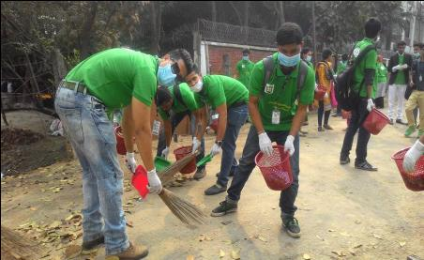
Fig 1 Voluntary cleaning program and Fig 2 Campaign against river pollution organized by CGEC

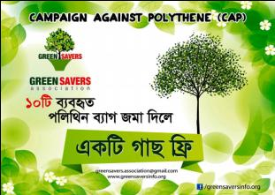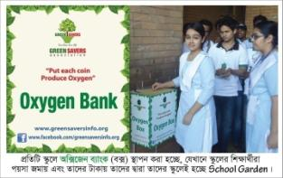
Fig 3 Voluntary campaign against polythene and Fig 4 Oxygen bank for voluntary School Gardening organized by GreenSavers

Environmental Volunteering in Eco-radius of 100+ schools and colleges:
Environmental volunteering is a driving force to achieve sustainable development goals and an integral part of ESD. This has been included in the ESD course curricula and students are being trained up for environment volunteering.
IUBAT University (host institute of RCE Greater Dhaka) is acting as central volunteering hub to many primary and secondary schools and colleges. Under the youth mobilization program, university students are engaged voluntarily to educate all the school and college students within 100 km diameter of IUBAT campus (as an active zone) on ESD practices. The student volunteers are working on community development projects to make themselves fully aware of the values of Sustainable Development Goals (SDGs). Around 1500 students are being trained up with ESD practices annually.
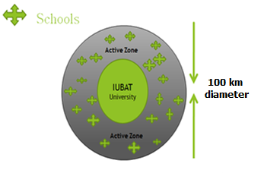
Fig 5: Environmental Volunteering in Eco-radius of 100+ schools and colleges

The volunteering activities focus on educational campaigns in the school and colleges. The volunteers conduct activity classes on selected topics such as resource utilization, carbon footprint, biodiversity conservation, environmental pollution, energy savings and waste management etc. Student’s feedback have been collected and analyzed to evaluate their level of knowledge, attitude and practice towards sustainable development. RCE Grater Dhaka has been organizing annual conference to exchange the views and ideas among the participant educational institutes and partner organizations.
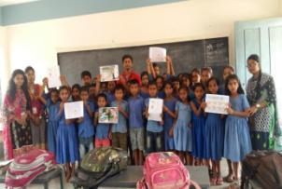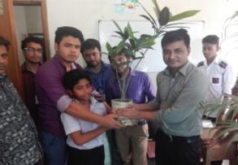
Fig. 6 & 7: Environmental volunteering campaign in Educational Institutions within the Eco-radius 100+

Table I: Environmental Volunteering in School and College
Total Students number engaged annually 1500
Summary of Activities
Sl no | School campaign | Location | Campaign theme | Online resources
1 | Khandoker Rojob Ali Bidda Niketon | Tongi, Gazipur | Water Saving | https://www.facebook.com/iubatyf/
2 | Kaichabari Primary School | Savar, Gazipur | Recycling product | https://www.facebook.com/groups/IubatEnv/
3 | Abdur Rahman High School | Tongi, Gazipur | Health Hygiene | https://www.youtube.com/watch?v=88ucHc__lkI
4 | Dhaka Brilliant School | Uttara, Dhaka | Slum Health | https://www.youtube.com/watch?v=nPlzTuWNueA
5 | Golden Life Ideal School | Gazipur | Anti-smoking | http://greenearth.tk/work.html
6 | Mazida high school | Tongi, Gazipur | Road safety
7 | Barakau Govt Primary school | Gazipur | Earthquake preparedness
8 | The Amirat School and College | Uttara 10, Dhaka | Tree Plantation
9 | Turag model school | Turag, Dhaka | Tree Plantation
10 | Talents High School and College | Azampur, Uttara, Dhaka | Biodiversity saving World Env Day 2016 | https://www.facebook.com/iubatyf/
11 | Brac School | Mirpur-2, Dhaka | Biodiversity saving World Env Day 2016 | https://www.facebook.com/groups/IubatEnv/
12  13 | Western Laboratory School  Paradise School and College | Uttara Sector 10, Dhaka  Uttara Sector 10, Dhaka | Biodiversity saving World Env Day 2016  Biodiversity saving World Env Day 2016 | https://www.youtube.com/watch?v=88ucHc__lkI  https://www.youtube.com/watch?v=nPlzTuWNueA
14 | Dhaka Paramount School and College | Uttara, Dhaka | Biodiversity saving World Env Day 2016 | http://greenearth.tk/work.html
15 | Brac Kishori Club | Dhaka | Biodiversity saving World Env Day 2016
16 | Mevis Int. School and Institute | 9, Uttara, Dhaka | Biodiversity saving World Env Day 2016
17 | Dhour Govt. Primary School | Turag, Dhaka | Biodiversity saving World Env Day 2016
18 | Dr. Muhammad Shahidullah Model High School | Dhaka | Biodiversity saving World Env Day 2016
19 | Blooming Flower International School and College | Uttara Dhaka | Biodiversity saving World Env Day 2016 | https://www.facebook.com/iubatyf/
20 | Grace International School | Uttara Sector 11, Dhaka | Biodiversity saving World Env Day 2016 | https://www.facebook.com/groups/IubatEnv/
21 | Uttara Ideal High School | Ranavola, Turag, Dhaka | Biodiversity saving World Env Day 2016 | https://www.youtube.com/watch?v=88ucHc__lkI
22 | Parashmoni Laboratory School | Uttara Sector 10, Dhaka | Biodiversity saving World Env Day 2016 | https://www.youtube.com/watch?v=nPlzTuWNueA
23 | Stamford College | Uttara, Dhaka | Biodiversity saving World Env Day 2016 | https://www.youtube.com/watch?v=nPlzTuWNueA

Following educational institutions have been covered under Environmental Volunteering Campaign for ESD

- Talents High School and College, Azampur, Uttara, Dhaka
- Touchstone School and College, Uttara Sector 10, Dhaka
- Brac School, Mirpur-2, Dhaka
- Turag Model School, South Kamarpara, Dhaka
- Western Laboratory School, Uttara Sector 10, Dhaka
- Paradise School and College, Uttara Sector 10, Dhaka
- Dhaka Paramount School and College, Uttara, Dhaka
- Brac Kishori Club, Dhaka
- Mevis Int. School and Institute, Uttara, Dhaka
- Dhour Govt. Primary School, Turag, Dhaka
- Dr. Muhammad Shahidullah Model High School, Dhaka
- Blooming Flower International School and College, Uttara Dhaka
- Grace International School, Uttara Sector 11, Dhaka
- Uttara Ideal High School, Ranavola, Turag, Dhaka
- Parashmoni Laboratory School, Uttara Sector 10, Dhaka
- Stamford College Uttara, Dhaka
- Uttara Model Academy, Kamarpara, Turag, Dhaka
- Holy International High School, Bhabnartek, Dhaka
- Batulia Govt. Primary School, Dhamrai, Dhaka
- Bidyakanaon Precadet and High School, Savar, Dhaka
- Uttara Ideal School and College, Sector-9, Uttara, Dhaka
- Bailjuri Govt. Primary School, Sector-13, Uttara, Dhaka
- Olympia Textile Mills High School, Tongi, Gazipur
- Abdur Rahman High School, Bhabnartek, Dhaka
- Kasimul Ulum Islamia Madrasha, Uttara, Dhaka
- Apon Pathshala, Sector-8, Uttara Rail Line, Dhaka
- New Prattasha High School, Khilkhet, Dhaka
- Skylark Model School, ECB Square, Dhaka Cantonment
- Kosba Model Academy, Brahmanbaria
- Muscot Innovative School and College, Dhaka
- Nawab Habibullah Model School and College, Uttara, Dhaka
- Sahid Model School and College, Kamarpara, Dhaka
- Pentone High School, Sector 10, Fulbaria, Dhaka
- Holy Int. High School, Goltolar Mor, Uttara, Dhaka
- The Brilliant College, Uttara, Sector-4, Dhaka
- Mavis Creative School, Sector 13, Uttara, Dhaka
- The Child Laboratory School, Dakkhinkhan, Dhaka-1230.
- Pioneer School, College gate, Tongi, Gazipur

Contextual framework of Environmental Volunteering
RCE Greater Dhaka, Bangladesh is working with RCE Greater Western Sydney (GWS), Australia to develop contextual framework and guidelines of environmental volunteering for Bangladesh. Mr. Rafiqul Huq, Manager, Greening Australia (partner of RCE GWS) is involved in this program and attended a seminar on environmental volunteering as keynote speaker organized by RCE Greater Dhaka on June 24, 2017.
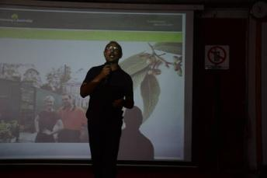
Fig. 8: Mr. Rafiqul Huq of RCE GWS presenting in RCE Greater Dhaka on environmental volunteering in Australia

The center has also been working with United Nations Volunteers (UNV), Bangladesh and organized a workshop for young volunteers of other partners.
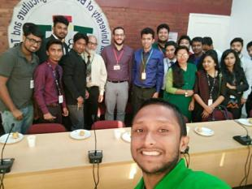
Fig. 9: RCE Greater Dhaka volunteer meeting with UNV representative

Emergency Rescue and Disaster Management;

RCE Greater Dhaka is working on emergency rescue and disaster management during erosion and landslides, tornados and cyclones, floods etc. and provides humanitarian assistance to vulnerable people. Its partners viz. Red Crescent Youth (RCY), Chittagong and South Asian Disaster Management Centre (SADMC) are actively involved in volunteering since 1990. RCY, Chittagong is a youth organization for adolescents and young members interested in the International Red Cross and Red Crescent Movement. The organization is committed to serve vulnerable people voluntarily. During the disasters of 1991, 1997, 1998, 2004, 2005, 2007, 2009, 2012-2017 youth volunteers of RCY and SADMC participated in the life challenging rescue of tornado, cyclone, flood and landslide victims. They successfully volunteered in the relief distribution and rehabilitation programs. Beside that the RCY volunteers encourage the school and college students to contribute their part of Tiffin money to the disaster affected people. They also take part in Community Based Disaster Preparedness Program (CBDP) in coastal belt. RCY, Chittagong plays a leading rule for International Friendship Exchanged Program. At present, it is working in the Earthquake Preparedness and Response Program (EPRP).
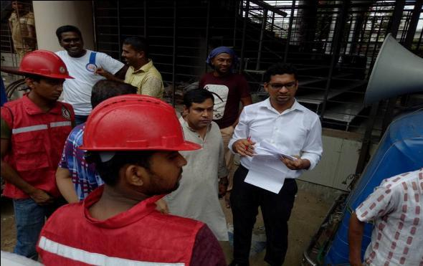
Fig 10 RCY, Chittagong volunteering health services to nearby communities
During the Cyclone Mora May 2017

Health, Hygiene and Nutrition; RCE Partners led by IUBAT College of Nursing and Health Science. IUBAT University conducts annual daylong free health check-up and health assessment services to adjacent vulnerable communities as a part of voluntary campaign led by IUBAT IUBAT College of Nursing and Health Science. A Group of medical professional volunteers from home and abroad mainly Canada and the Philippines participated in the daylong program to provide free health services. The comprehensive health care activities include checking blood pressure, eye vision testing, body mass index, blood sugar and health counseling for infants, children, adults, mothers, and geriatrics. More than 200 people of vulnerable communities from Uttara and urban slums attended the health assessment program. Expert physicians from nearby hospitals and medical colleges volunteered to support the free health services. The experience of health assessment programs will capacitate the volunteers in identifying community primary health care needs.
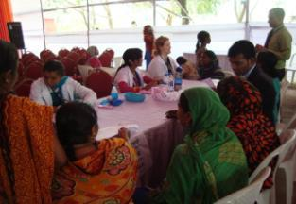
Fig 11 A daylong free health check-up and health assessment services to
adjacent vulnerable (urban slum) communities:

Volunteering on Organic Farming: WWOOF

World Wide Opportunities on Organic Farms (WWOOF) is the platform of sharing information, knowledge, techniques and cultural practices among the volunteers and organic farming community members across the globe. The WWOOF volunteers known as WWOOFers, exchange their experiences on organic farming, learn new things and contribute knowledge from/to the other regions as guest WWOOFer and Hosts and WWOOFing is a volunteer mechanism to re-establish organic farming worldwide for a sustainable agriculture to favor biodiversity conservation and reduce pollution effects to lives. In short, WWOOF is a worldwide movement linking volunteers with organic farmers and growers to promote cultural and educational experiences based on trust and non-monetary exchange, thereby helping to build a sustainable, global community (www.wwoof.net). WWOOFing explores the creation and provision of alternative farming knowledge, emphasizing on the social aspects to understand how the creation of collaborative spaces and social network of alternative agriculture enhance the learning of new techniques and practices through volunteering. Learning through volunteering as WWOOFer please visit the link: https://drive.google.com/drive/folders/0B-slDbzopA47UHhTVFRMWDdjWjg

WWOOF was started in 1971 in England by Ms Sue Coppard, a London Secretary, with a view to work on organic farming in the countryside during weekends and establish an organic movement. Her idea started with a trial working weekend, which she arranged for four people at the biodynamic farm at Emerson College in Sussex through a contact in the Soil Association. The weekend was a great success and things gathered momentum very quickly and the organization was called “Working Weekends on Organic Farms”, WWOOF. Soon many more organic farmers and smallholders were willing to take people keen to work on this basis (WWOOFers). It seemed that many people were just desperate to get into the countryside. Hosts and workers made new friends and enjoyed the experience of working in common in an exchange of assistance and knowledge. However, the name “Working Weekends on Organic Farms" was changed to "Willing Workers On Organic Farms". But eventually with the worldwide recognition, it was renamed as "World Wide Opportunities on Organic Farms" in 2000 to resolve the confusion caused by the word 'work' which usually meant for migrant workers to differentiate from the volunteers of organic farms, the WWOOFers.
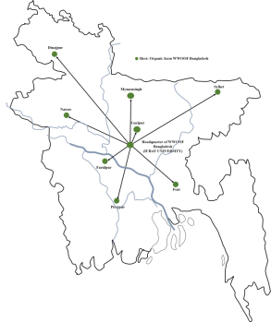
Fig 12 Location of WWOOF Bangladesh Headquarter and Host farms

WWOOFers are contributing towards a wider organic world and more people are getting interested to join WWOOF as volunteers and WWOOF is expanding worldwide very quickly. Now, WWOOF has expanded to over 317 members in 51 countries listed as independents and 46 countries worldwide with national organizations. WWOOF Bangladesh has started its volunteering activities since 2009. Hundreds of volunteers from home and abroad are working in different host farms every year to learn and exchange knowledge about organic farming and permaculture. Professor Dr Mohammed Ataur Rahman, Coordinator of WWOOF Bangladesh, has been working as Director of Federation of WWOOF Organizations (FoWO) since 2014.
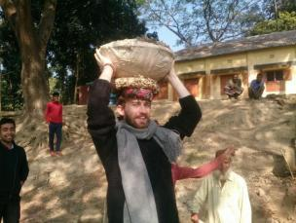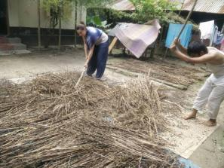
Fig 13 Mr. Ginas Ivanauskas, from Lithonia and Ms. Lauren Bovard, from USA international WWOOFers are volunteering in WWOOF Bangladesh
WWOOF Bangladesh is an active partner of RCE Greater Dhaka and contributing in ESD activities especially on sustainable agriculture towards organic living; excluding the use of chemical pesticides and fertilizers to reduce pollution and protect human health and other lives and also for biodiversity conservation (www.wwoofbangladesh.org).

Impact of Environmental Volunteering:
Environmental volunteering is a driving force for achieving sustainable development goals and an integral part of ESD. This has been included in the ESD course curricula and students are being trained up for environment volunteering. RCE Greater Dhaka provides practical training to 1500 students every year to develop themselves as environment volunteers following proper volunteering guidelines. Their volunteering activities are evaluated on a project basis as a part of the course content.
We have found that this impact is far reaching as a single university is nurturing 100 schools and colleges annually. Proper governmental policy and support will lead the program to all school and colleges in Bangladesh. RCE Greater Dhaka is persistently advocating on this to bring this to the focus of the government of the country.

Challenges of RCE Greater Dhaka
From the inception of RCE Greater Dhaka, the center has been working on various public awareness rising/building activities related to environmental issues and nature conservation. Most of the conducted activities by the center are self-motivated and voluntarily. To encourage and engage people for volunteer services, it is very important to explain them the benefits of volunteering as well as to identify the barriers that hamper their involvement. Following barriers have been identified during the volunteering programs:
  - Financial crisis
  - Lack of willingness in spending time for volunteering
  - Communication gap between the organizers and volunteers
  - Lack of flexibility and insufficient information
  - Differences in thoughts among the volunteers
  - Social conservativeness
  - Cultural differences
  - Recent terrorist activities
Some of the barriers have already been prevailed over by RCE Greater Dhaka. RCE Greater Dhaka Volunteers generate funds saving daily Tiffin money to overcome financial crisis. The center is trying to promote environmental volunteering for a sustainable society. However, recent terrorist occurrences discourage international volunteers to do volunteering in Bangladesh. The government is showing zero tolerance against terrorism and taken sufficient measures through community engagement.
Overcoming financial barrier, by volunteering can be done in a rigorous manner. Many of the environmental problems occur only because of lack of awareness and attitude towards environment. If every citizen of the world would plant a tree then there would be 7.5 billion trees in the world planted in a year. Environmental volunteering basically works on awareness development and sharing of knowledge. But volunteering cannot work on major capacity development sector. Though proper education, training and knowledge sharing require a huge amount of financial capital, it is difficult to allot by any developing country like Bangladesh. In this respect individual small contribution could play major role to overcome the barrier. An example is the annual school campaign by the students of IUBAT University of environmental course. Here nearly 100 schools are covered by campaigning of the 1500 volunteer students. Here each volunteers donate 200 BDT and total is (1500 * 200) = 300000 BDT nearly 4000 U$. This amount is solely operated by the group of students. They work in a small five member cluster and expend their money by themselves for posters, banners, leaflets, gifts etc. for the school campaigning. We can say that though our RCE did not get any local or foreign funds we are generating small funds by volunteering and operating our 100 school volunteering program. We teach our students “donate in volunteering than donate to street beggars”.

Develop Environmental Leadership: leadership is a vital thing that needs to be developed among youths. Bangladesh is a country where 30% of the population of 160 million people is youth. This trained youth has a lot to contribute in future sustainable nation. Environmental volunteering helps them to connect with community easily and get chance to do for nature. This will bring experience to them and this experience will help them to take decision in future whenever they are in a vital position in the society. The leading volunteer program of the RCE Greater Dhaka helped them to involve with global organic farming, underprivileged schools and colleges, disaster prone areas, health issue of urban slum dwellers. The experience, the youth gather here, is priceless. Environmental volunteering opens the door to gather positive experience to the youths. They also learn that satisfaction in our life depends on serving others.

Recommendation:
In overcoming the financial constraints in developing Bangladesh and playing role for future youth leaders Environmental Volunteering is taken into ESD context in RCE Greater Dhaka in IUBAT University. We are recommending that our government should take necessary step to include this in the primary and secondary education curricula. In this case we could extend our cooperation to them. We also recommend that with the local funding of government, our RCE could play role of a resource centre for training and developing environmental volunteering activities and for regional, local and organize international meeting on ESD.
Bangladesh is one of the most fertile regions of the world with a very high population density. To feed this huge population, short-term benefited technologies including high input depended cultivation practices like excessive use of chemical fertilizers and pesticides; deforestation in and around the region, change of the landscape, unplanned urbanization and industrialization viz. textile, dyeing, hide and skin and medicine industries etc. are polluting the air, soil and water-bodies. As a result, the ecosystem services are becoming less functional and affecting the human health as well as other lives. It is felt that inadequacy of skills and sensitivity to environmental issues among the planners and development workers in Bangladesh is the major cause of many environmental problems. Moreover, huge rural population, especially from the vulnerable coastal zones are enforced to migrate to Dhaka megacity and thus made it the most unlivable enclosed coastal megacity in the world (www. rcegreaterdhaka.org).

References:

Community Health Checkup video link: https://www.facebook.com/groups/IubatEnv/
http://www.bangladeshhealthproject.com/health-assessment-fair-at-iubat/
Dastagir, M. R. (2015), “Education for Sustainable Development in IUBAT, Bangladesh”, conference paper in Environmental Policies and Acts Implementation Problems of BAPA-BEN Conference, Dhaka.

Economist blog (2014), Volunteering [Online resource] accessed on 30/07/2017 online source,
https://www.economist.com/blogs/freeexchange/2014/09/economics-volunteering

Forestry, Environment, Plantation Crops and Permaculture, Consultancy and Research (2017) [Online blog] accessed from http://feppcar.org/

Green Australia, [Online resource], accessed on 31/07/2017: https://www.greeningaustralia.org.au/news/nsw-community-volunteer-program

Huq, R and Shelly, B., ( 2016) Eco-social capital: A proposal for exploring the development of cohesiveness in environmental volunteer groups, Volume 22 Issue 1: 49-68.
McDougle, L. M., Greenspan, I., Handy, F., (2011). Generation green: understanding the motivations and mechanisms influencing young adults’ Environmental volunteering. Int. J. Nonprofit Volunt. Sect. Mark. 16: 325–341 (2011), Published online in Wiley Online Library

Measham T. G. and. Barnett G. B, (2008). Environmental Volunteering: motivations, modes and outcomes; Australian Geographer, Vol. 39, No. 4, pp. 537552, December 2008

Rahman M.A. 2017 Personal communication, IUBAT University, Dhaka Bangladesh Email: marahman@iubat.edu

RCE Greater Dhaka, (2017) accessed from: http://rcegreaterdhaka.org/

RCY, Chittagong, May 2017 https://www.facebook.com/RCY.CTG/photos/pcb.1520622701316345/1520624221316193/?type=3&theater

Scheller, A., 2014 Healthy Living The Countries Where You’ll Find The Most Volunteers
Huffpost, Dec 02, 2014 http://www.huffingtonpost.com/2014/12/02/volunteering-by-country_n_6221046.html

State of World’s Volunteering report, 2015, United Nation’s Volunteers (UNV), United Nations Development Program (UNDP).

UNV Issue Brief Environmental Sustainability And Volunteerism: Considerations for post-2015 development agenda January 2014
https://sustainabledevelopment.un.org/content/documents/120020443_UN%20Volunteers%20POST-2015%20Brief%20-%20Environmental%20Sustainability%20and%20Volunteerism%20WEB.pdf

UN Volunteers. (n.d.). Retrieved August 05, 2017, from http://www.bd.undp.org/content/bangladesh/en/home/operations/un-volunteers.html

WWOOF (2017) accessed from: http://wwoof.net/
https://drive.google.com/drive/folders/0B-slDbzopA47UHhTVFRMWDdjWjg

WWOOF Bangladesh (2017), accessed from web link: http://www.wwoofbangladesh.org/wf_around_world.html

